Hello Everyone. I hope you are all keeping well and have had a good week. We are going to be using the story The Lighthouse Keeper’s Lunch by Rhonda and David Armitage this week to explore different activities. I hope you enjoy them.
Castle Douglas Primary - Home Learning - Primary 2. Week 5 - Week beginning 4th May
Please complete Spelling Week 23  Homework and sound booklet.  Write your words like a waterfall.  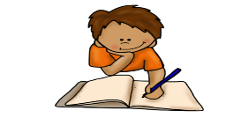  This Photo by Unknown Author is licensed under CC BY-SA-NC | 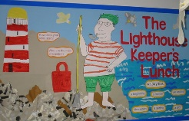  Listen to the Lighthouse Keeper’s Lunch. The address is below.  Write a set of instructions to teach someone how to make a disgusting sandwich for the seagulls in your green book. What horrid things could you put in it? Perhaps you could use crushed shells or an octopus tentacle.  https://www.youtube.com/watch?v=46wCRq50Wwg | The Light House Keepers lunch was delicious. Can you think of any words that mean the same as delicious?  Write them as a list. | Please try to learn the next five key words from your list.  Keep practising your reading by reading some books on  Oxford Owl  Remember to go to P1-7 Music Home Learning (Mrs Teale) where there are some fun music activities to try. | Look at the pictures of lighthouses below and design a new lighthouse for Mr Grinling in your green book. Let your imagination go wild. Remember it has to have a light and it has to be tall but other than that you could cover it in shells, seaweed, stones etc.
What part of your lunch do you think is the heaviest? Look at each part carefully and estimate (guess). Ask your family members to help you find the heaviest part and draw it in your book | Look at your name and try to add you’re your words.  The vowels are worth 1 and the other letters called consonants are worth 2  Miss Newall  2+1+2+2+2+1+2+1+2+2 =17  Does anyone have a larger answer than me? | Roll a dice and write down the number. Do it again and write the number next to the last one. What is that number? E.g. Roll a 3 and then a 4 to make 34 or 43.  See if you can make lots of different numbers. | 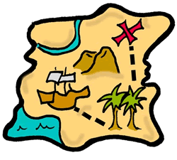  Hide a soft toy in the house or garden. Make a treasure map like a pirate to show where it is. See if a family member can follow your map to the toy. | We are going to revise symmetry today by copying patterns using Topmarks Symmetry. Try all the games with pictures, shapes and patterns. Click on the link below.  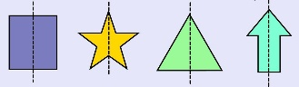
https://www.topmarks.co.uk/symmetry/symmetry-matching
Lighthouses Around the World

