Week 5 Learning activities Miss Gainford P2/3 4/5/20

Hello and welcome to another week of online learning.

This week we are continuing to look at special places. This week it is special place for Christians. When people travel to visit a special holy place it is called a pilgrimage.

“Our Blessed Mother” is Mary the mother of Jesus.

A saint is a holy person who has performed or seen two miracles.

A miracle is something amazing caused by God.

You may need help with the meaning of some of the words.
Or you could read The story of Saint Bernadette print out.

https://www.youtube.com/watch?v=XGe_P7oaSgQ

Now choose the sheets which are right for you.

P2,3,1 You will need the information sheet, question sheet and answer sheet.

P2,3,2 You will need the information sheet and the p2,3,2 answer sheet

P2,3,3 You are to cut and colour the pictures from the story and glue them in the correct order.

In health this week we are looking at a balanced diet. This is when you eat the correct amount from each food group each day.

https://www.youtube.com/watch?v=ARD1MAh434w

An easy way to remember how much of each group you should eat each day is to use the eat well plate which shows you the amount of each food that you should eat. Use your pictures from last week to help you to fill in the pictures of the food or look at the NHS example below. Write the names beside each food and colour them.

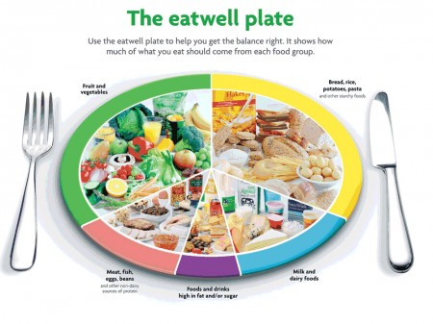

If you are feeling creative you could make your favourite, balanced 3d meal on a paper plate
Have fun, eat well and stay safe.

