Week 5 Learning activities Miss Gainford P2 4/5/20

Hello and welcome to another week of online learning.

This week we are continuing to look at Judaism and to learn that Jewish people visit their holy place, The Synagogue on a Saturday.

Watch the following video clip which shows you how a family celebrates Shabbat ( the Jewish day of rest) tells you a story about the Shabbat lion, shows you inside a Synagogue and lets you see how Shabbat ends on Saturday evening.

https://www.youtube.com/watch?v=gBVhIBgdNaM

Now complete the Synagogue worksheet that is right for you.

P2,1 Shows the two places that Sam’s family will be on the Sabbath or Shabbat. After dark on Saturday the Sabbath or Shabbat ends.

P2,2 Match the pictures to the words if you are not sure have a look at the picture for p2,3. All of the men will be wearing a prayer shawl including the Rabbi or religious teacher. Which item can you not see in the p2,3 picture? Which items have a different name? Can you point out where the women and the men will be sitting?

P2,3 Find the items and label them. The Torah Scroll word is above the Ark which means box and is always on the wall closest to Jerusalem. The Perpetual light never goes out and shines to show that God is there. Look at the information sheet about the star of David.

In health this week we are looking at a balanced diet. This is when you eat the correct amount from each food group each day.

https://www.youtube.com/watch?v=ARD1MAh434w

An easy way to remember how much of each group you should eat each day is to use a food triangle. You should eat more from the bottom ( the largest section) and less from the top ( the smallest section).

Here is a food pyramid or triangle to help you to remember how much of each group you should be eating.

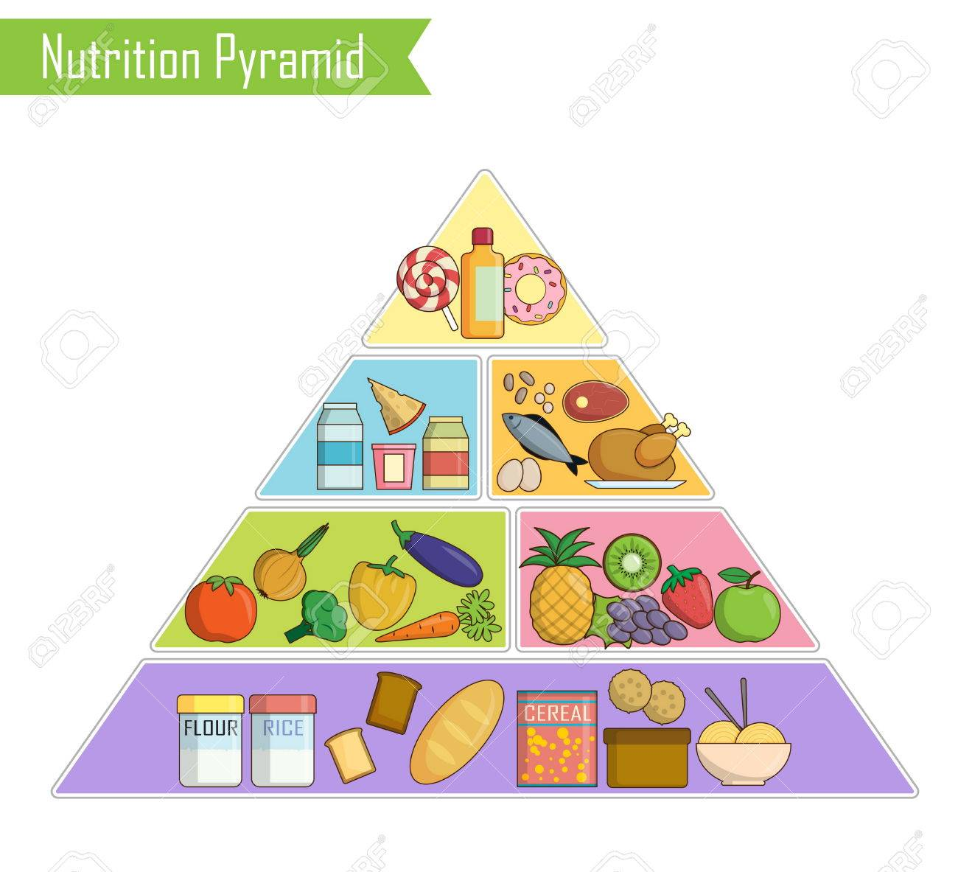

Some food can belong to more than one group such as macaroni and cheese.

Now print, cut out, arrange, stick and then colour the food pyramid sheet and use it to check your meals each day.

If you are feeling creative you could make a larger food pyramid and plate to choose a balanced diet from. You do not have to make it screw on ( unless you want to ) but you do need to colour code the backgrounds to help you to remember which group each food belongs to.

https://www.youtube.com/watch?v=KiXthrb1yFQ

Have fun, eat well and stay safe.

