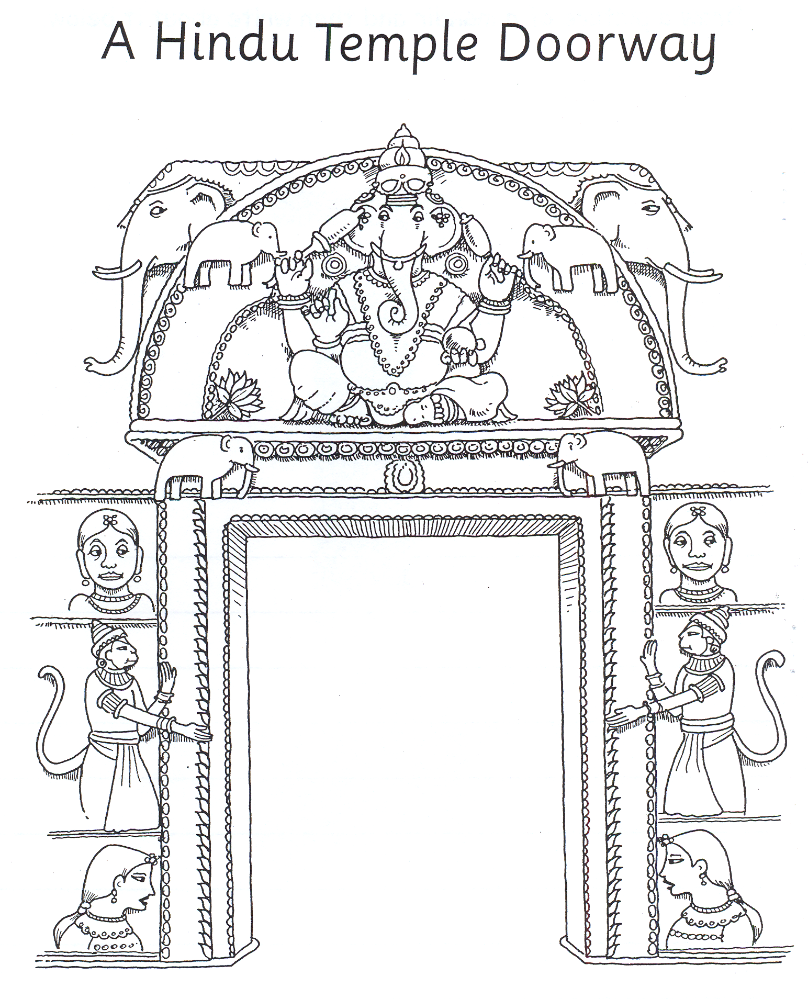
Seven two

Four Hanuman

Ganesh people
- I can see _ _ _ _ _ elephants.

- One elephant is called _ _ _ _ _ _ .

- I can see _ _ _ monkeys.

- The monkey God is called _ _ _ _ _ _ _ .

5.There are _ _ _ _ Goddesses.

- The statues are all on the outside to _ _ _ _ _ _ _ the Hindus for worship.

