[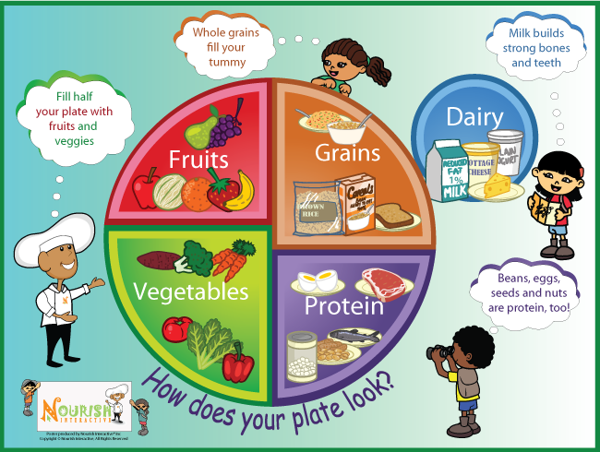](https://www.google.co.uk/url?sa=i&rct=j&q=&esrc=s&source=images&cd=&cad=rja&uact=8&ved=2ahUKEwi6_qvQu4fiAhWuxoUKHcEQAtAQjRx6BAgBEAU&url=https%3A%2F%2Fwww.pinterest.com%2Fpin%2F265079128044573361%2F&psig=AOvVaw3Wd9dozKwovMUmhBqr___3&ust=1557251377898921)