Week 4 Learning activities Miss Gainford 27/4/20

Hello and welcome to another week of online learning.

This week our story comes from and is called Bilal and the beautiful Butterfly

Watch the following clip to find out about the life cycle of the butterfly

https://www.youtube.com/watch?v=O1S8WzwLPlM

Now read this Muslim story about Allah ( the Muslim word for God ) and his beautiful creations.

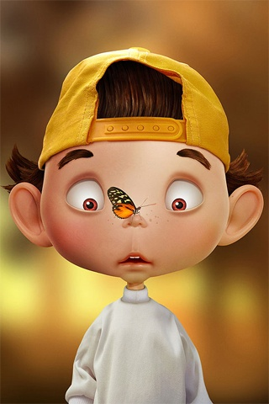

At the weekend, Bilal went to visit his grandfather.
The two days passed very quickly, and, before Bilal knew it, his father had arrived to take him home. He said goodbye to his grandfather and went to sit in the car. He was looking out of the window as he waited for his father to collect his things. A butterfly sitting on a flower a short distance away fluttered its wings and flew to the car window.
“You’re going home, aren’t you, Bilal?” asked the butterfly in a tiny voice. Bilal was astonished. “Do you know me?” he asked. “Of course I do,” smiled the butterfly. “I’ve heard your grandfather telling the neighbours about you.” “Why didn’t you come and talk to me before?” Bilal enquired. “I couldn’t, because I was in a cocoon up a tree in the garden,” explained the butterfly. “A cocoon? What’s that?” asked Bilal, who was always a curious boy. “Let me explain from the beginning,” said the butterfly as it took a deep breath. “We butterflies hatch out of the egg as tiny caterpillars. We feed ourselves by nibbling leaves. Later we use a liquid which comes out of our bodies like thread and wrap ourselves up in it. That little package we weave is called a cocoon. We spend a while inside that package as we wait to grow. When we wake up and come out of the cocoon we have brightly coloured wings. We spend the rest of our lives flying and feeding ourselves from flowers.”
Bilal nodded thoughtfully. “You mean all those colourful butterflies were once caterpillars before they grew wings?” “Can you see the green caterpillar on that branch?” asked the butterfly. “Yes, I see it. It’s nibbling away hungrily at a leaf.” “That’s my little brother,” smiled the caterpillar. “In a while he’ll weave a cocoon too, and one day he’ll be a butterfly like me.” Bilal had lots of questions to ask his new friend. “How do you plan this change? I mean, when do you come out of the egg, how long do you stay as a caterpillar and how do you make the thread to weave your cocoons?” “I don’t plan any of it at all,” explained the butterfly patiently. “Allah has taught us what we need to do and when we need to do it. We just act in the way our Lord wills.”
Bilal was really impressed. “The patterns on your wings are wonderful. And all butterflies have different patterns, don’t they? They are really colourful and eye-catching!”
Everything in the heavens and the earth glorifies Allah... (Surat al-Hadid, 1).
Do you not see that Allah sends down water from the sky and by it we bring forth fruits of varying colours? And in the mountains there are streaks of white and red, of varying shades, and rocks of deep jet black. And mankind and beasts and livestock are likewise of varying colours. (Surah Fatir: 27-28).
“That’s a proof of Allah’s artistic creations. He created us one by one in the most beautiful way possible,” explained his friend. Bilal agreed enthusiastically: “It’s impossible not to see the beautiful things Allah has created. There are hundreds of examples all round us!” The butterfly agreed: “You’re right Bilal. We need to give thanks to Allah for all these blessings.” Bilal looked over his shoulder: “My father’s coming. It looks like we’re about to set off. It was really great to meet you. Can we talk again when I come next week?” “Of course,” nodded the butterfly. “Have a safe journey home.”

How do you think Bilal felt when the butterfly started to talk to him?
What is the most beautiful thing that you have seen, talk to someone about it and then draw it on the back of the butterfly life cycle sheet below. Try to make your butterfly colouring symmetrical and neat.

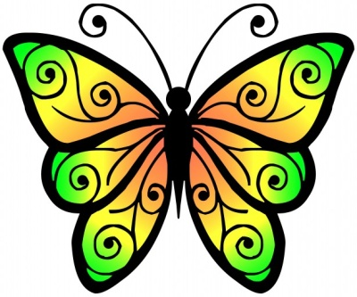
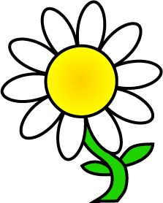

Butterfly game - Create large, colourful daisy-shape flowers with a circle in the middle large enough to write one letter/word/number that you are learning this week on each flower. Hang the flowers on the wall with double-sided tape. Have a butterfly race; you are the butterfly. Fly to the flowers to get some nectar. When you get to the flower use your arm as the butterfly’s tongue and unroll it from under your chin, (butterflies keep their tongue rolled up except when eating). Can you identify the letter/word/number/calculation and fly back to be told which flower to fly to next. If you get any answers wrong, don’t worry you can fly back again later and have another go.

In drama use the “ Life of a Butterfly” sheet to sing and act out the life cycle and you could use some of the art follow up activities.
Have a look in your garden or out on your walk to see if you can spot a butterfly or beautiful things.

Have fun and take care.

