[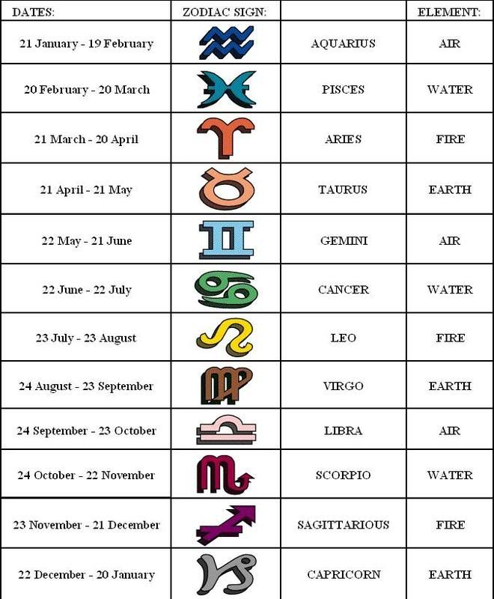](https://www.google.co.uk/url?sa=i&rct=j&q=&esrc=s&source=images&cd=&cad=rja&uact=8&ved=0ahUKEwjE18SX24vMAhUD0xoKHWkgAmEQjRwIBw&url=https://www.pinterest.com/pin/136093219961835833/&bvm=bv.119408272,d.d2s&psig=AFQjCNGx6ASjdFGHyFRlAAQ28nAZQNQPNw&ust=1460640252656631)