[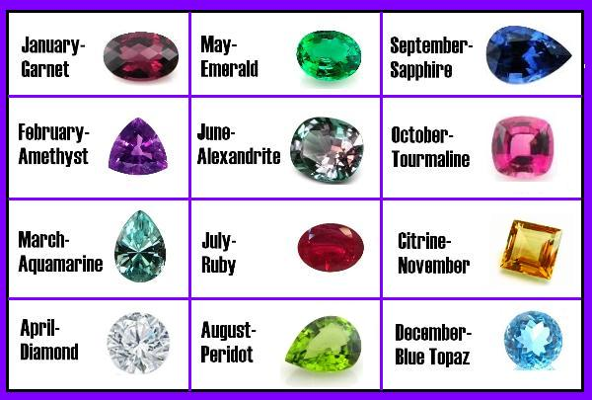](http://www.google.co.uk/url?sa=i&rct=j&q=&esrc=s&source=images&cd=&cad=rja&uact=8&ved=0ahUKEwiK1pj624vMAhVLfhoKHeTjA6IQjRwIBw&url=http://www.gemstobuy.com/Article.asp?id=2545&bvm=bv.119408272,d.d2s&psig=AFQjCNHy19eIidQ7t1lLH9Y3Qc_rhvB43Q&ust=1460640460976719)