[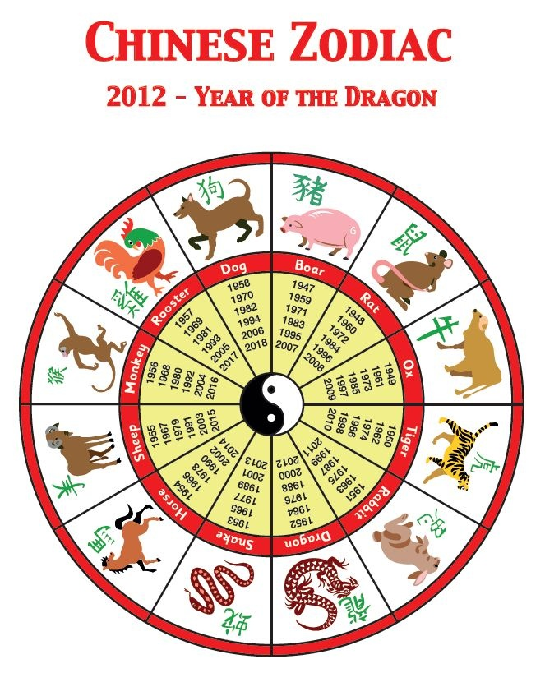](https://www.google.co.uk/url?sa=i&rct=j&q=&esrc=s&source=images&cd=&cad=rja&uact=8&ved=0ahUKEwihz6Dw2YvMAhXK2xoKHXIRAmgQjRwIBw&url=https://www.pinterest.com/pin/311452130450287593/&bvm=bv.119408272,d.d2s&psig=AFQjCNG1eJogPBo8J4zJSJmVEds_fGjAwA&ust=1460639878336680)