Castle Douglas Primary School – Primary 7 Online Learning – Week Beginning 30/03/2020

Please feel free to email me with any pictures of your learning or with any questions you may have at primary7cdps@gmail.com. I will update our class Twitter feed regularly with ideas for home learning activities (@p7andmrwhan) and tweet me some pictures of you working on this week’s challenges!

Maths and Numeracy

(Mrs Reilly’s Maths Group: Make sure that you are keeping up to date with the maths work that is being set here.)

Maths – Ongoing  Challenge set on Sumdog for everyone focused on your maths group’s previous learning.  I’ll keep an eye on your progress.  Continue with your maths calendars for March/start April one. Complete one problem a day as usual. (April ones will appear on the above link on 1st April.) | Maths - Multiplication  Complete the 3 and 4 times table sheets in your Multiplication Target Booklet.  Top Marks – Hit the Button Game. Follow the Hyperlink to revise your tables. | Maths- SAMSON Sheets  Triangles should complete the time challenge sheet starting 35-18.  Circles and Rectangles should complete the Area Sheet (starting 9cmx15cm). Remember the formula: A=LxB! Then complete the addition sheet starting 764+397  Squares – work through your booklet independently. | Maths - Countdown  Target Number is: 180  100, 7, 2, 9, 3, 7  Email or tweet me your solutions if you can!  To play an Online Countdown game follow this link.

Literacy
If you are someone who uses Reading Wise in class and can access this online then please have a go. Suggestion is that you access it 15minutes every day. J
Accelerated Reader runs between 9am and 3pm to take tests so please keep reading and taking tests where possible.
Literacy- Writing  See if you can spot some birds in your garden. See if you can identify them on the RSPB Website.  Choose a bird and create a leaflet detailing:  - Its distinctive features  - Habitat  - Diet  - Pictures/diagrams  - Use sub-headings to separate information. | Literacy - Spelling  I’ll upload your spelling words for the week to practise at home.  Spelling Training is a good place to practise.  Maybe someone could test you after you’ve practised them for a few days?  You can also play some of our usual Active Spelling games with people at home!  Spelling words are listed below. | Literacy – Reading  Mary Poppins, Lightning Girl and Kat Wolfe – Continue reading and add to part B of your book study. Then choose one activity from the list in Part C to complete. I have added pictures of these activities below if you don’t have your paper copy of the book study to hand.  Jilly P – read Chapters 3,4 and 5. Write up some bullet points (no more than 10) to summarise the main points in the story so far. | Literacy – Listening and Talking  Make up a quiz for your friends/siblings/family.  Prepare 10 questions. Act as the quiz master and score keeper.  Maybe you could team up with others and each create a round of questions on a different theme.

Across the Curriculum
Mrs Teale will set music Home Learning tasks each week. Follow this link to find Mrs Teale's Home Learning activities.
IDL - Social Studies  Research Mount Vesuvius and Pompeii. Display your research however you wish (Poster/essay/PowerPoint/Video Blog etc.)  Think about:  - Location  - What happened?  - When?  - Any interesting/unusual facts. | IDL – STEM Creativity Challenge  What can you do with a Cereal Box?  Tweet or email me your creations. Give a description of what you’ve made and what purpose it has! | IDL - Ready Steady Cook  If you are able, use this time to get involved in some cooking! Help an adult prepare a meal. Make sure you have permission and support to do this safely.  I’d love to see some pictures of you getting involved in the kitchen and of course, your finished dishes! | IDL - P.E  Complete a Joe Wickes Workout  Can you create your own workout for someone else to follow?  Video yourself demonstrating and giving instructions and I'll post on Twitter for others to follow!

This Week’s Spelling Words

Blue | Red | Green | Purple | Orange
Front | something | overcast | burnt | useful
onion | sometimes | overhead | modern | careful
back | somebody | overall | quarter | fearful
trick | everyone | overbook | remember | graceful
brick | everything | underage | early | hopeful
shock | everybody | underground | earthquake | skilful
luck | everywhere | understand | heard | thankful
Ireland | centimetre | undercover | search | watchful
March | metre | underneath | hearse | wonderful
 |  | Edinburgh | sincerely | either
 |  | London | library | neither

Pictures of the Book Study for those that need. 😊
Part B
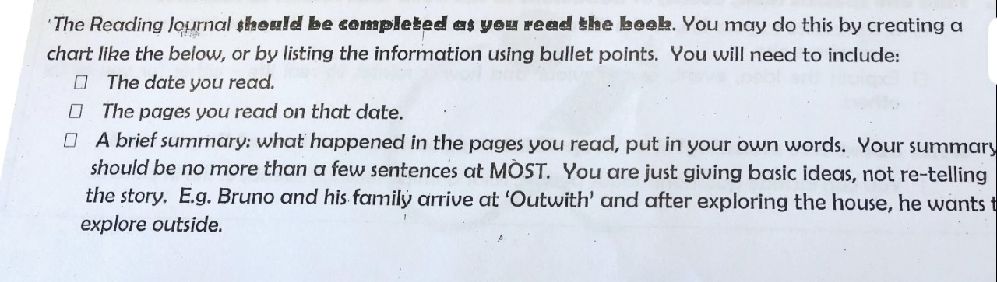

Part C
