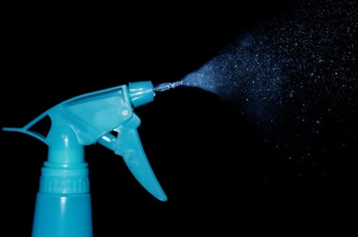
DIY Chalk Spray
You will need:
1 cup cornflour
1 cup warm water
Gel food colouring or ready mixed paints
Empty plastic spray bottles
- In a large bowl mix together the cornflour and half the water until well combined.

- Before it settles, divide the mixture into as many spray bottles as you want to make colours of paint.

- When divided, add a small amount of food colouring or ready mix paint to the bottle. Shake well until the colour is completely combined.

- Ready to spray and create!

