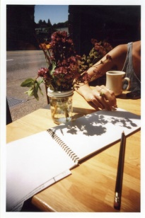
Tracing Shadows
You will need:
Paper
Pens / pencil / crayons
Toys eg.dinosaurs, vehicles, dolls

- Lay paper flat in sunshine or in front of a lamp / light.

- Position toy on paper so it creates a shadow.

- Draw around the outline of the shadow.

