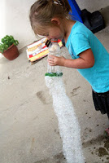
Bubble Snake
You will need:
Empty plastic bottle
Sock
Water
Washing up liquid
Basin

1. Cut off base of bottle.
2. Stretch sock over base of bottle.
3. Mix water and some washing up liquid in the basin.
4. Dip the sock end of the bottle into the water mix.
5. Blow through the top of the bottle to create a bubble snake!
* You could try adding a little food colouring to the water.

