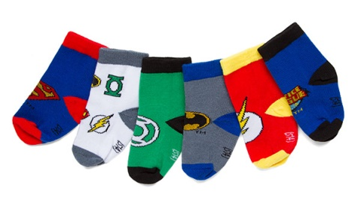
Socks!
You will need:
A pile of socks – different sizes, colours, patterns – the more the better!

- Sorting: sort by colour
sort by size – keep it simple eg Big and Small
sort by pattern eg all the spots, stripes etc

- Matching – mix the socks into a big pile –
- Adult holds up one sock, child to find sock to match
- Makeshift washing line – peg the socks in pairs (or adult can peg one and child to peg matching sock next to it.)
- Make all pairs
- Competition – who can make the most pairs.
- Use of timer – how many pairs can be made in a given time?
Final task – match all socks into pairs and sort into who they belong to!

