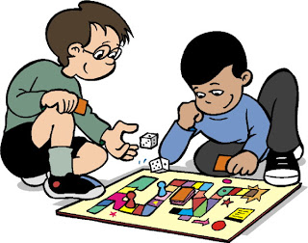
Other Activities to do home
- Make a bird feeder.
- Build a den using blankets.
- Have an indoor picnic/tea party.
- Play hide and seek.
- Build towers etc with paper cups.
- Bake some cakes/biscuits.
- Matching games/activities eg Picture Lotto, use of ‘Snap’ cards
- Watch a film.
- Make your own pizza.
- Number/letter hunt around the house.
- Look at family photos together.
- Plant seeds.
- Ice and decorate biscuits.
- Fly a kite.
- Make a fairy garden.
- Prepare and make a family meal together.
- Make a fruit kebab.
- Hide and seek with toys.
- Keep a tally of the colours of cars going past your house
- Make a bug hotel.
- Play a board game.
- Dressing up
- Do some gardening/weeding
- Collect flowers/twigs and put in a vase.
- Play with a big cardboard box.
- Lego.
- Build a fort using the couch and all the cushions/pillows you can find.
- Read a story.
- Use masking tape to make a race track.
- Have a picnic outside.
- Go for a walk.
- Jigsaws.
- Sorting activities eg by colour, by size, by type.

