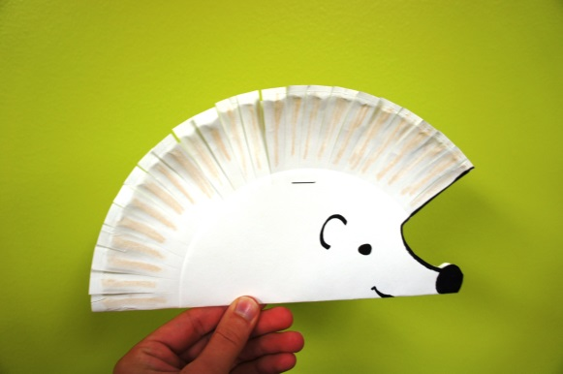

Art & Craft Activities to do at home
- Junk modelling
- Paint a picture
- Paint on foil
- Make prints using different vegetables
- Paint rocks/stones
- Make a picture from nature eg leaves, flowers
- Make prints using Lego
- Roll cars through paint
- Make paper chains
- Make a mask
- Use cardboard tubes to make shapes to print with.
- Make a paper plate creation/picture.
- Make some mud cakes in the garden.
- Make a musical instrument.
- Make a crown/hat to wear.
- Build a boat that floats.
- Colouring.

