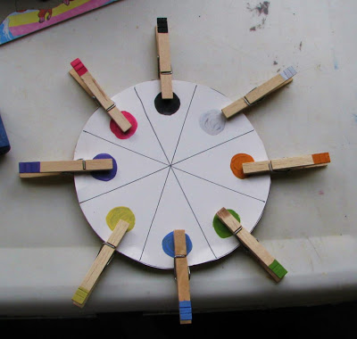

Motor Skill Activities to do at home
- Mark making – use a variety of utensils eg pens, paintbrushes, chalk, fingers.
- Playdough.
- Thread pasta onto string/wool.
- Thread Cheerios onto spaghetti (uncooked!!).
- Play with Lego.
- Use chalk outside.
- Inset puzzles.
- Shaving foam – practise writing shapes/letters/numbers.
- Practise using scissors.
- Colouring.
- Wind up toys.
- Set up an obstacle course.
- Take turns to peg each other’s clothes – encourage to remove pegs by squeezing (not just pulling).
- Use pegs for colour (or number/letter) matching – see picture at top.
- Throw an item eg bean bag/small ball, into a target eg bucket.
- Make a picture using stickers.
- Keep a balloon in the air as long as possible.
- Build a tower with blocks.
- Indoor bowling/skittles
- Tracking
- Practise using a knife, fork and spoon.

