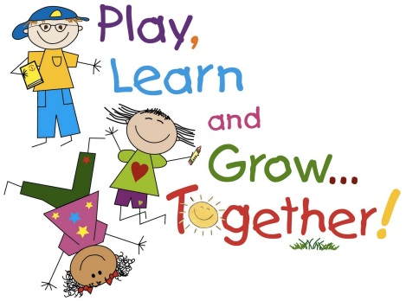

Sensory Activities to do at home
- Finger painting
- Shaving foam - on a table/on the shower screen
- Big bowl of jelly – encourage to put hands in and play with jelly/squeezing/smelling
- Bowl/tub of rice – cup/funnels/sieve/scoop
- Playdough
- Play with bubbles and warm water
- Baby/toy wash station
- Freeze toys in ice and rescue them with warm water.
- Make a tower with shaving cream and wooden blocks.
- Have a bubble bath
- Soak feet in basin of warm water and bubbles
- Create a sensory shaker bottle using an empty plastic (clear) bottle, glitter and water (and whatever else you’d like to put in there!)
- Water play – buckets, scoops, whisk, jugs, straws
- Draw/paint with feet

