Care Experienced Pupils and SEEMiS

How to identify pupils who are Care Experienced in your school
(subject to a CSO both currently & previously)
Schools can regularly extract data from SEEMiS in order to monitor which pupils are Care Experienced within their establishment. If schools have queries regarding the pupils appearing on this report please email MISS@dumgal.gov.uk in order this can be clarified with the relevant agency.

Log into SEEMiS Click & Go and go to My Profile> Reports> Custom Reports | 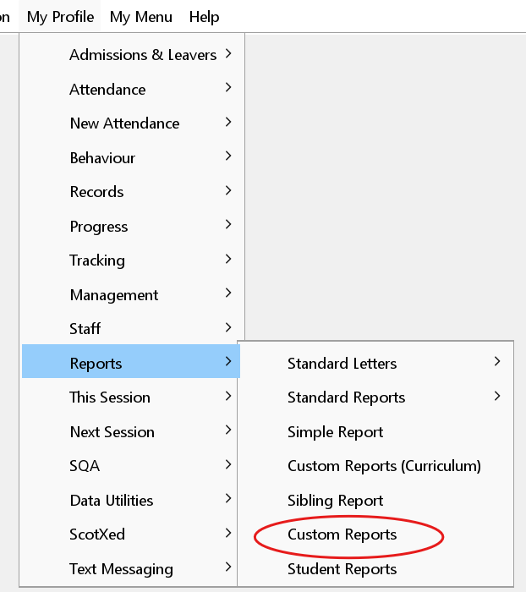
Click on the yellow folder, highlight the Care Experienced Pupils report, click Open  Note: There is also a report called LAC/CP Pupil Info V2 but this will ONLY show pupils who are currently recorded as having a CSO (LAC) or are on the Child Protection Register. This report is mostly used when LAC/CP information has been updated by the MISS team | 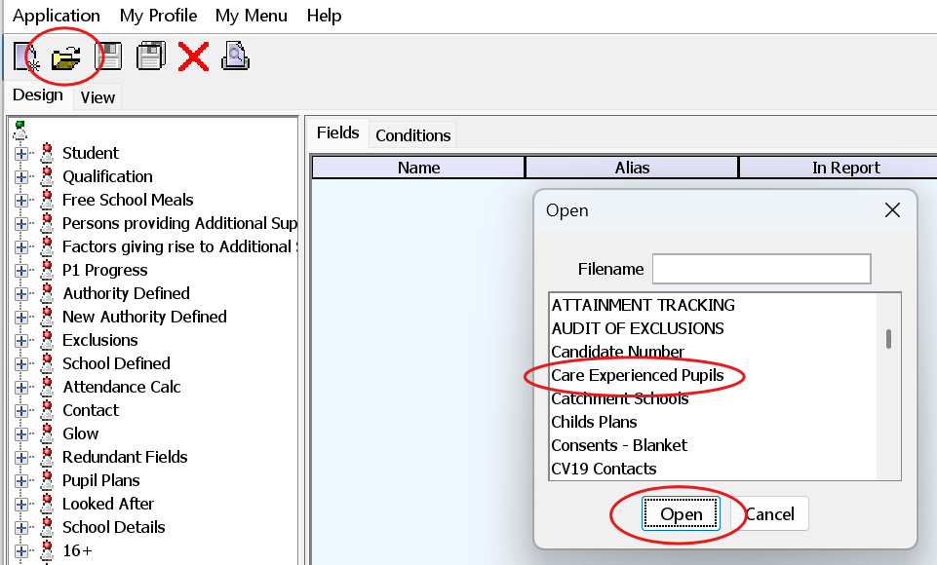
Click on the View tab to see all your school’s pupils who are recorded as Care Experienced  By right clicking over the data you can Copy All and paste into an excel document if easier to view/filter | 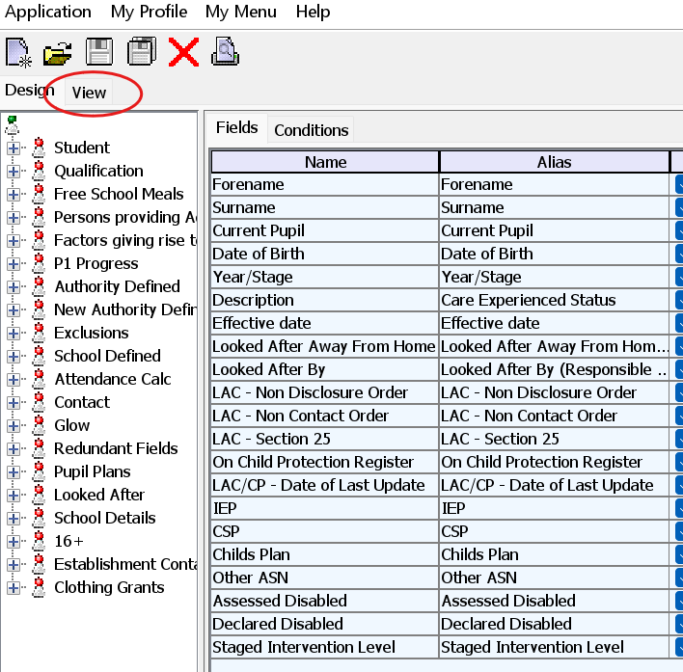

How to Record Care Experience Status as an ASN on SEEMiS
All Care Experienced pupils should have the below recorded in their SEEMiS record. This information is used to extract data at both a school and central level. Failure to record this information will result in support needs being missed. This status should only ever be removed if it was entered in error.

Log into SEEMiS Click & Go and go to My Profile> Records> Edit | 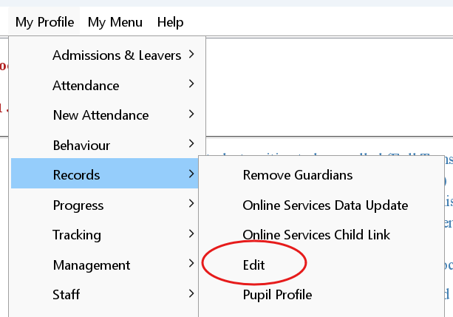
Click New List and highlight the relevant pupil  Select the Personal tab | 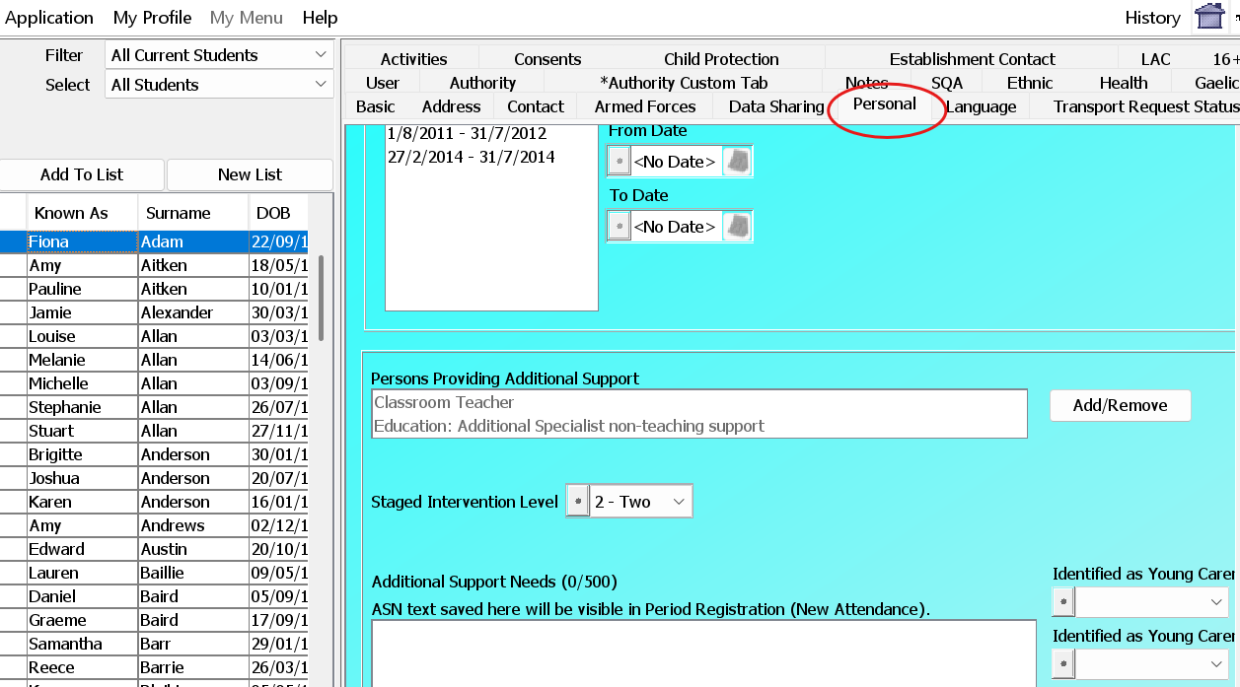
To log an ASN you require to populate the following fields:  - Person Providing Additional Support (by clicking Add/Remove)  - Staged Intervention Level (from the drop down list)  - Student Need List (by clicking Add/Remove/Edit)  NOTE: For all Care Experienced pupils, the Student Need that requires to be entered is LAC. There is no actual Care Experienced option within SEEMiS | 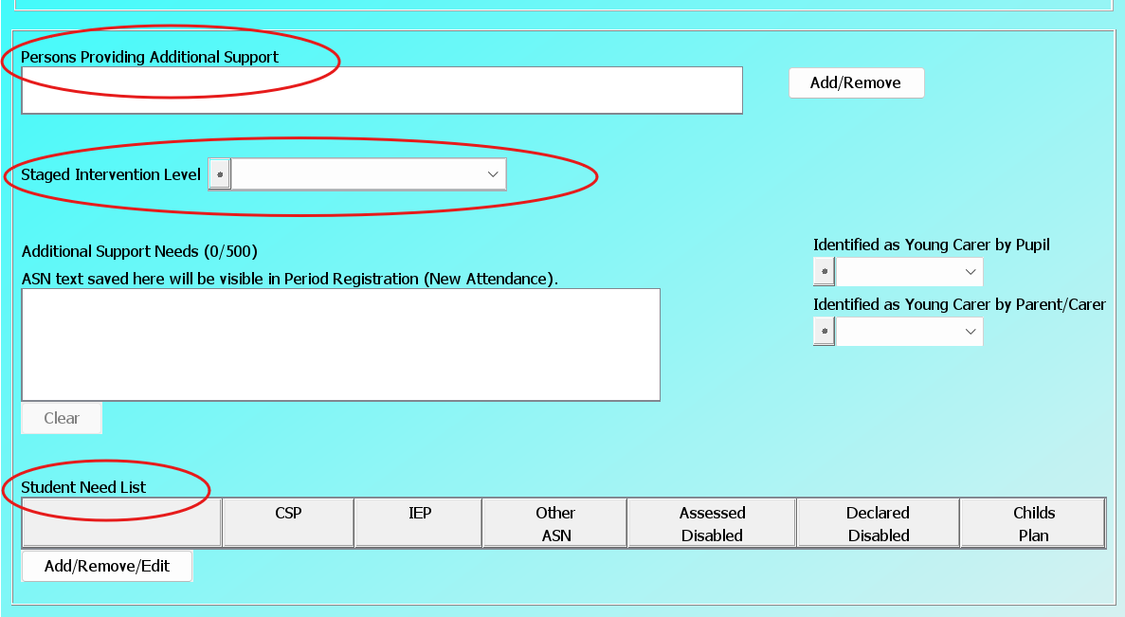  NOTE: If you enter Person Providing Additional Support there MUST be a need added to the Student Need List

Recording a Pastoral Note

Due to Care Experienced pupils being vulnerable Pastoral Notes must be used to record any updates/information in order that these are picked up should a Single Agency Chronology be required.

Log into SEEMiS Click & Go and go to My Profile> Records> Latest Pastoral Notes> Manage Pastoral Notes | 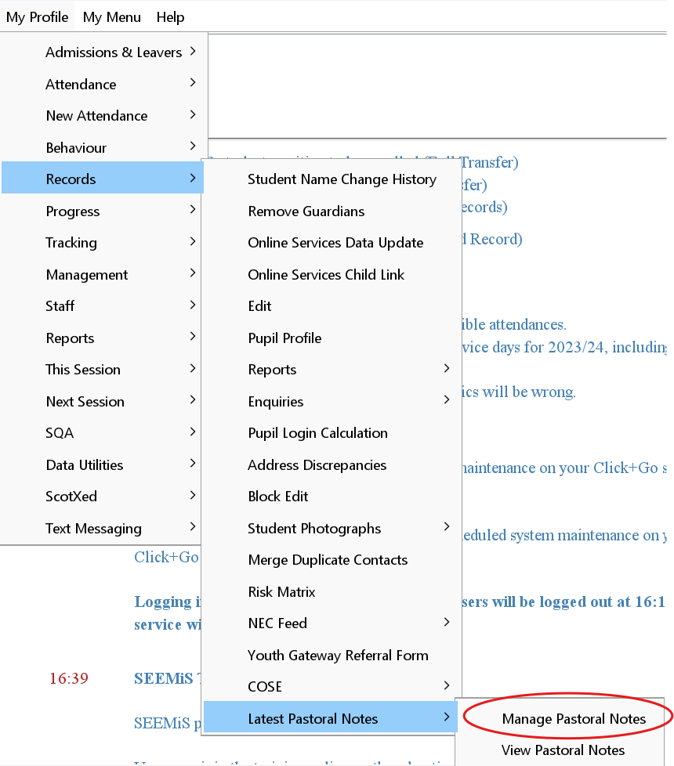
Click New List, highlight the relevant pupil, click New Note | 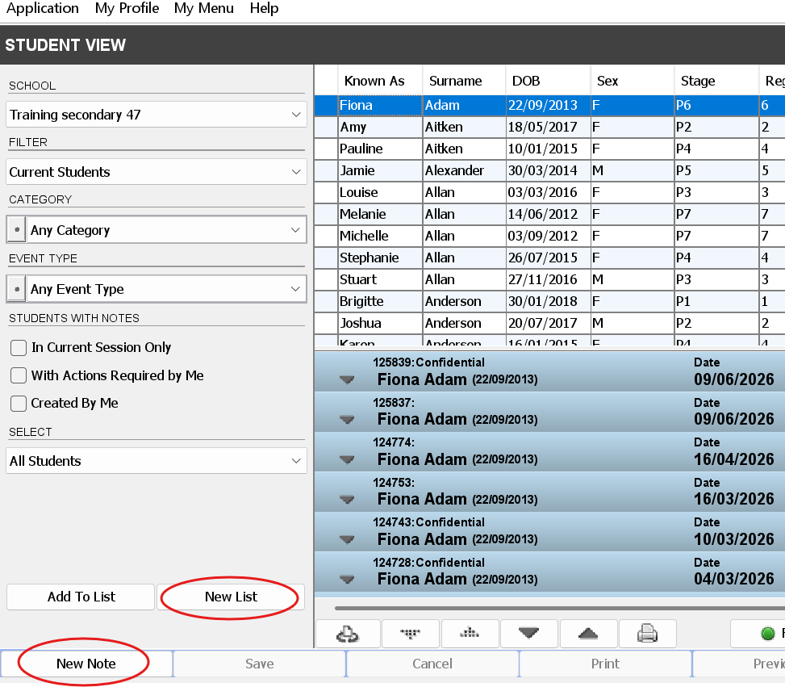
Complete the relevant information. Notes regarding Care Experienced information for a pupil should all be Significant Events  Please remember to follow the format for the note details of Source, Detail, Action & Outcome  Once complete click Save at the bottom  Note: Significant Event type notes should only be accessed/entered by Senior Management. | 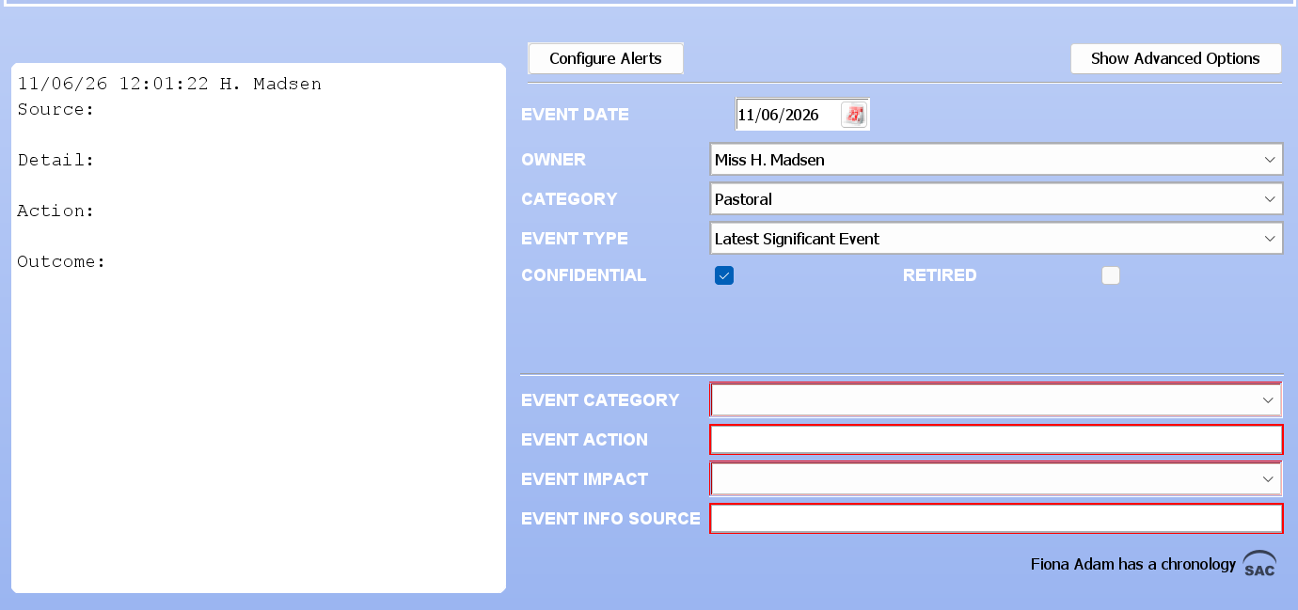  NOTE: Once a significant event type note is saved it CAN’T be amended. If the note requires to be updated later, schools can initially save as a Centrally Recorded note and then once complete can change to Significant Event.
What & How to Upload Care Experience Information onto SEEMiS Wellbeing

Any documentation that is received from SCRA/Social Work should be uploaded onto the Wellbeing system, i.e. CSOs, letters etc.

Log in to Wellbeing, if you have more than one school double click into the relevant establishment> find the relevant pupil> double click into their record | 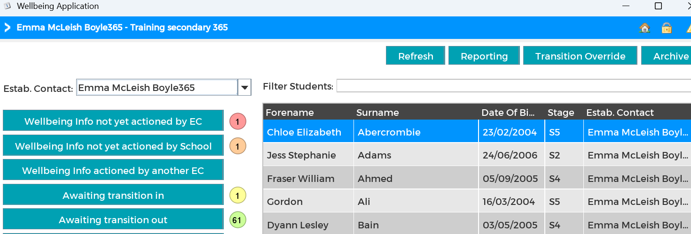
Select Create/Upload> click Upload Document> complete information in the relevant boxes (red boxes are mandatory)> click Choose File to upload the relevant PDF document> once completed click Save.  NOTE: All documents MUST be saved as a PDF before they can be uploaded. | 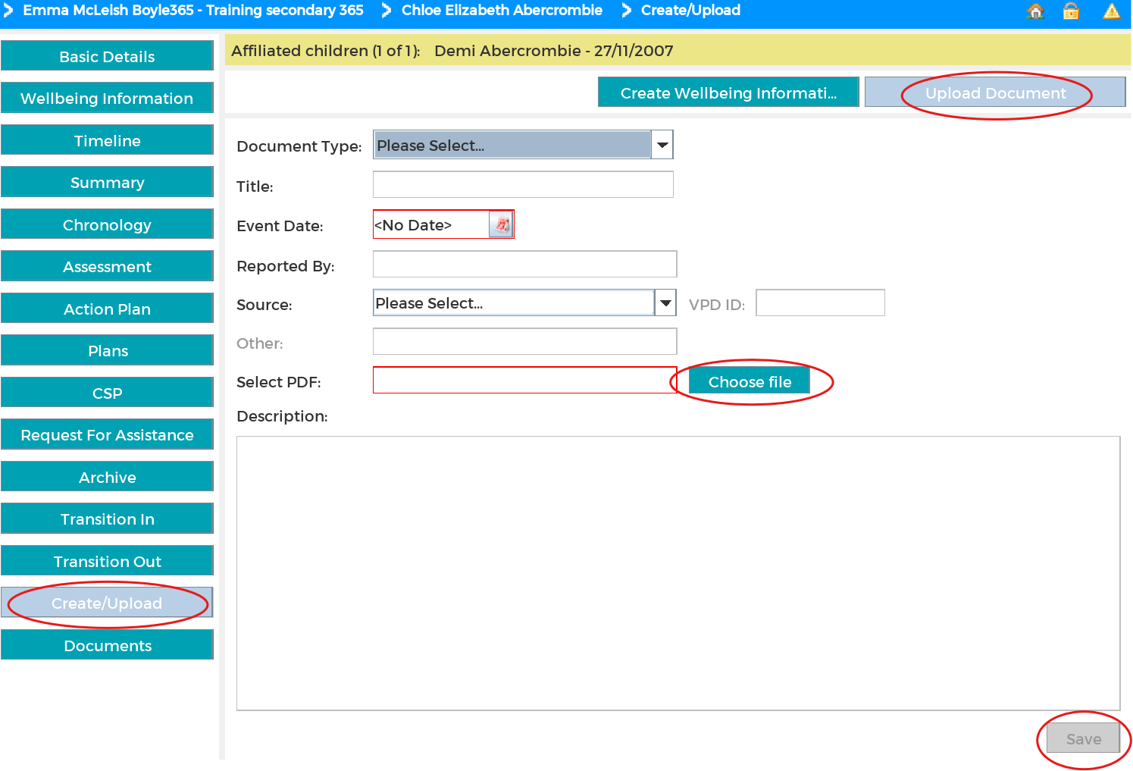

Communication with Care Experienced Pupil Contacts

For any Care Experienced pupils schools need to ensure that the relevant persons are added as contacts in the SEEMiS record. At no time should any contacts be deleted, however, the main contact may be changed depending on who the pupil is living with. Please keep in mind that even though living arrangements may have changed, this does not automatically give the new carer relevant rights to provide permission for trips, image consent, etc.

Log into SEEMiS Click & Go and go to My Profile> Records> Edit
Click New List> highlight the relevant pupil> select the Contact tab | 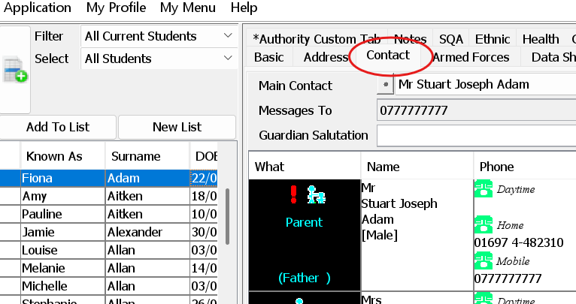
If you need to add additional contacts click New at the bottom | 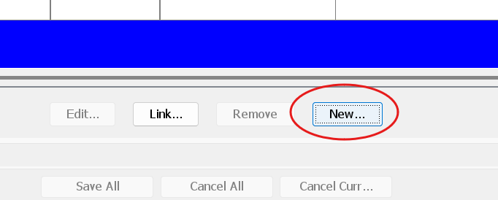
Once you have added all contacts if you need to change the Main Contact you can do this by selecting the relevant person from drop-down box at the top of the page | 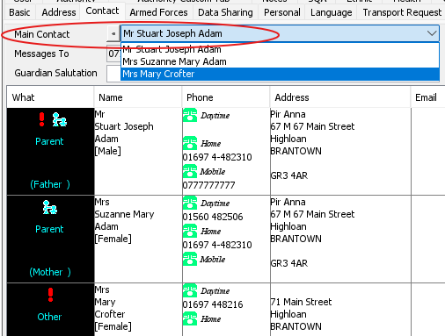
If you require to send communication through Groupcall to any Non-Main Contacts, you need to select the relevant contact> click Edit> add a priority number next to Groupcall Permission/Priority  It is recommended to use Priority 2 for anyone who does not live with the pupil so it is easier to filter in Groupcall  NOTE: Main Contacts will automatically flow through to Groupcall there is no need to complete this task for them. | 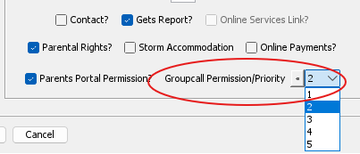  NOTE: This only needs completed for contacts you want to send Groupcall communications to, it does not need done for all contacts.

