 |  | 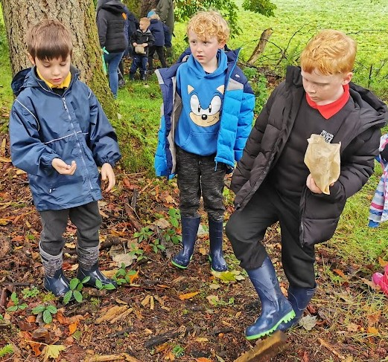
 |  | December 2023
2022 |  | 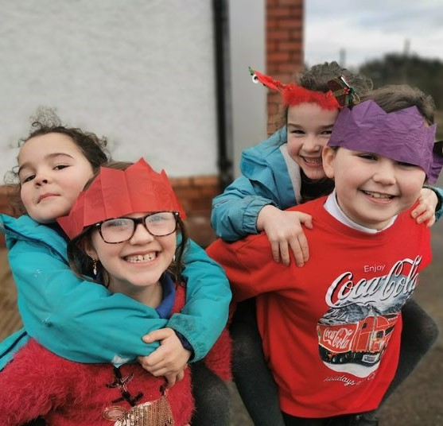
Information at a Glance
School Information  School Information  School Address:  Gelston Primary School,  Gelston,  Castle Douglas  DG7 1SH  Telephone: 01556 502415  Email address:  gw08officegelston@ea.dumgal.sch.uk  Parent Council Chairperson: Pam Shuttleworth  Head Teacher: Miss Mary E Cruickshanks  School Roll: Primary 1-7 = 39  Denomination Status: Non-denominational  Status of Gaelic: N/A  School Staff:  Teaching Staff  Principal Teachers: Miss Reid (Mon-Thurs) and Mrs Lumsden (Fri)  P1-3 Teachers: Vacancy (Mon) and Miss Scott (Tues – Thurs)  P4-7 Teachers: Miss Reid (Mon-Thurs) and Mrs Lumsden (Fri)  Additional Support for Learning Teacher: Mrs Callander  RICCT Teachers: Mrs Bielinski and Miss Holman  Clerical Assistants: Miss McNeill and Mrs Motherwell  Learning Assistant: Miss McNeill  School Education Officer: Mrs Rachael Williams  Auxiliary Staff  Janitor: Mr McWilliam  School Cook: Mrs Fenwick  Cleaner: Mrs Fenwick | The School Day  The school playground is supervised from 8.45am  Primary School  09:00 School starts  10:30-10:50 Morning Interval  12:30-13:15 Lunch Time  15:00 End of School Day  Communicating with home  Our main method of communication is through the school website and blog. Parent Council information is on the website. The link can be found here:  https://blogs.glowscotland.org.uk/dg/crossmichael/  You may contact your child’s class teacher directly by emailing them or by writing in your child’s homework diary. Alternatively, you can contact the school office to arrange an appointment with them.  We use GroupCall to text important information directly to your mobile phone. We also email information.  Please contact the school office by telephone or email at any time.  If your communication is urgent then you can contact the Head Teacher directly on 07741 686730.
Welcome from the Headteacher

Welcome to Crossmichael Primary School which has been working in partnership with Gelston Primary School since 2012.

The purpose of this handbook is to provide you with key information that you will need as your child starts the school. Please contact us if there is anything else that you wish to know.
We believe in working together with all members of the school community to ensure that pupils are safe, healthy, active, nurtured, achieving, respected, responsible and included. All children are encouraged to reach their full potential and our experienced teaching and non-teaching staff strive to ensure that all barriers to learning are reduced or removed to ensure the best education for all.

Best wishes,
Miss Mary E Cruickshanks
Partnership Head Teacher
School Aims, Values and Ethos
We believe that it is important for pupils, parents, staff and the local community to work together to foster positive relationships in our schools.
We have worked together to develop a shared Vision, Values and Aims for the schools so that we have a clear understanding of our expectations of all children and adults involved in the school community. We have joint ownership and responsibility to ensure that these standards are upheld.
We promote our values in our daily interactions and ensure that praise and positive reinforcement are used to encourage a safe and friendly learning environment.

Learners are encouraged to believe that they have the capacity to grow and develop in all areas of their learning. We aim to help build resilience by learning from mistakes.
We believe that all learners should be able to achieve their full potential and we look for ways to reduce and remove barriers to learning. Sometimes we will invite parents/ guardians in to school to discuss this. Our teachers are experienced in working with colleagues from other agencies to support pupils with a variety of learning needs. If we feel that your child would benefit from support from other professionals then we will always discuss this with you first. Other professionals may include the Educational Psychologist, Occupational Therapist, Speech and Language Therapist, Physiotherapist, etc.
We are committed to raising attainment and to ensuring that there is equity for all learners. That is why we work in partnership with pupils, parents, staff and the wider community to ensure that our learners experience the best education.
We are fortunate to have many pupil groups within the school including a Pupil Council, Eco-Group, Health Group and Blogging Group. These forums give pupils a voice in contributing to their education and to the wider life of the school.
Our Parent Council meet termly to discuss a variety of topics. They help to organise fundraising events, to support the school, to promote contact between school and home, to become involved in school improvement plans and to raise any other important issues.
Our dedicated teaching and non-teaching staff provide a range of learning opportunities within and out with the classroom.

Contact Us  The school welcomes suggestions and enquiries from parents and carers.  If you need to find out something  We can be contacted by e-mail, telephone, group call text messages or face to face. Where it is not possible to resolve enquiries straight away, we will make arrangements to follow up as necessary with the most appropriate member of staff.  If you have a comment or concern  A comment might be some brief feedback about how we have handled a situation or delivered a service. It is best to pass a comment straight to the school so that we can take any necessary action.  If you are not happy with the response you receive or a decision that has been made, you can Ask us to Look Again. You can do this by contacting Educationsupport@dumgal.gov.uk. At this point an Officer will contact you and discuss the issue and share directly with you the outcome of this work.  Remember you can also access Dumfries & Galloway Have Your Say at http://www.dumgal.gov.uk/ article/17349/Have-your-say | How the School Works  Class Organisation  We have capacity for 50 pupils across three classrooms. We can have up to 25 pupils in each multi-composite class. It is sometimes necessary to split year groups across two registration classes depending on the number of pupils in each class. We do ensure that year groups have opportunities to work together.  Positive Behaviour and Celebrating Success  Building positive relationships with pupils, parents, staff and visitors is vital to the success of our school. Our school values are at the heart of everything we do and we reinforce them daily.  If a child displays behaviour that is not in keeping with this, then we discuss the behaviour displayed, what triggered it and how we can support the child to find a more suitable way of dealing with a similar situation in the future. We ensure that children are aware of the impact of their actions on themselves and others. We do not punish children but their actions do have consequences. Just as a child needs to learn how to read, we believe that they must learn how to behave and be equipped with strategies to use to help them deal with a variety of situations.  We focus on a school value and promote this at our weekly assembly. Pupils who demonstrate this value receive a certificate at the next assembly.  Success is celebrated at assemblies, in newsletters, on the website/ blog, in the local press and on wall displays. We are very proud of our learners and their achievements.
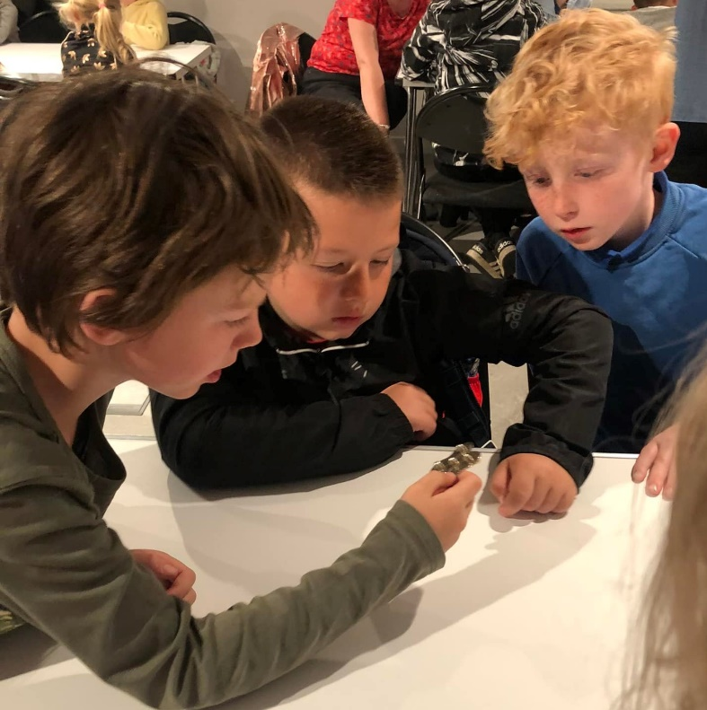
 | 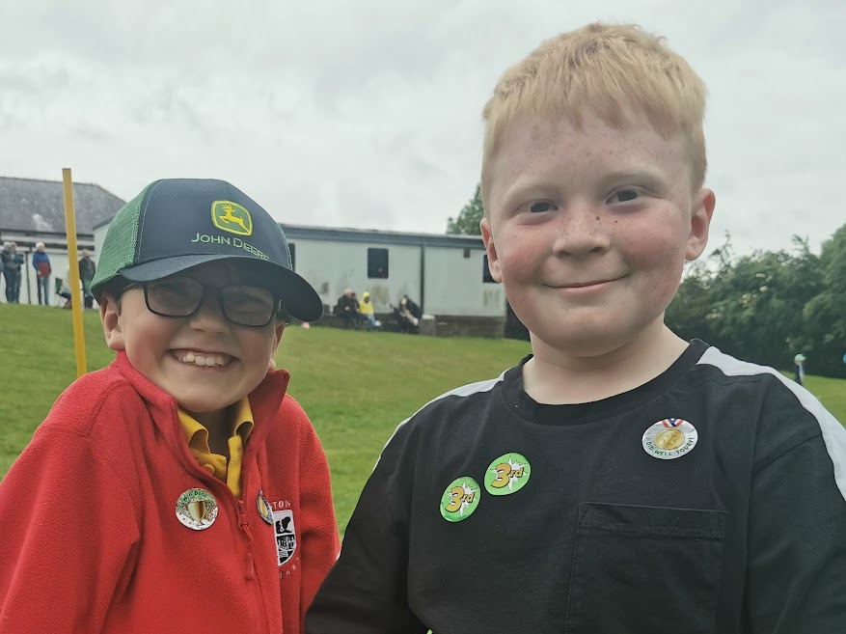

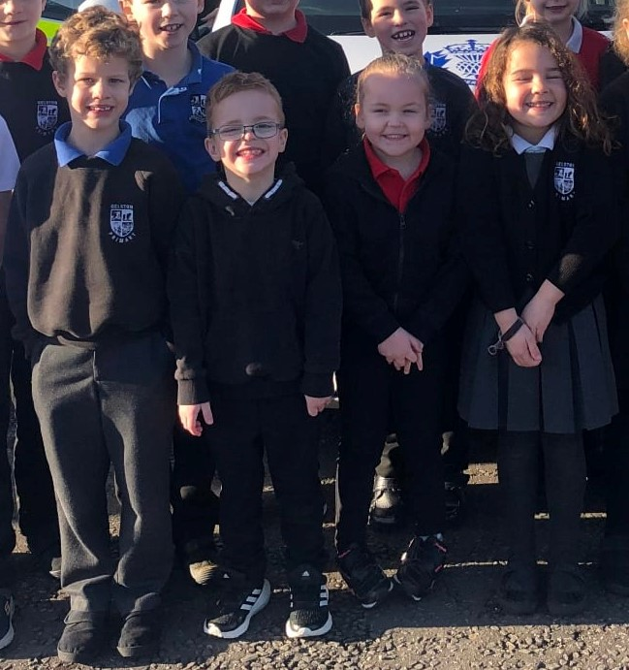School Uniform  All Dumfries and Galloway schools have a dress code which encourages pupils to dress in a way appropriate to attendance at school. www.dumgal.gov.uk  Our school uniform consists of blue sweatshirts, cardigans and white school polo shirts. All have the school logo embroidered on the front. These should be worn with black or grey school trousers, shorts or skirts. All items should be purchased online through the School Trends website. Here is the link: https://www.schooltrends.co.uk/.  School Clothing Grants  The award of clothing grants is to assist with the cost of school clothing for families who are on a qualifying benefit or on low income. The current award is £134 per child. Guidance and more information is available at http://www.dumgal.gov.uk/article/15246/Schoolclothing-grants  School Meals  School Meals, Naturally D&G local provenance for a sustainable future.  Detailed information on school meals is available at https://www.dumgal.gov.uk/schoolmenus  Pre-ordering lunch  All menus are nutritionally analysed, offering a fantastic choice and flexibility. Primary schools have introduced an advanced pre order system for lunch. Pre order forms are handed out to all pupils. | Special dietary requirements  For food allergy and intolerances; medically prescribed diets; or diets for religious or cultural reasons specific meals for children of different ethnic origin may be catered for. Ask the school for a registration form or call 030 33 33 3000 and ask for Facilities Operations (Catering)  Free School Meals  Free School Meals are provided for all pupils in Primary 1, 2 and 3. Younger children at nursery or older pupils at primary may also be eligible for free school meals in certain situations as well as those families on qualifying benefits.  For more information on free school meal entitlement visit http:// www.dumgal.gov.uk/schoolmeals or contact Education Support Services on 01387 260 493  School Transport  Free school transport is available for some school children attending primary or secondary school if they live within the school catchment area and if they meet certain criteria. For more information and guidance visit http://www.dumgal.gov.uk/article/15245/Freeschool-transport  Attendance  It is your responsibility as parents to ensure that your child/children attend school regularly. For the safety of all children it is important for you to telephone the school office prior to/at the beginning of the absence. Absences are recorded in class registers and frequent or irregular absences not supported by a reasonable excuse, will be notified to parents and the matter may be referred to the Opportunities for All Service. If possible please, try to make dental/medical appointments out with school hours. However, if this is not possible please inform us in writing or by telephone of the appointment and arrange to collect your child from class. More information: www.dumgal.gov.uk  Absence from School  Pupils who need to leave school during the school day ie doctor /dentist appointments, must be collected by a named contact confirmed with the school office. They must also report to the school office on their return to school.

Curriculum for Excellence  Curriculum for Excellence Curriculum for Excellence (CfE) is bringing learning to life in the way education is delivered for all 3-18year olds – in nursery, primary, secondary, at college, workplace or community learning. It aims to raise standards, improve knowledge and develop skills, closing the gap between the lowest and highest performers. Ultimately it aims to nurture children and young people as successful learners, confident individuals, effective contributors and responsible citizens.  Broad General Education  Children and young people work their way through Experiences and Outcomes in each of the five Curriculum Levels (Early, First, Second, Third, Fourth) and in each of the eight Curricular Areas. The five Curricular Levels span pre-school to the end of S3. This is the Broad General Education. Pupils progress at their own pace, working through the Experiences and Outcomes of the most appropriate level for them. Pupils will be supported in collecting evidence of their achievements, with a profile of these being produced in P7 and S3.  Our curriculum is based on Curriculum for Excellence 3-18 where learners experience a broad general education where they can access a wide variety of learning experiences.  Our curriculum is designed around the seven principles of the Curriculum for Excellence:  • Challenge and enjoyment  • Personalisation and choice  • Progression  • Depth  • Breadth  • Coherence  • Relevance  Curriculum Levels are such that Early Level is normally achieved at the end of P1, First Level at the end of P4 and Second Level at the end of P7.  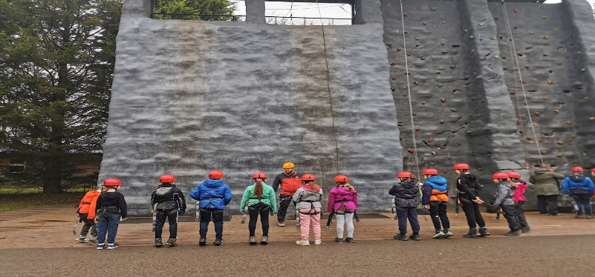 | Our curriculum structure is divided up over three years. That means that we have looked at the individual Experiences and Outcomes (Es and Os) and bundled them together to provide opportunities for learners to learn in context to make it more meaningful for them. We have also looked at stand alone learning within subject areas and we have carefully planned when this block of learning naturally fits in with other learning. To allow for pace, depth and challenge, teachers can plan to teach the same Es and Os at the same time. This allows for collaborative working and the professional dialogue that takes place should mean that there are no ceilings put on a child’s development. If a child in P4 is ready to learn at Second Level of the curriculum then they will be able to do so. Likewise, if a child is in P4 and needs to work at Early Level then will happen. Regular quality assurance and self-evaluation is in place to ensure that all learners receive a high standard of education in our schools.  Home/School Partnership/ Parental Involvement and Engagement  Parent Council and Parent Forum  Every parent who has a child at our school is a member of the Parent Forum. The parent council is a group of parents who have chosen to represent the parent forum. As a member of the Parent Forum, each parent can expect to:  • Receive information about the school and its activities  • Hear about what partnership with parents means in our school  • Be invited to be involved in ways and times that suit you  • Identify issues you want the parent council to work on with the school  • Be asked your opinion by the parent council on issues relating to the school and education it provides  • Work in partnership with staff  • Enjoy taking part in school life in whatever way possible  More information is available at http://www.dumgal. gov.uk/article/17608/Parental-Involvement  More information and support for Parents/ Parent Councils is available at https://connect.scot/

Homework/ Family Learning  All pupils have a homework diary. Teachers in P1-3 tend to stick a label into these diaries so that parents/ guardians can clearly see homework arrangements for the week ahead. Pupils in P4-7 are encouraged to note down key information about homework by themselves. We also use Microsoft TEAMS and Class Facebook pages to post updates for pupils and parents.  Our Homework Policy needs to be reviewed, but in the meantime a rough guide is:  P1-3:  - Reading homework 2-3 times per week (including phonics and key words)  - Numeracy and Maths homework once a fortnight  - Topic work once per term  P4-7:  - Reading to be encouraged for 10-15mins each night and reading task once per week  - Spelling homework once a week  - Numeracy and Maths homework once a fortnight  - Topic work once per term  We plan to re-establish open days so that parents/ guardians can drop-in to experience learning in different curricular areas. We also have ‘Learning Afternoons’ where pupils showcase their learning and parents/ guardians can find out more about what they have been learning in school. We are hoping to develop this further in the future to include more opportunities for Family Learning. | How is my child doing?  There will be several opportunities for you to discuss your child’s progress. This may be through informal discussion with the teacher or at Parents’ Nights/ Learning Conversations, formal reports or for some it may be through more formal, focussed meetings with other agencies.  Helping the School  There are many things which as a parent you can do to support your child’s learning in school: www.dumgal. gov.uk/article/17608/Parental-Involvement  Support for All  Support for Learners  Dumfries and Galloway Council is committed to the well-being and educational development of all learners. The process of inclusion requires all involved in the business of learning and teaching to demonstrate commitment, innovation and flexibility to ensure that all children and young people have access to quality learning opportunities and experiences. More information is available at https://www.dumgal.gov.uk/article/16163/Support-for-Learners  Getting It Right For Every Child (GIRFEC)  You are the expert on your child and what you think matters. Getting it right for every child (GIRFEC) means that the School will always seek to involve you, to listen to your opinions and take them seriously. More information is available at www.dumgal.gov.uk/girfec  Child Protection  All children have the right to be protected from harm, abuse and neglect. The vision for all children and young people in Dumfries and Galloway is that they should be: safe, healthy, achieving, nurtured, active, respected and responsible and included. Schools and front-line education and child care services will play an important role in ensuring all children and young people are safe and well. Further information can be found at http:// www.dumgal.gov.uk/article/16640/Support-forchildren-and-families  Parents, carers and pupils have a key role in keeping the school community safe. We would therefore urge parents to share any information which would keep everyone safe, and to support and encourage their child(ren) to do the same.
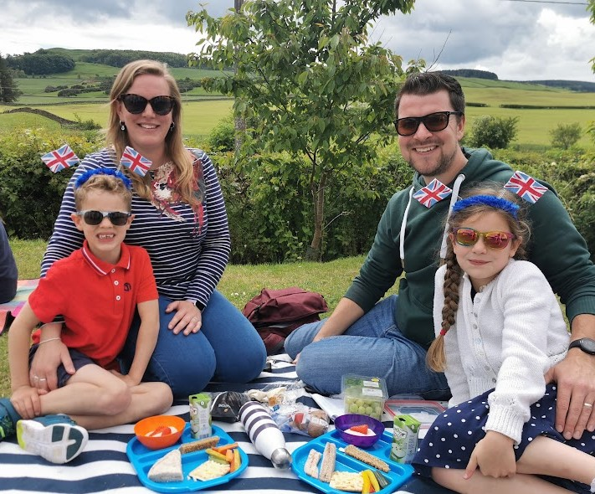
Enrolment in Schools and Transitions  Information on enrolment in school and catchment areas is available at http://www.dumgal.gov.uk/article/15241/School-places Information regarding catchment areas can be found on the Council’s website by accessing “Find My Nearest”.  School Improvements  In May/June of each year, the school publishes a Standards & Quality Report providing all stakeholders with a comprehensive summary of the school’s work and learners’ achievements over the last year. The first part of this report provides an overview of the school’s progress in addressing its key priorities, while the second part gives information about, for example, how well pupils are learning and achieving; how well the school is supporting children/young people to develop and learn. In June, we publish a School Improvement Plan which outlines the key priorities for the school during the year ahead, following engagement with staff, pupils and parents.  In 2022/2023 our partnership schools are focusing on:  - Raising attainment in writing  In addition, Castle Douglas High School Cluster is focusing on:  - Embedding the D&G ‘A Framework for Numeracy’ programme  - Improving Digital Leadership  - Inclusion and Rights Respecting Schools  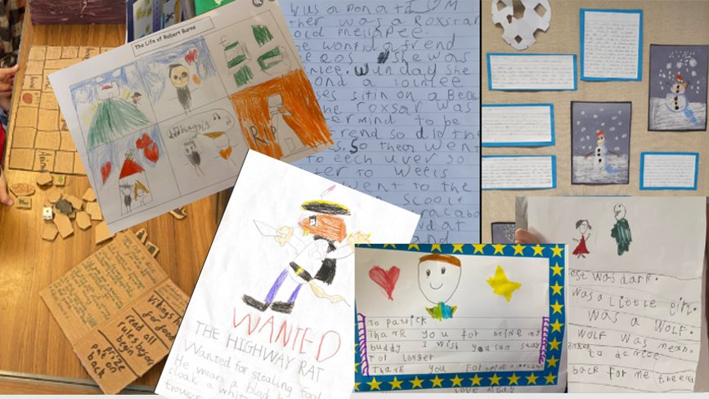 | Health and Safety Emergency Procedures  If your child feels ill during the school day and we feel that he/she would be better at home, we will telephone you or your emergency contact.  Minor accidents, e.g. cuts, bruises, are dealt with by the school staff. Serious accidents are few, but should one occur your child will be immediately taken either to your doctor or to hospital, if necessary, and you or your emergency contact will be notified.  We cannot stress enough the importance of supplying the school with the relevant information we require in such a situation, i.e. your own home and work number and a telephone number of an emergency contact. Please remember that if your child stays in more than one home setting contact details should take account of this.  Severe Weather and School Closure Arrangements  Headteachers are authorised to make an emergency closure when the state of the weather or any other exceptional circumstance make it necessary in the best interests of the pupils. In these circumstances parents will be communicated with in a variety of ways including text messages/ phone calls and emergency contact arrangements.  All school closures will be notified on the Council Website. http://www.dumgal.gov.uk/article/15240/Emergency-school-closures  Data Protection Information on how the Council uses personal data is available at https://www.dumgal.gov.uk/article/15129/Data-protection and https://www.dumgal.gov.uk/privacy  ICT in Schools  For more information on ICT in school please see page 19 of the Education Authority Handbook.  Use of the Internet, Social Networking Sites  As part of the process of learning we allow our children supervised access to the Internet and e-mail. The authority runs its own filter system to ensure that young people are not at risk from exposure to inappropriate material. This filtering system is regularly being upgraded. We have a policy for use of the Internet and a contract for responsible use, which we ask parents and young people to sign up to.

