

CASTLE DOUGLAS HIGH SCHOOL

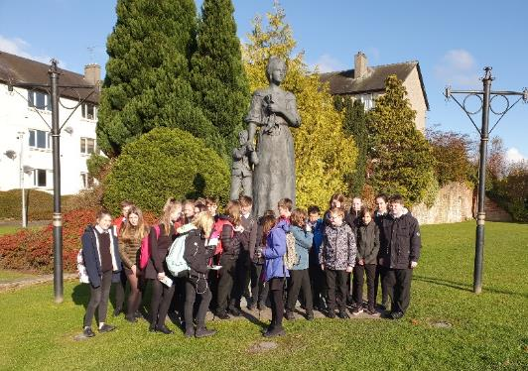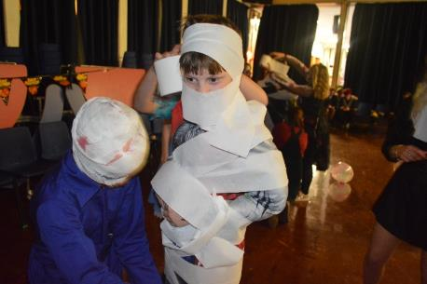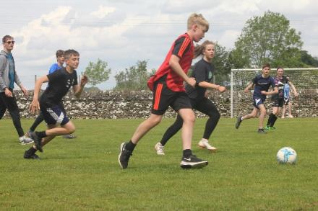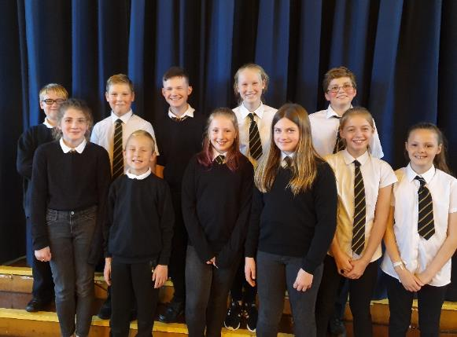

Up

**PRIMARY**

**SECONDARY**

**WHERE**

**NEXT?**

Moving

On

You are about to move on from Primary to Secondary School. We want to put you at your ease so we have asked some of the pupils in the school to put together this small magazine as a guide.

If you work hard and use your common sense, you will do well – and you will probably enjoy yourself as well!

Remember to try to mix with others and talk to new people.

And talk to teachers if there is anything you don’t know or don’t understand.

You’ll be fine!

Best Wishes

All the other pupils of Castle Douglas High School

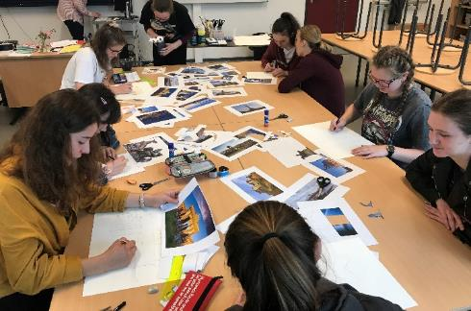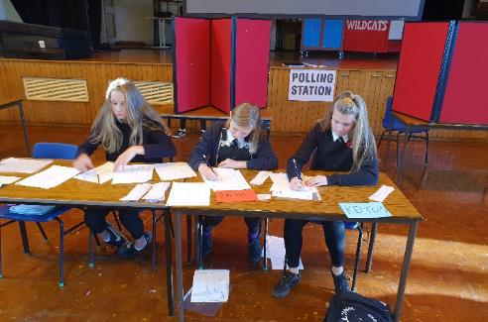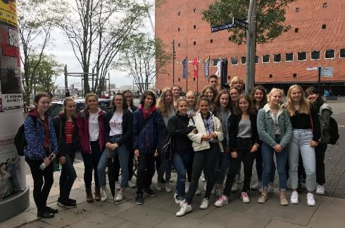

2

**What Happens on the Induction Days?**

**Wednesday 24th to Friday 26th June 2020**

(Depending if schools are back)

**Day 1**

**1.** Meet in Assembly Hall – All pupils

Presentation by Mr Smith and Mrs Cook

Meet Pupil Support Staff and sit in classes.

**2.** Introduce Junior House Captains

**3.** Junior House Captains take you on a tour of the school

**4.** Follow timetable period 2 onwards

**INTERVAL (10.35 – 10.50 am)**

**5.** Meet in Assembly Hall after interval – taken to period 3, 4 and 5 class

**LUNCH (1.10 – 1.55 pm)**

Junior House Captains collect from class and take you

to the Dining Hall for lunch

**6.** Meet in Assembly Hall – taken to period 6 and 7 class

**Day 2**

Meet in Assembly Hall – taken to classes and collected

**Day 3**

Meet in Assembly Hall

Follow normal timetable – taken to classes and collected

3

**A Match-up Game**

Play this game to match-up some of the teachers at Castle Douglas High School to the subjects they teach, by drawing a connecting line.

If you get stuck, don’t worry, the answers are at the bottom of page 6.

 Mrs Dunlop History

 Ms Connelly PE

Mr Kay Art

 Ms Thorburn Science

 Mrs Bowles French

Miss Fowke Maths

 Mrs Cook Science

Ms Todd English

MC900021362[1] Mrs Little Technical

Mr Courten Music

4

**Trouble Shooting Guide to**

**Castle Douglas High School**

**CDHS is a friendly school and remember that staff are here to help you.**

**What happens if . . . . . . .**

**Question 1** *I am late to school?*

**Answer:** _______________________________________________________________

**Question 2** *I have been absent, how do I explain my absence?*

**Answer:** _______________________________________________________________

**Question 3** *I am late to a class?*

**Answer:** _______________________________________________________________

**Question 4** *I have a dental appointment?*

**Answer:** _______________________________________________________________

**Question 5** *I have forgotten my homework?*

**Answer:** _______________________________________________________________

**Question 6** *I have forgotten my equipment for class?*

**Answer:** _______________________________________________________________

**Question 7** *I have forgotten my PE kit?*

**Answer:** _______________________________________________________________

**Question 8** *I get lost?*

**Answer:** _______________________________________________________________

5

**Question 9** *I forget my Young Scot Card or money for my lunch?*

**Answer:** ______________________________________________________________

**Question 10** *I am unable to do PE because of an injury?*

**Answer:** ______________________________________________________________

**Question 11** *I feel unwell in school?*

**Answer:** _____________________________________________________________

**Interval and Lunchtimes**

Interval is between 10.35 and 10.50 and most students meet up with friends and walk around the playground on good days and stay in the Assembly Hall area (downstairs) on wetter days.

Similarly, at lunchtimes (1.10 to 1.55 pm), students meet up with their friends and sit with them in groups at tables. You can have school lunch or bring a packed lunch.

6

Mrs Dunlop – Science, Ms Connelly – History,

Mr Kay – PE, Ms Thorburn – Maths, Mrs Bowles – Art,

Miss Fowke – English, Mrs Cook – Music, Ms Todd – French,

Mrs Little – Science, Mr Courten – Technical.

**Club** **s & Ac****ti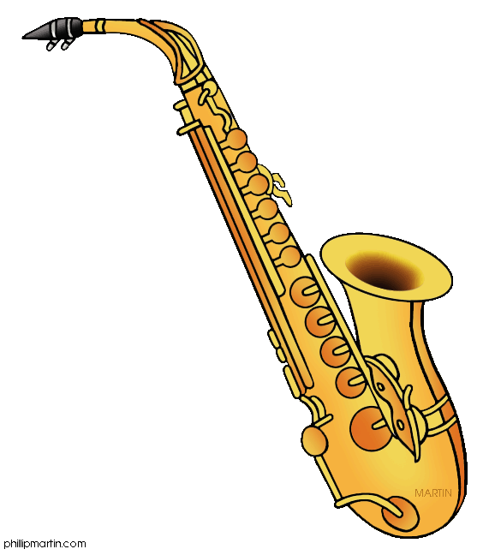viti****es**

This is an example of clubs that have been running in previous years. 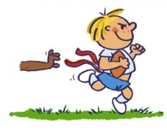   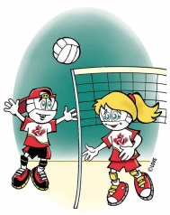

7

|  |  |  |
| --- | --- | --- |
|  | LUNCHTIME | AFTER SCHOOL |
| Monday | **S1/S2 Badminton**  badminton*Games Hall* | **Netball**  netball%20clip%20art[1]*Games Hall* |
| Tuesday | dodge-ball-graphic**S1/S2 Dodge Ball**  *Games Hall*  dodge-ball-graphic | **Senior Basketball**  basketball[1]*Games Hall* |
| Wednesday | **S1/S2 Football**  5iRAp6xia[1]*Games Hall* | **Boys Cricket**  165064400[1]*Games Hall* |
| Thursday | **S1/S2 Basketball**  *Games Hall*  **Eco Group**  *Room 20* | **Senior Football**  *Games Hall*  footballer |
| Friday | **S1/S2 Touch Rugby**  *Games Hall* | **S1-S6 Girls Cricket**  1222828-Clipart-Of-A-Sporty-Batting-Cricket-Girl-Royalty-Free-Vector-Illustration[1]*Games Hall* |

**Events in S1**

Opportunity to join the

School of Dance or Rugby

S1–3 Assemblies

S1 Parents’ Evening in early October

Chance to go on the S2 Trip

to Edinburgh

October – Halloween Disco

S1–3 Junior Dance

Music Concert

S1 Geography Trip

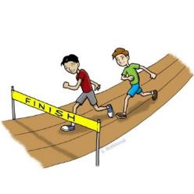May – S1 Full Report

Sports Day in June

Activities Day in June

8

**Classroom Code**



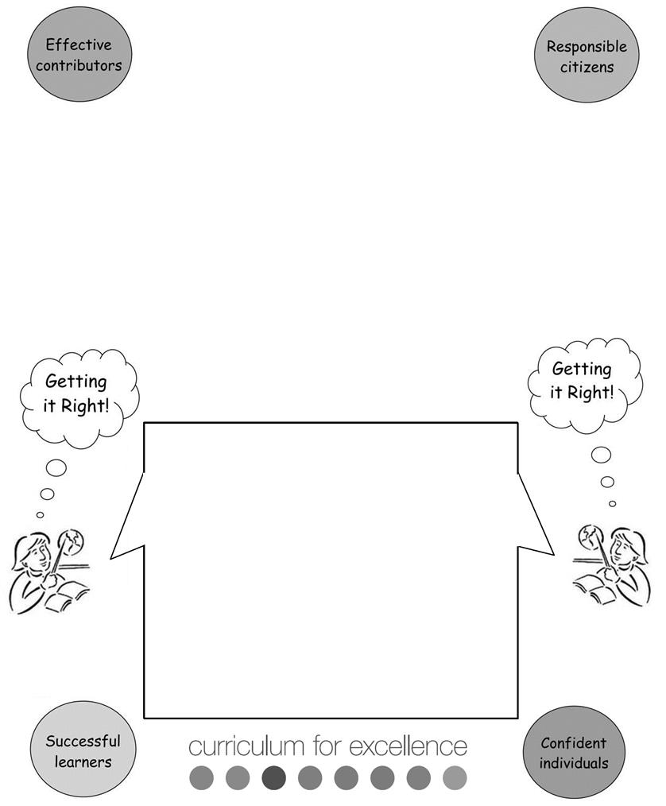

9

How to Get It Right!

**Classroom Code**

* Pupils should arrive at class on time.
* Pupils are responsible for bringing the correct equipment.
* Good manners are expected at all times.
* School property should be respected at all times.
* Eating in class is not allowed.
* Only water should be consumed in class.
* Outdoor clothing should not be worn in class.
* Mobile phones and music players should be switched off during class time, including study classes.
* I will follow the classroom code.
* I will respect my teacher and other pupils by not talking when they are talking.
* I will listen carefully to all instructions given to me.
* I will give others the chance to succeed by allowing them to focus without distractions.
* I will make every effort to complete tasks to the best of my ability.

**Communication with School**

Good communication with your school is important.

We encourage your parents/carers to get in touch by phone or e-mail if they have concerns about you at any time.

Your parents and you can access the school website www.cdhs.info to get information on a range of school related topics. Why don’t you and your parents/carers sit down and have a look tonight.

School News and Pupil Achievements are shared on the School Facebook page and on the school website.

We want to hear from your parents/carers if you are absent or are going to the Doctor/Dentist or any other appointment, normally by phone call or letter to the school office.

The school will sometimes group call – send a text message to inform your parents/carers of your absence (if we have not had a call) or to remind your parents/carers you have a letter to give them.

The Principal Teacher Pupil Support may get in touch with your parent/carer if they have any concerns about you. This will normally be by phone.

Finally, you will receive a report in May, giving details of your progress.

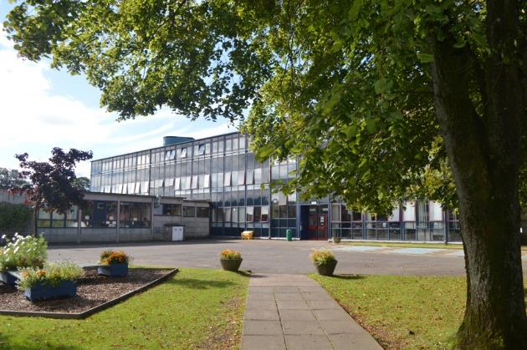

10

**Quiz on Castle Douglas High School Presentation**

|  |  |
| --- | --- |
| **1.** | How many subjects will you study in S1? |
|  |  |
| **2.** | What is acceptable as school uniform? |
|  |  |
| **3.** | How many periods are there in a day? |
|  |  |
| **4.** | How many teachers are there at Castle Douglas High School? |
|  |  |
| **5.** | How does the Cafeteria System work? (answer briefly) |
|  |  |
| **6.** | What is the S3 Junior House Captains’ role in the induction days? |
|  |  |
| **7.** | If I want to ask a question on the induction days, who can I ask? |
|  |  |
| **8.** | Name **three** things that are the same in Castle Douglas High School as at your current school. |
|  |  |
| **9.** | Name the **four** pupil support staff and briefly explain what their role is |
|  |  |
| **10.** | Name **three** things you are looking forward to. |
|  |  |
| **11.** | What is on the home page of the web site? |
| 11 |  |

**Getting it Right for Every Child**

Castle Douglas High School has put GIRFEC at the heart of our school.

We at Castle Douglas High School aim to treat each pupil as an individual, to take care that each pupil settles quickly and progresses in their learning as well as possible.

We make sure that we consider the principles of GIRFEC to ensure that each pupil can get the support/help they need early, when and if they need it.

We aim to make sure that every child is safe, healthy, achieving, nurtured, active, respected, responsible and included. Pupils’ wellbeing is the responsibility of all staff.

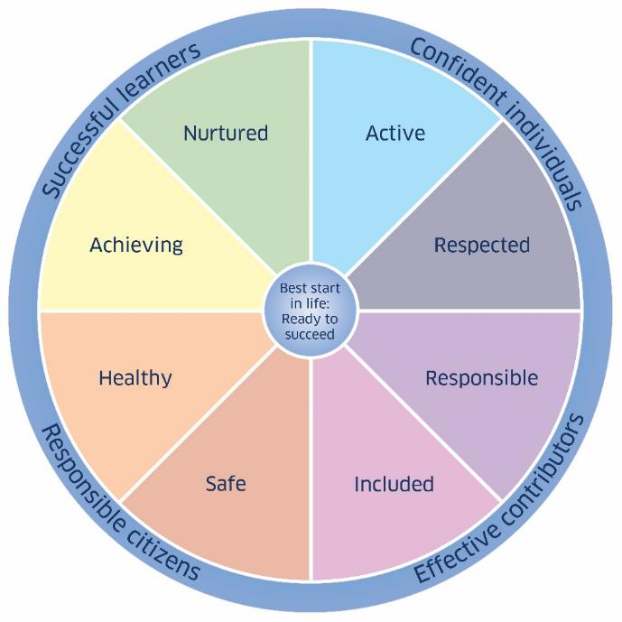

12

**Castle Douglas High School – Staff**

Did you know there are approximately 40 teachers at Castle Douglas High School?

The Head Teacher is Mr Smith, he is assisted in his job by three Deputes – Mr Cathro,

Mrs Cook and Mrs Gillies. All the staff are divided into the three House Groups.

|  |  |  |  |
| --- | --- | --- | --- |
|  | **Kelton** | **Solway** | **Threave** |
| Principal Teacher  Pupil Support | Mrs Cathro | Mrs Brown | Miss Linton/  Mrs Parker |

**Teachers’ Word search**

|  |  |  |  |  |  |  |  |  |  |  |  |  |  |  |  |  |  |
| --- | --- | --- | --- | --- | --- | --- | --- | --- | --- | --- | --- | --- | --- | --- | --- | --- | --- |
| S | FH | UO | LM | TS | OO | NN | U | E0E | DD | GO | PI | B | W | G | T | O | H |
| U | A | E | B | F | Y | O | H | C | E | I | K | U | F | D | S | M | E |
| B | G | T | A | N | B | M | R | I | K | L | P | Z | D | J | I | D | N |
| W | I | L | L | I | A | M | S | T | W | L | C | L | S | L | U | E | D |
| I | H | Z | A | Z | L | A | L | N | O | I | Y | E | L | W | R | C | E |
| H | R | E | K | R | A | P | E | E | F | E | X | E | A | D | C | G | R |
| B | I | S | K | B | B | J | B | R | I | S | R | A | J | A | L | O | S |
| M | C | C | L | U | R | G | B | P | N | E | J | D | T | J | Q | B | O |
| I | B | R | J | E | G | N | X | W | P | H | L | H | J | O | E | N | N |
| A | J | I | C | W | H | N | O | C | F | N | R | L | D | H | W | O | I |
| K | C | L | I | H | T | R | O | B | S | O | N | E | O | N | P | T | M |
| V | L | E | Q | A | P | O | J | R | N | Z | Y | T | S | S | X | S | F |
| B | D | Y | H | N | K | N | Q | K | A | O | W | A | H | T | O | G | J |
| M | M | R | C | N | T | W | R | B | Y | M | T | J | K | O | Y | N | G |
| C | E | R | J | A | E | V | K | H | L | V | S | T | M | N | N | I | K |
| N | N | S | C | H | U | T | Z | O | P | D | V | A | A | D | Z | V | H |
| A | F | S | Q | U | A | B | O | W | L | E | S | K | Y | P | A | I | L |
| Y | O | C | O | U | R | T | E | N | N | N | E | L | T | T | I | L | E |

|  |  |  |  |
| --- | --- | --- | --- |
| Fulton | Gillies | Cook | Ramsay |
| Miller | McNay | Robson | Patton |
| Little | McClurg | Prentice | Hannah |
| Williams | Livingston | Courten | Johnston |
| Parker | Riley | Cathro | Bowles |
| Henderson | Schutz | Kay | Fowke |

13

**Advice from Senior House Leaders**



**Solway** – *Jessica Quigley*

My advice would be to enjoy the experience. Try not to worry about coming up because you will get used to the way the school works really quickly Take advantage of all the clubs the school offers and always do your best.



**Kelton** – *Nathan Wilson*

My advice would be to think of others and be friendly to everyone.



**Threave** – *Anya McCreadie*

My advice would be to not be afraid of older students. Everyone is friendly and no one will laugh or be angry if you ask any of us to help you with something.

14

**Evaluation of the Induction Days**

**1.** Did you feel adequately prepared for your three day visit?

adequate good excellent

If you selected adequately – what would you like to see improved.

**2.** Were the arrangements for being **shown around the school** helpful (Junior House Captains)?

adequate helpful very helpful

**3.** Did you understand and like the lunch arrangements.

satisfactory liked really liked

**4.** On a scale of 1 – 5, how much did you enjoy:

Day 1 Day 2 Day 3

Enter the number that you think is appropriate, 1 being **low**, 5 being **high**.

15

