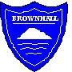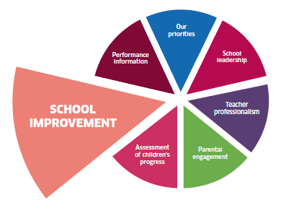-

**Believe to Achieve**

**School Improvement Plan**

**2019-20**

**Refresh of the Digital Literacy strategy after D&G Windows 10 rollout**

**Improvement in attainment, providing learners with the right skills to succeed**

Key Tasks

* Update to all primary schools, the cluster digital literacy strategy to be updated to reflect the range of software and hardware now available
* A cluster inventory of hardware e.g. Sphero, Micro:bits to be collated so that all schools can access the same range of hardware
* Development of professional learning opportunities
* Achieve Digital Literacy Award

**Continue to develop pupil ownership of their learning and promote parental engagement**

**Work with parents to support children to develop respect, citizenship and the foundation skills & attitudes for learning, life and work**

Key Tasks

* Whole staff to work together to build a shared, consistent language and format at each stage.
* Evaluate updates, and refine if needed.
* IEP targets to be moderated at cluster level, and adjustments made as needed.

**Refresh of our curriculum following new documentation from D&G and national guidance**

**Improvement in attainment, providing learners with the right skills to succeed**

Key Tasks

* Review the Literacy, Numeracy/Maths and HWB tracking.
* Following the publication of updated D&G Health & Well-being Strategy, evaluate our HWB programme against the strategy and update as needed.