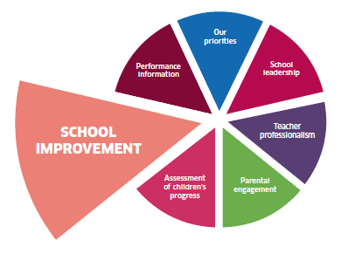-

**Believe to Achieve**

**Progress on**

**School Improvement Plan**

**2019-20**

**Building shared standards and expectations in Numeracy**

**Improvement in attainment, specifically in reading, writing and numeracy**

Progress

* Joined with Cluster sub group to moderate planning
* Literacy tracking- implemented and refined
* Cluster moderation focus on numeracy/maths: developed both focused interventions and holistic assessments towards achievement of a level.
* Sub-cluster moderation with a focus on numeracy/maths developed, implemented and refined holistic assessments.

**Building shared standards and expectations in Literacy**

**Improvement in attainment, specifically in reading, writing and numeracy**

Progress

* Joined with Cluster sub group to moderate planning
* Literacy tracking- implemented and refined
* Cluster moderation focus on reading: developed both focused interventions and holistic assessments towards achievement of a level.
* Sub-cluster moderation with a focus on listening and talking: developed, implemented and refined holistic assessments.

**Closing the Gap**

**Closing the attainment gap between the most and least disadvantaged children; Improvement in children and young people's health and wellbeing**

Progress

* Attainment is improving; the majority to almost all pupils are now achieving the expected CfE in most stages. Children’s learning is supported through appropriate interventions that are having a positive impact upon learning.