
Auchencairn News
Ready. Respectful. Kind
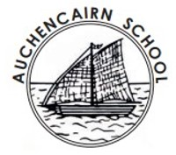
JANUARY 2025
Dear Parents and Carers,
Welcome to 2025 at Auchencairn and to our new format Newsletter. This will come out monthly rather than termly, to keep you up to date with the learning that is happening in school and with any up and coming events. We had a great end to 2024, with our P4-7 class taking part in Curling Competition week, promoting our children being healthy and active. Maddie, George, Bertie and Angus B represented our partnership at the Curling final and achieved silver. A big thank you to Active Schools for making this possible and to parents and staff who supported our team at the finals.

Best wishes,
Mrs Jarvis

What’s been happening….

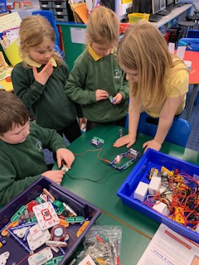
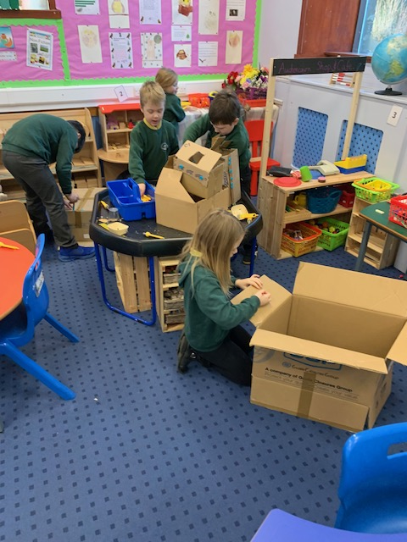
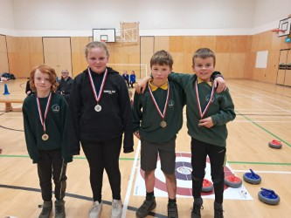
P1-4 have had an electrifying start to 2025, with a wonderful hands-on session on electricity. They took responsibility for collaborating together to achieve a working circuit. They have learnt about how to be safe around electricity and how to be environmentally responsible by remembering to turn the lights off and recycle old batteries!

Maddie, George, Bertie and Angus B represented our partnership at the Curling final and achieved silver. A big thank you to Active Sports for organising this.

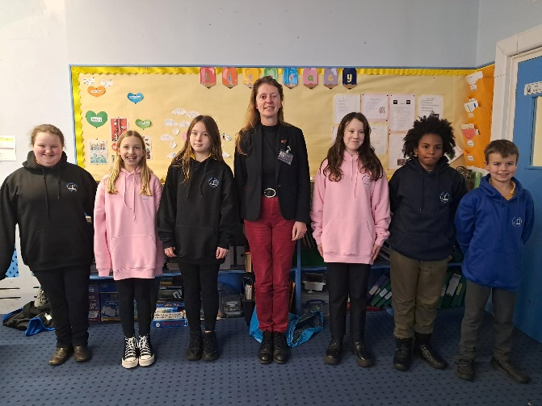

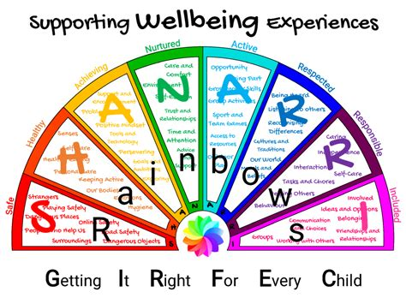
Our P7s have started preparing for their move to S1 and received their leavers’ hoodies.

Be happy, Responsible citizens, Aim high, Value all, Explore our world

Be happy, Responsible citizens, Aim high, Value all, Explore our world

“I really enjoyed getting together with my classmates to sing”
-Mel P5

- M

Auchencairn News
Ready. Respectful. Kind
Community engagement….

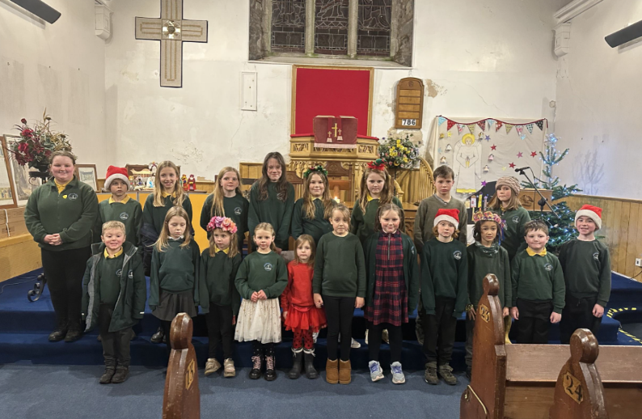

Children from our schools took part in the community Christmas carol evening which was a huge success.


Our school partnership

Our partnership Christmas show went brilliantly. The next partnership event we will be celebrating is Burns at Palnackie. We are also still enjoying our weekly partnership day which gives children the opportunity to work together.
From February our Partnership day will be changing to Friday. The last Monday partnership day will be the 10th February and the first Friday one will be the 28th.
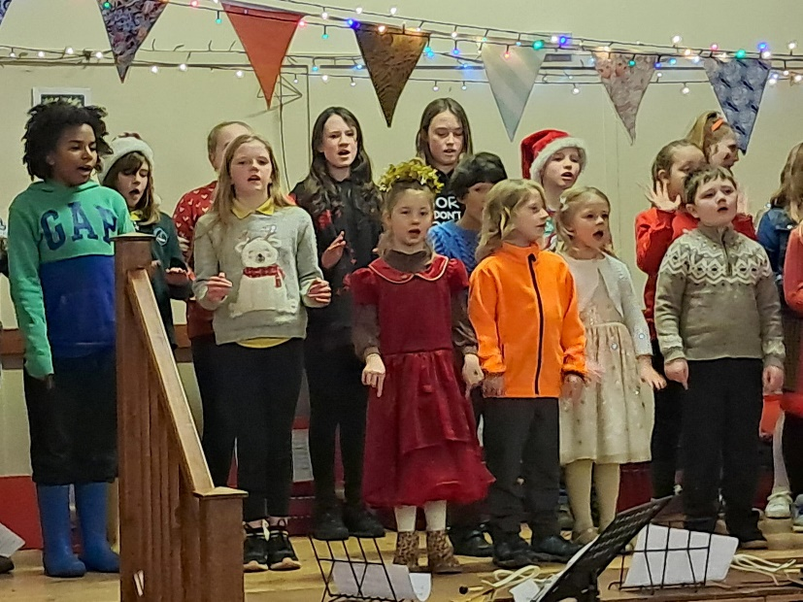

Auchencairn News
Ready. Respectful. Kind
Dates for the fridge….



Term 3
Thursday 23rd Jan – Partnership Burns celebration/competition @ Palnackie
Wednesday 5th – Active school gymnastics afternoon (PE KIT NEEDED)
Thursday 6th Feb – PC Meeting
Friday 7th Feb – School photos
Wednesday 12th – Active school gymnastics afternoon (PE KIT NEEDED)
19th, 20th and 21st Feb – School closed for midterm holiday
Tuesday 18th March – P4’s start swimming lessons
Wednesday 26th March – Learning Conversations
Friday 28th March – Partnership Easter celebration @ Palnackie
Friday 28th March – Last day of term 3

Extra-curricular sports activities
This is not a school led activity so parents must register their interest and supervise their children.
Super 3’s Cross Country
- Open to all pupils p1-7
- Tuesday 4th March, Wednesday 12th of March, Tuesday 18th March.
- All events at Castle Douglas High School
- Arrival 4pm- races to start at 4.15pm.
- Sign up - https://forms.office.com/e/VxSSug1TNh

Be happy, Responsible citizens, Aim high, Value all, Explore our world

Be happy, Responsible citizens, Aim high, Value all, Explore our world

The next parent council meeting will take place on Thursday 6th February at 3:00pm.
If you would like to be involved or have any ideas of your own in regard to upcoming school events or fundraisers, please feel free to come along.



For local community events please check out:
Auchencairn News
Ready. Respectful. Kind
https://sway.cloud.microsoft/2jb5oTZDZvxNn1ct?ref=Link
Parent Council News….

