Borgue Primary School
Newsletter April 2022
Head Teacher  Dear Parents  I hope you have had an enjoyable Easter break.  I am pleased to let you know that restrictions now allow us to have parents and community partners in school again. We look forward to re-building our community links over the coming weeks and months.  We therefore look forward to welcoming you for Sports Day, Jubilee and P7 celebrations!  Ms F Christie  Parent Council News  Our next Parent Council Meeting will be held in School on Thursday 28 April at 1.45pm. It will be lovely to meet more of you in person! If you have pre-school children, please feel free to bring them along.  Sports Day  You are invited to join us on Wednesday 18 May at 1.30pm for Sports Day (25th reserve date). We plan to hold a variety of traditional races for the whole family to enjoy.  Barrhill Woods  P1-4 had a great day at the Barrhill Woods in Kirkcudbright. They visited the red squirrels, cooked on a fire, hunted for bugs, made clay faces and played with sticks! We’d like to thank the Kirkcudbright Development Trust for helping to organise the day.  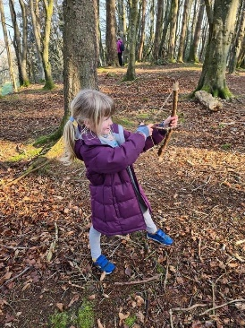  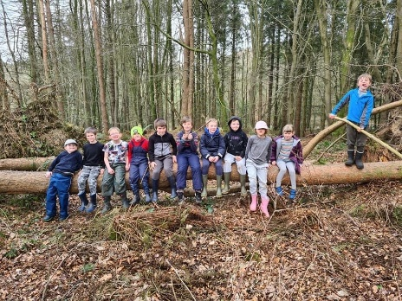  Active Schools  Badminton was so popular in term 3, a second block of Badminton in term 4 will be delivered for all our budding players within the Stewartry!  The sessions will be as follows-  3:45pm - 4:45pm for p5  4:45pm - 5:45pm for p6 & 7s  Dates - 19th May to the 23rd June (not including the 2nd of June as this is a bank holiday).  The club will be held at Dalbeattie Learning Campus.  Deadline for sign up is the 12th of May. Please complete the link to register - https://forms.office.com/r/DkUKmnizzS  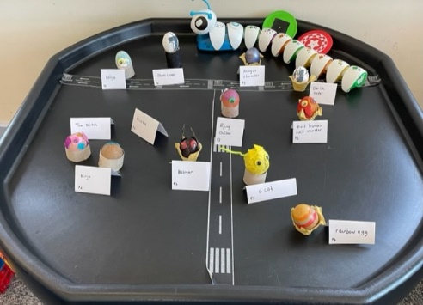  Uniform  If you would like to order School Uniform for next session you can do so online by visiting:  www.brigade.uk.com  Click on “parents click to order” button  Start typing “Borgue Primary” in the box  Select “Borgue” from the drop down list  Then follow the online instructions.  To ensure delivery for August, we recommend ordering no later than 20 May 2022.  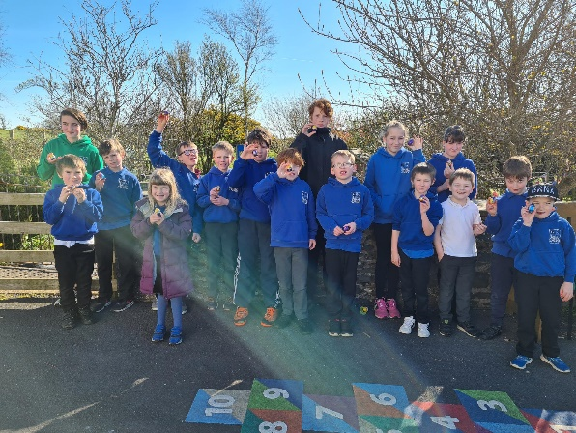  Egg Hunt Fun !  Jubilee Celebrations  Primary 4-7 are very busy organising a celebration 'Picnic on the Pitch' for the Queen's Platinum Jubilee. This will take place on Wednesday 1st June, from 12-3pm on the school playing field. Now that Covid restrictions are being eased, we'd be delighted to welcome families and community members to join us for this afternoon. Remember to bring your own picnic and picnic blanket! Further details will follow from the children, including details of games, activities and fundraising stalls that we'll have on the day.  We really hope you are able to join us.  Concerns/Complaints  We aim to deliver high standards of education and to communicate well with parents however sometimes things go wrong therefore if you have concerns or complaints regarding any aspect of school life, please do not hesitate to get in touch with us. Often matters can be resolved/clarified following a quick discussion. We want our school to have a good reputation within the local community.  P7 Transition  P7 will visit Kirkcudbright Academy on Wednesday 4 May, Tuesday 24 May and Week of 13 June. Pupils will require cash for a school lunch. School Transport have informed us that they can not guarantee a space on the Academy bus for transition days, so in the unlikely event there is no space it will be parents responsibility to transport pupils.  Friday Forest Fun  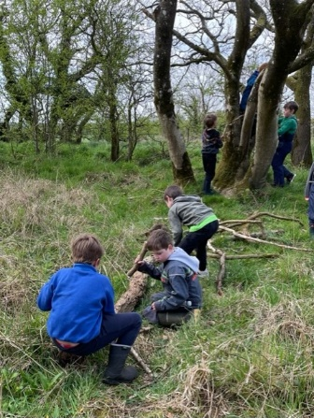  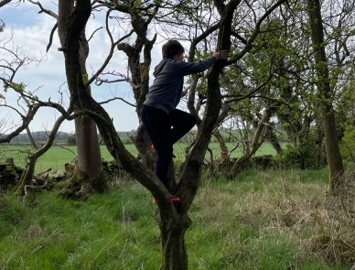 | School Improvement Plan  Many thanks to those of you who returned Parent questionnaires, your views help to inform our priorities for the coming year.  In session 22-23, based on the evaluations of staff, pupils and parents our two main priorities will be:  - Improving the range of teaching methodologies used to make learning more engaging for children  - Improving our approaches to early literacy development and reading skills (P1-7)  Details of our progress will be shared at Parent Council meetings throughout the year.  Rag Bag  Rag bag will be coming to empty our clothing recycle bin on 19 May, any donations prior to then would be gratefully received.  Summer Outing  We have organised a summer outing for the Partnership on Wednesday 22 June to Ernespie Farm Park. The children will have the opportunity to enjoy outdoor adventure play, indoor soft play and a farm tour and activity organised by the Royal Highland Education Trust (RHET).  The Parent Council have kindly agreed to fund 100% (£13pp) of the outing meaning there will be no additional cost to families. We’d like to thank them very much for their generosity.  P1-3 Music  P1-3 will receive a 6 week block of music from a Dumfries and Galloway specialist based on singing games, rhymes and percussion instruments  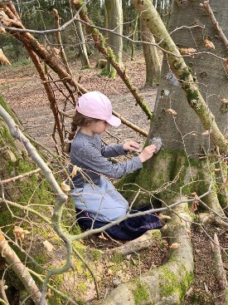  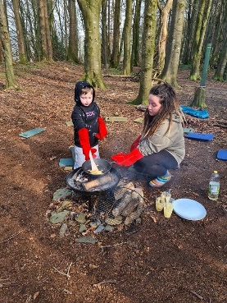  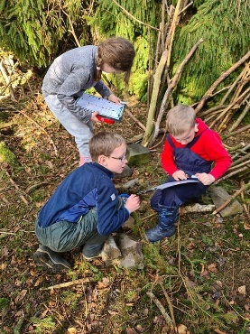  Easter Egg Competition  On Wednesday 30 March the children decorated eggs in school to celebrate Easter. I undertook the very difficult job of judging them! Two winners from each class were chosen and our congratulations go to:  P1-3 – Samson and Alexander  P4-7 – Gracie and Lily  Well done to all, it was close run contest!  P4-7 Radio Show  P4-7 worked with Feis Rois over a number of weeks learning traditional Scottish music. Their sessions culminated in a radio broadcast which you can enjoy using the link below.  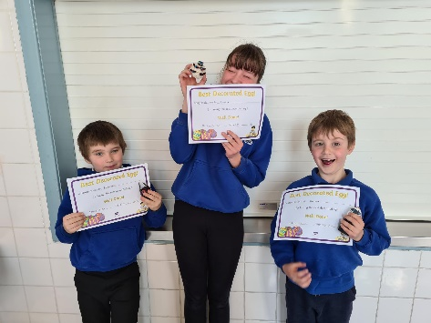  https://bit.ly/BorgueRadio  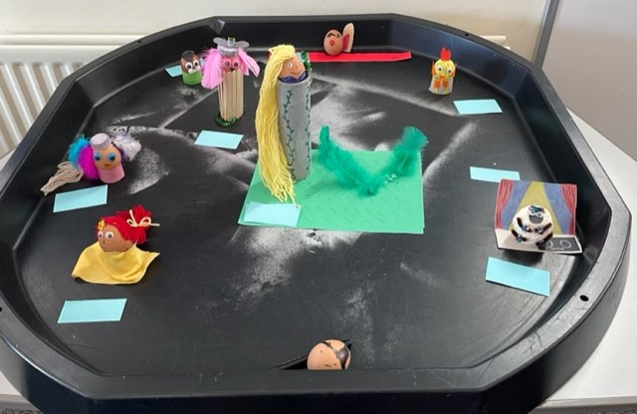  Sound Trap Music  Our Primary 4-7 class will receive a 4 week block this term of digital music making. The children will develop skills in music, IT, creativity, teamwork and collaboration. The sessions are fully funded by Creative Scotland and the Youth Music Initiative so we are delighted to have secured a place.  Cross-Country Success  We’d like to congratulate our P4-7 pupils for their participation in the recent Stewartry Cross-Country event. Particular congratulations go to Arthur M, Morann and Lily who were 2nd and 5th in their respective age groups.  Sport  This term Active Schools will be running a lunchtime club for P1-7 and P4-7 will receive a four week curriculum block of Rugby from Stewartry Rugby Club  School Fundraising  To raise some money for school funds, we hope to hold a raffle for an adult and child hamper. If you are able to donate an item for either hamper, it would be greatly appreciated. Please send donations to school by Friday 13 May. We hope to display hampers and sell tickets at Sports Day.  School Organisation August 2022  We are anticipating our school roll to be 19 pupils in August. This allows us to retain two classes for next session. As Mrs Harrison will be on Maternity leave, it is likely a probationer teacher will be allocated to the post. We will be able to confirm this toward the end of May. Based on this information classes for next session will be:  P1-3 - Mrs Kirk/Mrs Graham  P4-7 - TBC  Dates for the Diary  28 April Parent Council meeting 1.45pm  2 May Spring Holiday  4 May P1, P3, P7 Transition Day  18 May Sports Day (25th reserve date)  24 May P1, P3, P7 Transition Day  1 June – Jubilee Party  2&3 June School Closed - Jubilee Holiday  13 June P7 Transition Week  22 June – Summer Trip – Ernespie Farm Park  27 June – Fun Week (various activities)  29 June – Leavers Concert 1.30pm  