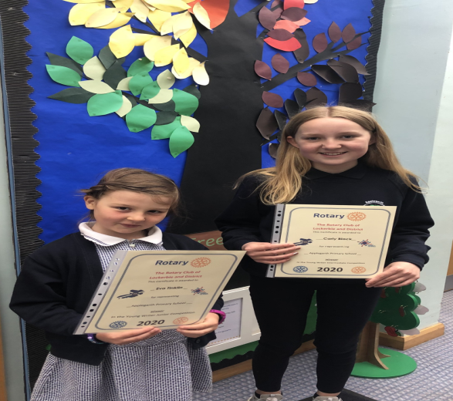
ROTARY YOUNG WRITER COMPETITION
Last October our pupils took part in the Rotary Young Writer Competition – “My Happiest Day”. We are delighted to announce that Eva Tinklin won the Junior section and Carly Black the Intermediate section with their entries. We just found out on Monday so it came as a lovely surprise. Our lucky winners were awarded with a certificate and a £10 gift voucher.

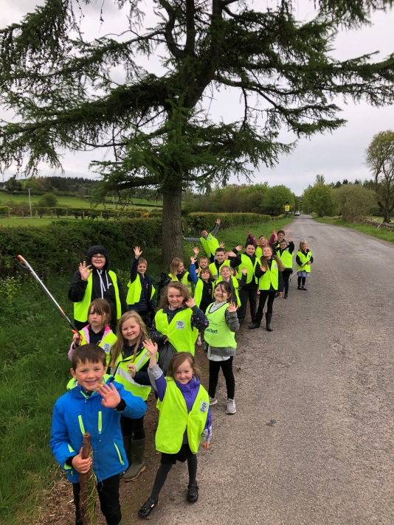
OUTDOOR LEARNING DAY

P1-4 pupils had fun carrying out a litter pick during Outdoor Learning Day yesterday. The litter pick was used as inspiration for their writing – Super effort!
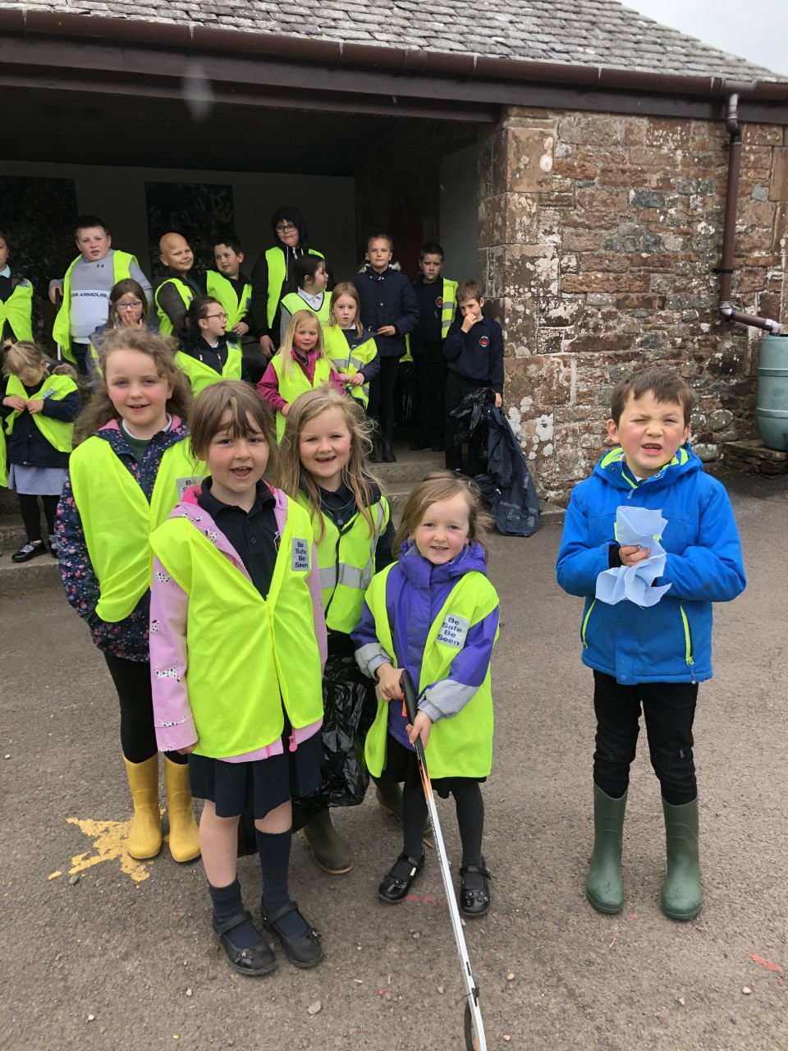

SCHOOL PHOTOGRAPHS – 4 JUNE 2021
The Tempest photographer will be in school on 4 June to take individual and sibling photographs. Family photographs which would involve pre-school children will not be taken this year. Uniform should be worn and please send in a hair brush/comb. I appreciate that this is a PE day – on this occasion can pupils please come to school in uniform and bring their kit with them. Complete the link below to indicate your preference of photo.

LINK FOR SCHOOL PHOTOS
https://forms.office.com/Pages/ResponsePage.aspx?id=oyzTzM4Wj0KVQTctawUZKUW24qU1tIVHikdiRiM0NrhUQ1pXOERONUtPTjFFODhUSUVUQUUyNTNPVi4u

HEALTHY SNACK INITIATIVE
The Pupil Council is delighted with the uptake and great participation to the Healthy Snack Initiative.
This will continue to the end of term.
Well done to the following pupils as they had a healthy snack every day this week:

Hadassah Natasza Caleb
Tilly Ellie Evie
Eva Izzy Isaac H
Milly Caleb James
Holly Khloe Eve
Jasmine Howie William

ECO FRIENDLY OLD SWEATSHIRTS
If you have any old sweatshirts please send them in to school as we recycle and re-use them. Thank you.

UNIFORM ORDER
Please complete link below if you would like to order new school uniform for next session.

LINK FOR UNIFORM ORDER
https://forms.office.com/Pages/ResponsePage.aspx?id=oyzTzM4Wj0KVQTctawUZKUW24qU1tIVHikdiRiM0NrhUQ1o1WlZNODJaQkRZN1dGTkYwRjZIMzlFTy4u

PARENTAL SURVEY MAY 2021
We have very quickly come around to the time of year when we ask for your feedback – It would be really appreciated if you could please complete the link below.
Your responses directly contribute to the School Improvement Plan for next session.

LINK FOR PARENTAL SURVEY MAY 2021
https://forms.office.com/Pages/ResponsePage.aspx?id=oyzTzM4Wj0KVQTctawUZKZ1O2J7PzLFBrXDBxDZ139BUMVZDQ0o1S0JJRThBNEtOQU0zV01OMFpOTS4u

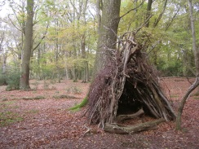
DEN BUILDING
As part of the OUTDOOR LEARNING DAY we had planned a den building activity – it was wonderful to see lots of interesting things appearing from your cars yesterday! Sadly it was too windy to be in the outdoor classroom, but I am delighted to say that our pupils managed to do it today! Exciting photos to follow.

REMINDERS:
- Walk to School Week 24-28 May - Children to be dropped off at school as per normal
ENCLOSURE:
- Child Health Programme Review P1 pupils only

