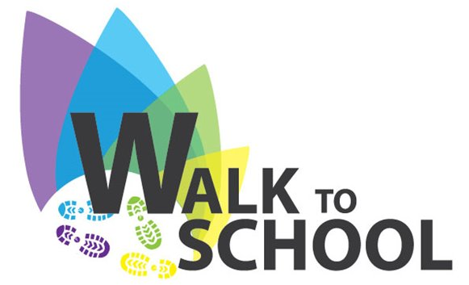
WALK TO SCHOOL WEEK 2021
24 – 28 MAY
Following on from our very successful Sustrans Fortnight we will be participating in the Authorities Walk to School Week. All pupils, accompanied by staff, will walk from SCHOOL to and from Perchhall Cottage each morning for the week 24-28 May. Pupils should be dropped off and come to school at their usual time.

OUTDOOR CLASSROOM DAY
Thursday 20 May
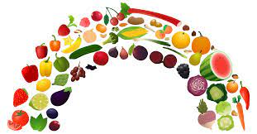
Our pupils have been planning their dens in preparation for the ‘Outdoor Classroom Day’. We have said that they are able to bring in materials from home – within reason – on the day. There will also be materials provided by staff that they can access. I’m looking forward to seeing their plans transform into a reality!

HEALTHY EATING
At a recent Pupil Council meeting the pupils have suggested that we promote bringing a healthy snack into school. This will be launched on Monday 17 May. We hope you are able to encourage your child to eat healthily at break times.

This term we are focusing on encouraging healthy eating. We are encouraging this because healthy eating is important to keep your body healthy and in good shape.
Each pupil will get a snack chart, snacks will be checked at break times and every day they bring in a healthy snack a sticker is earned on their chart.
Snacks considered as healthy are:
- Fruit
- Vegetables
- Cereal bars (fruit bars, not chocolate or high in sugars)
- Healthy yoghurts
- Baked crisps
- Rice cakes/oat cakes
- Soreen bars
- Oat based products, low in sugar
- Healthy drinks
- Non processed cheese
Remember that this is not compulsory but we would love you to join in.
Applegarth and Hutton Primaries Pupil Council
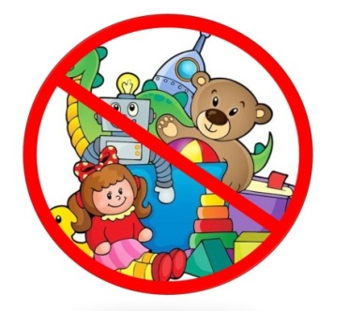

TOYS
We would like to remind you that toys should not be brought into school. Thank you.

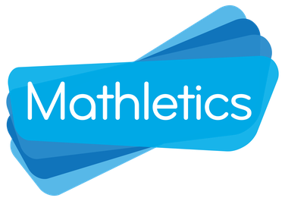
MATHLETICS
Thank you for your patience – it is my understanding that everyone now has access to Mathletics again. Phew!
I’m hoping for a record amount of activity during National Numeracy Day on Wednesday 19 May.

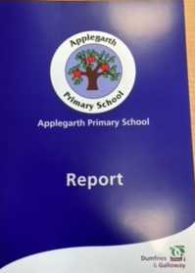
REPORT FOLDERS
Thank you to everyone who returned the report folder. We are still short of a few so could you please, please check again and send it in.
