Another busy week –and a timely bank holiday to look forward to. The Parent Council met this week for the last time this session. I can’t encourage you enough to get involved next year, you always get such a warm welcome. Join in on a great conversation about current issues, enjoy a real insight into the school priorities from staffing to events as we agree our plans – so very worthwhile and very supportive of our whole school community. A big thanks to Emma Boyes and our other members for sustaining our meetings throughout lock down and adapting brilliantly to online this school year.
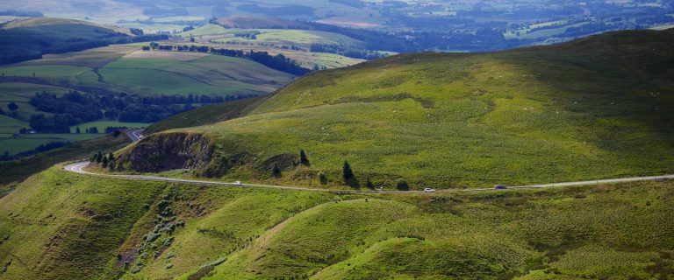
PARENT COUNCIL ANNANDALE WAY
Dear Parents,
During our recent Joint Parent Council meeting the state and safety of the decking in Applegarth playground was raised. We have decided to try to raise some funds to ensure the decking is repaired and brought up to a safe standard for our children to play on, well into the future. The proposed fundraiser is to try and complete the Annandale Way heading north from Applegarth to the top of the Beef Tub. We realise every child and parent has different abilities and levels of enthusiasm for walking, but all participants are welcome whether it’s to walk the entire route, wave us off at the start or join us for a 5-minute walk halfway through.
The Northern stretch of the Annandale Way has been chosen since we completed the Southern Stretch 6 years ago when our current P7’s were in P1 and two of our P5’s and a P4 joined in from preschool!
A provisional date of 12th and 13th June has been chosen weather and COVID permitting. I will update you as we become more organised with plans, but in the meantime all your suggestions and ideas are most welcome. “
Emma
TERM 4 EVENTS
Route Map
As we progress into the term and move down the levels, we should be able to continue to extend the school activities e.g. having a weekly assembly, school trips and if at level 1 at the end of term a leaver’s ceremony. We will notify you through email and newsletter of events that are forthcoming, however we will not be able to provide as much notice as we usually do. Please keep reading the newsletter for key information. Thank you in anticipation for your understanding.
TRANSITIONS
An email has been sent out regarding the Primary – Secondary transition detailing the current arrangements.

We will be in touch very soon with our new P1s, we can’t wait to see you!

MAY DAY BANK HOLIDAY
A wee reminder that we have a May Day Bank Holiday on Monday 3 May. I hope the sun shines for us.

HUTTON PRIMARY ONLY
You will see enclosed a letter in the home school link bag which follows up on the conversations we had this week – I would be obliged if you could please complete, sign and return to school on Tuesday – thank you.

PE
Gentle reminder – no football strips should be worn to school on PE days or any other time. Thank you.

Link to Earth Day Sway https://sway.office.com/MHDWHrtfQg7idgc2?ref=Link
Link for Wheelie Good Fun Event https://sway.office.com/JkWqPr5gGSR5c060?ref=Link

SUSTRANS
Last week all our pupils participated in a daily walk to start the day off enjoying the fresh air and light exercise. This week we had a ‘Wheelie’ good afternoon where most of our pupils were able to bring in their bikes, roller skates or scooters. We were able to borrow some scooters too – so no one was left out!
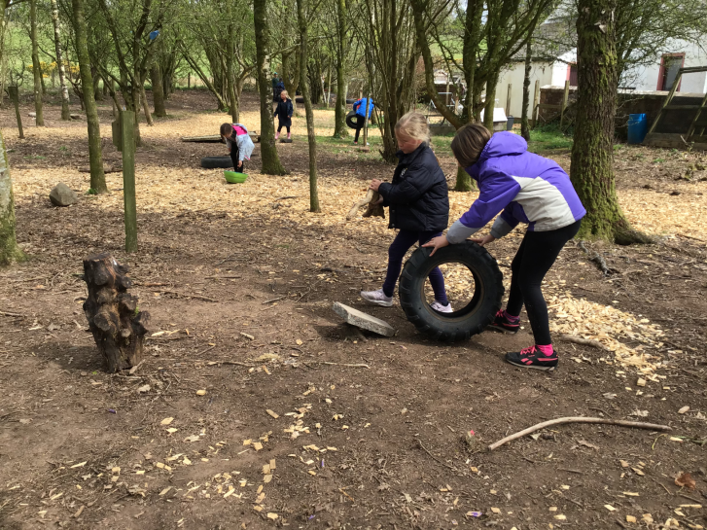
We had a tremendous afternoon as all the pupils participated in our wheelie themed sessions. We had assault courses made for the tyres – showing great teamwork and creativity, and scooter and cycling fun, demonstrating confidence, expertise and great listening. We also had a session on ABC bike safety check, developing awareness and how to keep themselves safe. Thanks to everyone for supporting us – the feedback from the pupils has been very positive and most encouraging towards a sustainable future
