Please see below for some helpful links to support you and your child/ren in using Microsoft Teams and its useful tools.
Microsoft Teams will be exceptionally busy in the current circumstances and at certain times during the day. Please don’t worry if it takes time for work to upload, or just try again later.
If you need further help please email: applehuthelp@outlook.com or you can post a message in Teams.

How to ‘Turn In’ work (assignment) on Microsoft Teams:
Video:
https://www.youtube.com/watch?v=6OGxofISrjg
Link to Microsoft Support:
https://support.microsoft.com/en-us/office/turn-in-an-assignment-in-microsoft-teams-e25f383a-b747-4a0b-b6d5-a2845a52092b

How to use Immersive Reader in Microsoft Teams:
Videos:
https://www.youtube.com/watch?v=sf5ypT9TpW4
https://www.youtube.com/watch?v=GIRVT4jiS9g

Upload and Share documents and files in Microsoft Teams:
Video:
https://www.youtube.com/watch?v=mRAmivNyj90
Link to Microsoft Support:
https://support.microsoft.com/en-ie/office/send-a-file-picture-or-link-in-teams-0e930dcd-46fd-42c3-8d7d-15af4f9bcfca

Turn in an assignment in Microsoft Teams

Microsoft Teams for Education
To turn in an assignment, select its assignment card. Depending on the status of your assignment, you may be turning your work in on time, late, or submitting revised work.
- Navigate to the General channel in the desired classroom, then select Assignments. You can also use your search bar to search for an assignment by keyword.
- Your upcoming assignments will show in order of when they're due. Select any assignment card to open it and view the assignment’s details.
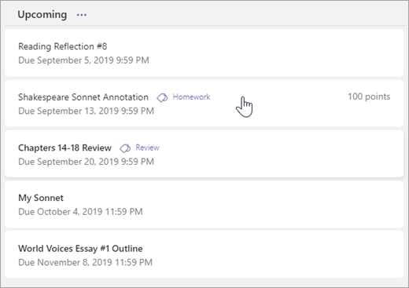
Tip: Select the Expansion icon (diagonal, double sided arrow) to work in full-screen mode.
- If your teacher specified a document for you to turn in or you have other files to attach to this assignment, select +Add work and upload your file. Note: You can attach a file up to 50 mb in size.
Tip: Work on Office files associated with this assignment right from here—no need to leave the app. Older files with .doc, .xls, and .ppt file extensions can only be edited in the desktop versions of those apps. You can copy content into a new file created in Teams to make them editable again.
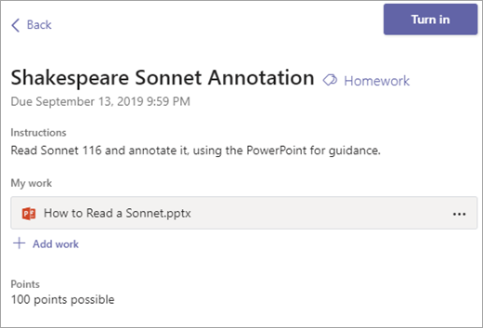
- Select the Turn in button to turn in an assignment before its deadline. The button will change depending on the status:
  - Turn in again if you’re editing an assignment you’ve already turned in and need to submit work again.
  - Turn in late if you’re turning in your assignment after the due date, but your teacher has allowed late turn-ins or asked for a revision.
  - Not turned in if the assignment is past due and your teacher is no longer accepting turn-ins. You cannot turn in work.
  - Undo turn in if you decide you want to edit your assignment before the due date. You'll need to turn it in again after you make your edits.

Send a file, picture, or link in Teams

Microsoft Teams for Education

When you're in a chat, you can send messages that include files, pictures, and links.
Send a link
To send a link, select Format beneath the compose box, then select Insert link .
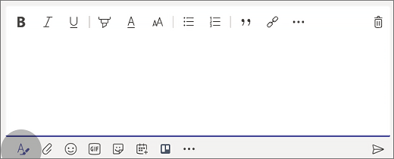
Add display text and the address, and then click Insert, or simply copy and paste the link into the compose box and select Send . Once you send it, the message containing your link includes a thumbnail image and preview, which you can close if you'd rather not see it.
Note: Teams has its​ own ATP Safe Links security to verify that any link that you send or receive is safe to click on. As an added layer of protection, we'll let you know if we've identified a potentially unsafe link.

Include a file or picture
To include a file or picture in a message, click Choose file beneath the compose box. Then you can upload an file or picture from your computer or OneDrive, or search for one from the Files tab for that channel.
In a chat conversation, click Choose file and pick the file or picture you want from your computer or OneDrive.
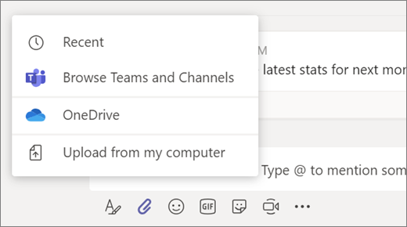

Use Immersive Reader in Microsoft Teams

Microsoft Teams for Education
Hear posts, chat messages, and assignments read aloud using Immersive Reader in Microsoft Teams for Education. Immersive Reader also includes grammar tools such as Parts of Speech and Picture Dictionary.
Launch Immersive Reader from a message
- Hover over a message with your cursor or tap with your finger on a touch screen device.
- Select More options , and then Immersive Reader .
Immersive Reader will launch as a full-screen experience.
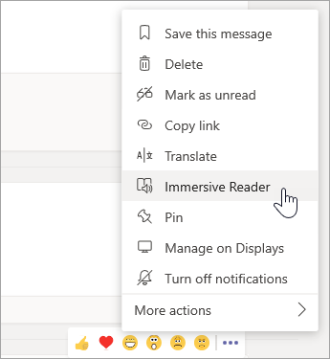
Launch Immersive Reader from an assignment
If you're a student, open an assignment and select Immersive Reader .
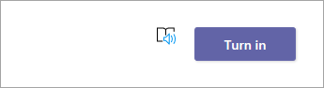
If you're an educator, open an assignment and select Student view, then Immersive Reader .
Immersive Reader will launch as a full-screen experience.
Immersive Reader features
You can do one or more of the following in Immersive Reader, depending on how you'd like to focus on the message or assignment text.

- Select Play to hear your document read aloud and to see the text highlighted simultaneously. The narrator starts reading from the top of your page by default, unless you have selected a word, in which case it will start reading from the selected word. Select Pause to stop narration.
Select Voice Options on the top right of the document to change the speed of narration.

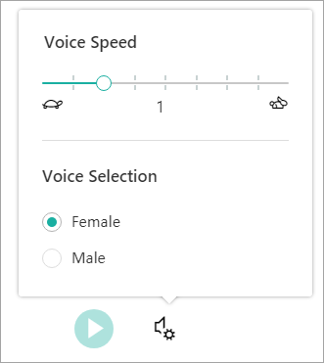

- Text Options
You can change the appearance of your document by using Text Options. Text options can help you focus on your content and remove visual distraction.
Set Text Size, Spacing, Font, and Themes that suit your learning needs. You can increase or decrease text size and the amount of spacing between letters and words. The Theme colour you select becomes the background colour of the document.
Switch on Show Source Formatting to retain formatting from the original text, such as bolding or underlining.
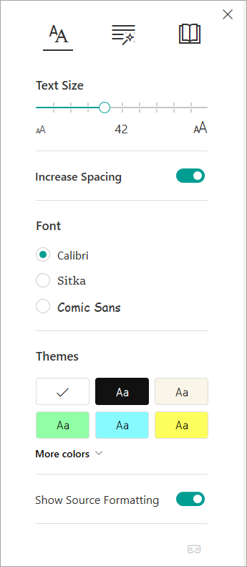

- Parts of Speech in Grammar Options
Select one or more of the following options:
  - Syllables to break words into syllables.
  - Nouns to highlight nouns in your document in purple.
  - Verbs to highlight verbs in your document in red.
  - Adjectives to highlight adjectives in your document in green.
  - Adverbs to highlight adverbs in your document in yellow.
Switch on Show labels to see the label underneath the highlighted parts of speech.
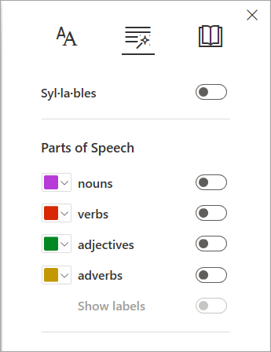

- Reading Preferences
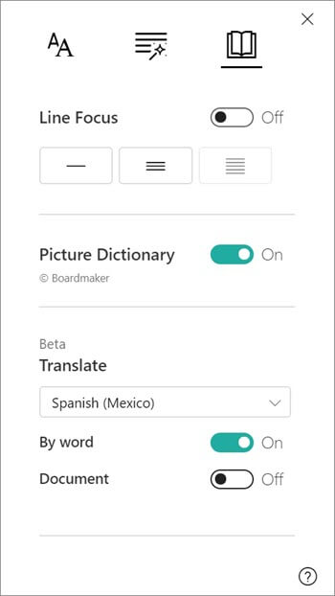

  - Line Focus enables readers to narrow the focus of their reading experience by highlighting sets of one, three, or five lines within their chosen material in Immersive Reader. Use the toggle to turn it on or off.
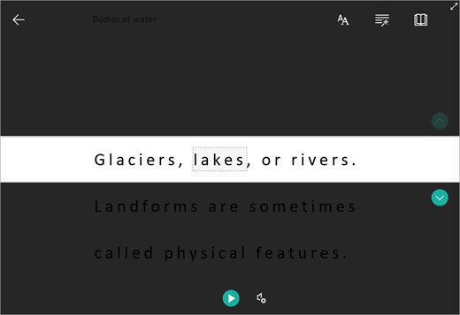
  - Picture Dictionary gives you the ability to click on any single word to hear it read aloud and see a picture that helps define the word.
  - Translate lets you translate your text into other languages by word or document.

Select Close to exit Immersive Reader.

