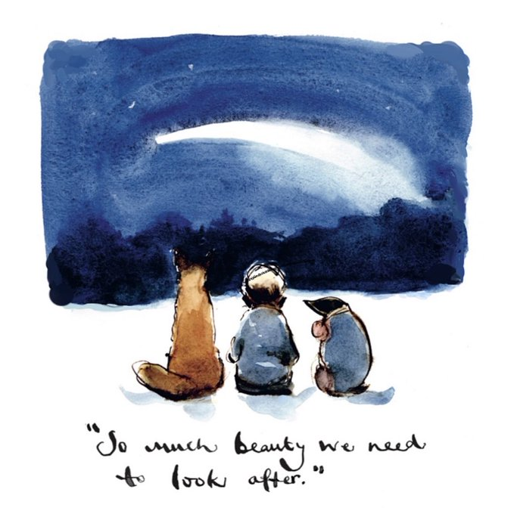

Happy Earth Day

Another busy week, which has flown by.

We have had fabulous weather as we continue to participate in the Sustrans Big Pedal Fortnight. Next week we hope to involve our pupils in a different activity – read on. It promises to be wheelie good!

I look forward to seeing you at the Parent Council Meeting, if you are able to attend on Wednesday.

Homework will start again on Tuesday – more details are in the body of the newsletter.

HOMEWORK P1-7
Starting next week, as from this Tuesday, homework will be issued to pupils on a weekly basis via our Microsoft Teams tile in Glow. This will ensure we maintain and develop further our technology skills.
Each week there will be an active spelling task, reading and a mathletics challenge within your child’s ‘Team’. There is also the termly jigsaw where pupils can try to earn points and explore areas within their topic and wider learning. We would encourage your child to achieve at least ‘100 points’ in their chosen tasks. Certificates will be awarded.
Homework will be issued on a Tuesday and should be completed by Monday. Active spelling and Jigsaw tasks can be photographed and uploaded to Teams. Reading books will be sent home every Tuesday and should be brought to school daily. Mathletics will be completed online.
Your child will be shown in class how to access their homework and upload their work to the site. They will also be re-issued with their login details. If you have any trouble accessing the homework, please let us know and we will do our best to support you. The attached ‘help sheets’ should also guide you in using Microsoft Teams if you require a ‘refresher’.
Thank you for your continued support and cooperation.

SUSTRANS 19-30 APRIL
BIG PEDAL THURSDAY 29 APRIL
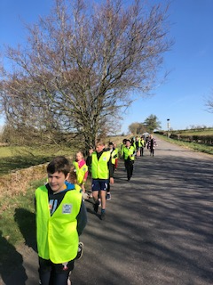
We have experienced beautiful sunny mornings as the whole school has participated in their daily walk this week. Well done everyone, what a wonderful way to start the day.

Next week we are planning to have a Really, Wheelie fun afternoon session. Pupils are invited to bring in their bicycles, or scooters or anything they can transport themselves on, that has wheels (probably not a quad bike or anything with an engine!!).

Don’t worry if you don’t have anything or are unable to transport your bikes etc – we will have other fun activities that pupils will be able to participate in.

- Please ensure pupils have essential protective head gear.
- If anyone has any spare scooters at home we would really appreciate ‘borrowing’ them for the day. We appreciate everyone will not be able to transport their bike to school or may not have one.

Please let the office know if you can lend us a scooter or two!

Families can be involved too…

The Big Pedal family competition gives parents and guardians the chance to win one of these three amazing prizes for your family. All you need to do is take a photo or a short video of your child(ren) taking part in Big Pedal between 19-30 April. Post it to Instagram, Facebook or Twitter, tag @Sustrans and use #BigPedalWin. Please note families whose children are remote learning can still take part from home. There are three amazing family prizes up for grabs!
Good luck

GARDENING CLUB
Tuesday 3.15-4pm
Applegarth Primary
The Gardening Club started on Tuesday 20 April and will run until further notice.

APPLEGARTH AND HUTTON ECO COMMITTEE - Volunteers for Chickens
Thank you to the families who offered to look after the chickens at the weekends. A separate email will be sent to the families involved.

Offers of straw are also gratefully received! Eggs will continue to be available on sale at £1 per half dozen. Please send your order with the money, clearly labelled in an envelope. Thank you.

JIGSAW/OVERVIEWS
The class overview for learning for Term 4 is enclosed in your child’s home/school booklet.
Your child’s homework jigsaw is also enclosed in your child’s home/school booklet for your convenience.

REPORT FOLDERS
In preparation for reports coming out in the future can you please return the school report folder if you still have it at home.

HAPPY EARTH DAY!

Primary 1-4 have had a fabulous Friday learning all about caring for our Planet Earth.

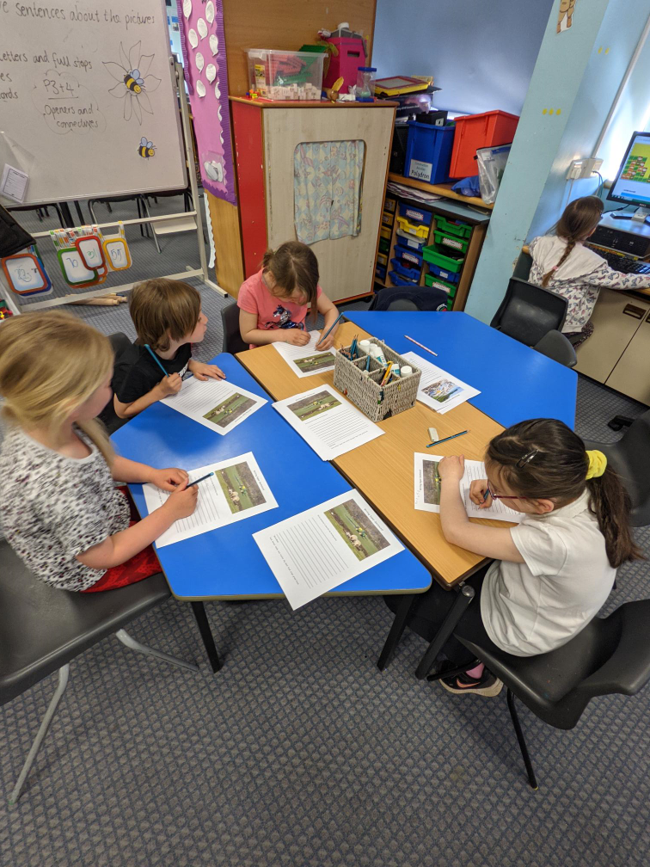
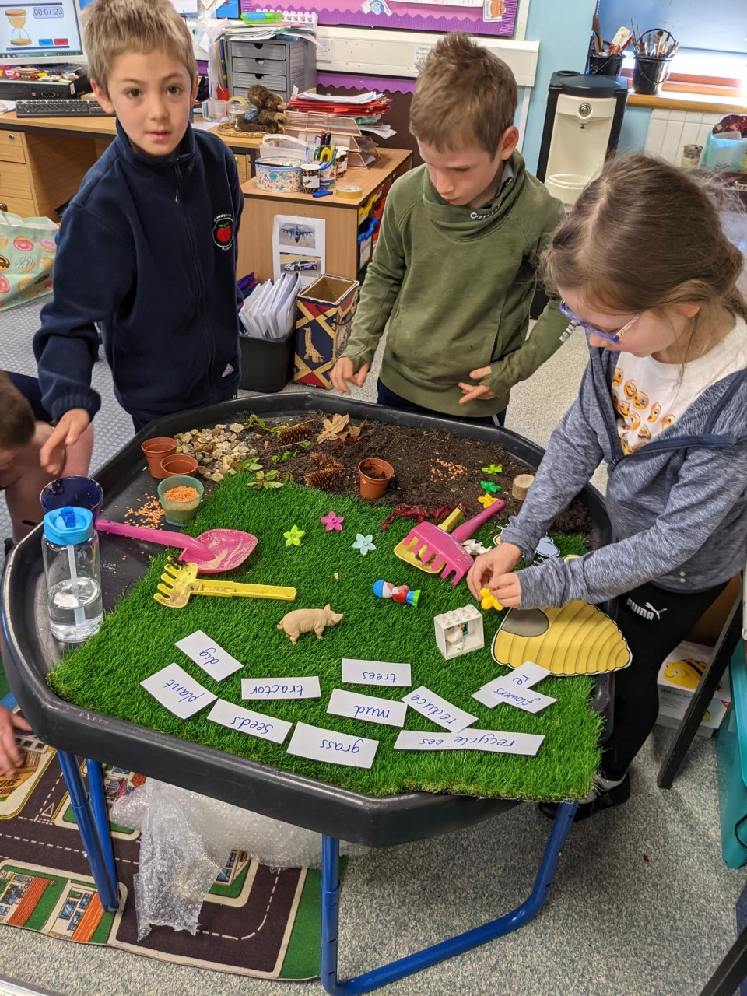

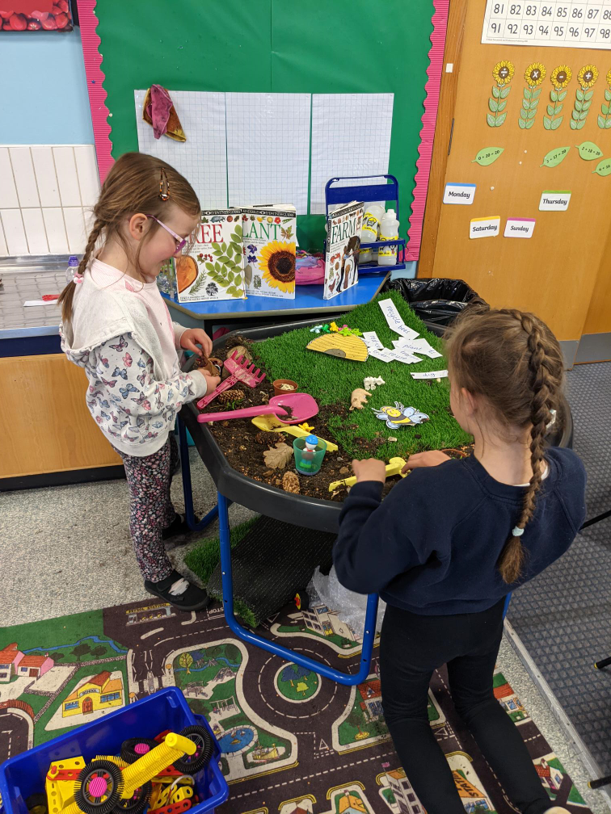
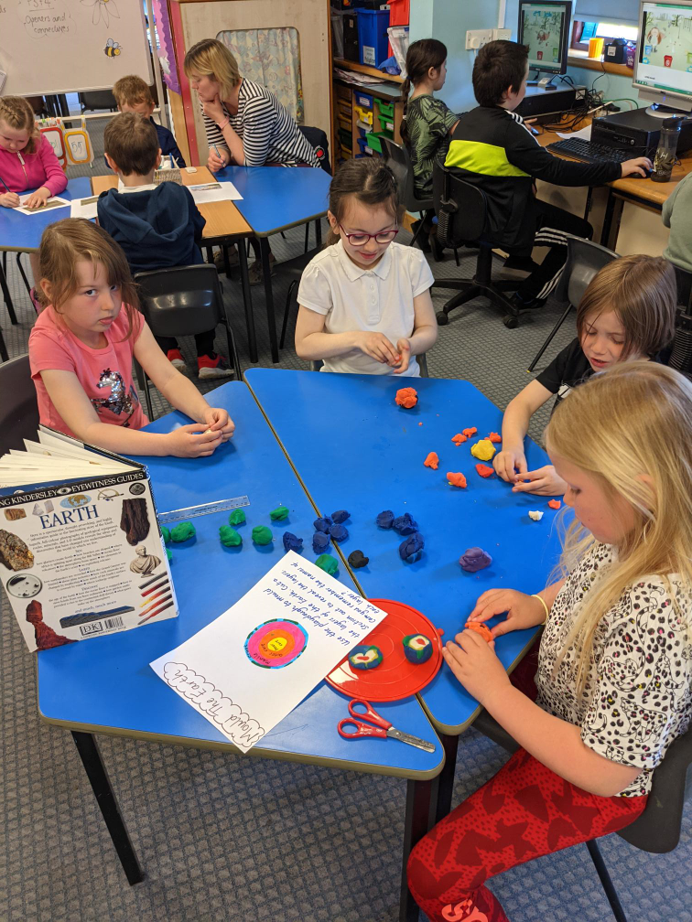

REMINDERS:
28 April Applegarth and Hutton Parent Council Meeting 6.30pm via Zoom
28 April Rag Bag bin at Hutton will be emptied
3 May May Day holiday

