Welcome Back Everyone!
I hope you all enjoyed the Easter break and managed to find time to relax and recharge with your family. COVID restrictions still apply so thanks to everyone for adhering to the rules.
Great excitement this week when 2 new additions joined our school community. Read on to find out more.

MAY DAY HOLIDAY
There will be a May Day Holiday on Monday 3 May.

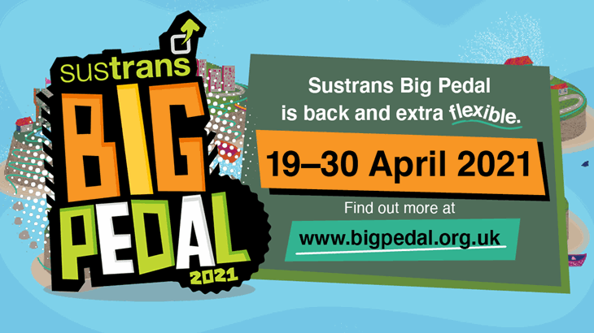
SUSTRANS BIG PEDAL 2021
19-30 APRIL
Sustrans Big Pedal is the UK’s largest inter-school cycling, walking, wheeling and and scooting challenge. All pupils will be accompanied by staff, walking to and from Perchhall Cottage every morning for a week 19-23 April. Pupils should come to school at their usual time.

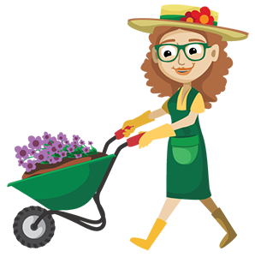
GARDENING CLUB
Tuesday 3.15-4pm
Applegarth Primary
It’s the time of year for our gardening club to start again.
On a Tuesday after school Mrs Boyes will be offering her green fingered services and helping our pupils with all things gardening. All pupils are welcome. If your child would like to take part or if you are interested in supporting the club please indicate on the form via the link below.
https://forms.office.com/Pages/ResponsePage.aspx?id=oyzTzM4Wj0KVQTctawUZKUW24qU1tIVHikdiRiM0NrhUMVE3R1hHTVo3V0tETDg0VVMxSTlWRTBRRS4u

APPLEGARTH AND HUTTON ECO COMMITTEE - Volunteers for Chickens
Meet our two hens Chickpea and Daisy

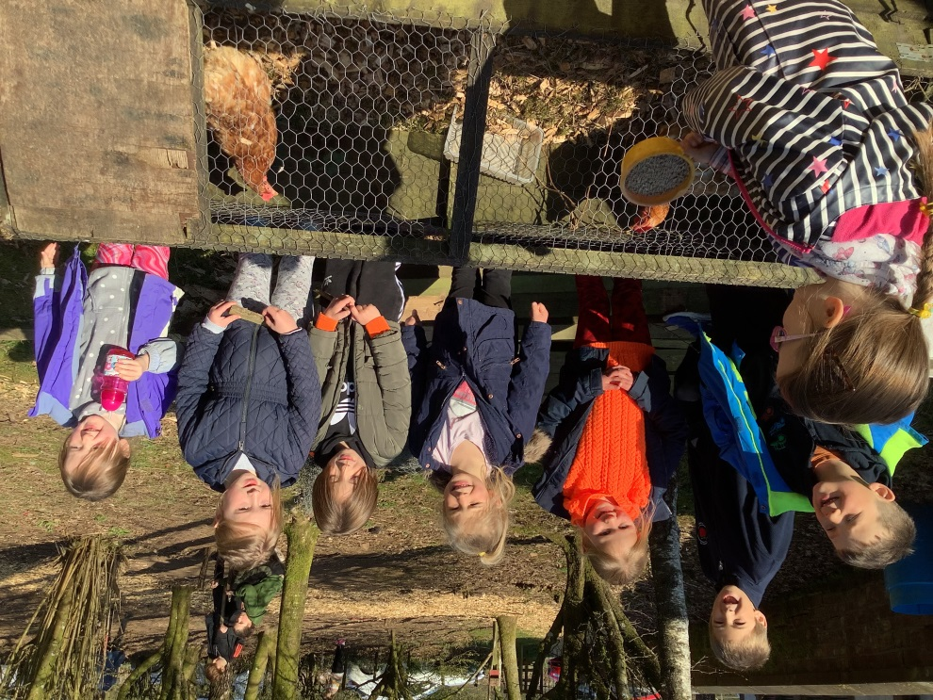

A huge "thank you" to Mrs Boyes and family for delivering them safely to Applegarth! All of the children have made them feel very welcome in their new surroundings. As part of the daily routine the pupils take turns in looking after Chickpea and Daisy and collecting their eggs. During this session we require help from families to look after them at weekends. We would be grateful if you could indicate on the form whether, and when, you would be able to help with this.

https://forms.office.com/Pages/ResponsePage.aspx?id=oyzTzM4Wj0KVQTctawUZKUW24qU1tIVHikdiRiM0NrhURThYMElFMzZNRklSOFhOMkJQWlNLRFJHOC4u

Offers of straw are also gratefully received! Eggs will continue to be available on sale at £1 per half dozen.

COVID 19 GUIDELINES
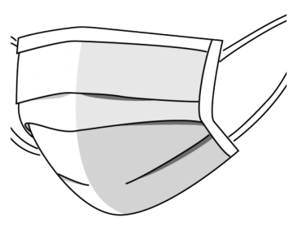
As we have all returned safely to school there is still a risk that it could cause an increase in people getting the virus. So here are 5 important things you can do to make sure this doesn’t happen, and to help our nurseries and schools stay open.
- Wear your face covering at all times when you’re dropping your children at nursery or school and when you’re picking them up.
- Only one parent at a time should do drop offs and pickups.
- Stay 2 metres from other parents at the gates and avoid travelling to and from school in groups with others.
- Don’t car share with other households and limit using public transport if you can.
- Look out for symptoms at home and follow Test and Protect guidance if anyone shows any signs of COVID.
Applegarth and Hutton Parent Council Meeting
Wednesday 28 April 2021
6.30pm via Zoom
A reminder the next Parent Council meeting is on Wednesday 28 April 2021. All welcome. If you wish to attend and have not completed the previous form, please email the office.

RAG BAG – Hutton
The Rag Bag Bin at Hutton will be emptied on 28 April 2021. The bin is situated next to Boreland Village Hall. If you have any clothes that need recycled, please donate these as all funds raised go to the school. The previous amount raised was £66.40 so it is worth having a clear out. Bags can be requested from Applegarth school office.

Marking the death of HRH The Duke of Edinburgh.
Following the death of HRH Prince Philip, it has been announced that there will be a national one minute silence on the day of his funeral, Saturday 17th April, at 3pm.
A national online Books of Condolence is open to allow people to pay their respects at: https://www.royal.uk/

- If your child has milk at snack time please send £1 in an envelope clearly marked with your child’s name at the beginning of each week.

- PE is on a Wednesday and a Friday – pupils should come dressed in their PE kit.

