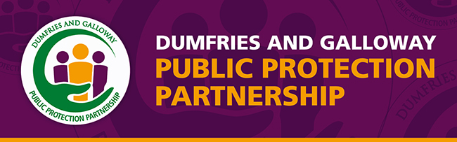

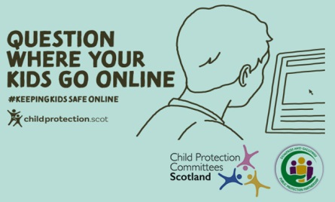
#Keepyourkidssafeonline

During lockdown many children have been online for longer, and more have been at risk of online abuse. Be curious and talk to your children and young people about what they are doing online. If you have concerns call social work on 030 33 33 3001 or Police Scotland on 101, if there is immediate danger call Police Scotland on 999. Remember it is always better to do something than do nothing!

