We have made it!
What an exciting end to a very difficult term. Our pupils enjoyed the Easter Egg Hunt, Easter Bonnet Parade and toasted marshmallows by the log fire in the woodland classroom in celebration. The fire log seems to be coming quite a tradition to mark the end of term and one we all enjoy.
I know I say this every week so no apology for repeating myself. A huge thank you to all staff, parents and pupils for ensuring that we all tried our best and made such a tremendous effort to get it right for each other – especially our pupils. I know we may not be out of the woods just yet, but we do hope that we can enjoy our final term in school after the holidays.
This term and year has tested all of us. Have a wonderful Easter holidays, take time to enjoy the break from school work and have fun as a family. I’m sure you all deserve it.

Mrs Fraser

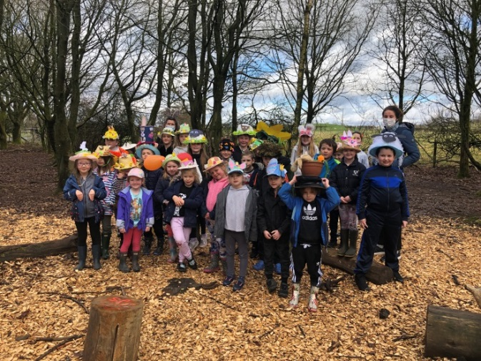
EASTER BONNET COMPETITION P1-7
And the winners are…….
P1 Isaac
P2 Durrie
P3 Tilly
P4 Charlie
P5 William
P6 Finlay
P7 Maddie

Well done to everyone who entered, it was an extremely difficult for the judges to decide. We had bonnets in all different shapes and sizes from Charlie the sheep to Dinosaur eggs nesting. There has been so much time and effort gone into making their very creative bonnets. Happy Easter.

Miss Bremner

Please visit our Sway link to view our full gallery.
https://sway.office.com/aiiodYrt17xt2JM1?ref=Link

Design a One Planet Picnic Pocket Garden Competition
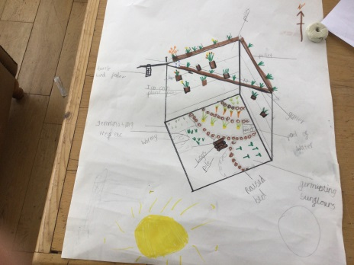
Congratulations William Boyes! We are delighted to announce William’s design has been chosen as one of the winning designs for the Planet Picnic Pocket Garden Competition 2021!

We are looking forward to seeing his garden design come to life.

COMPETITION – Easter Activity
The Community Engagement Team at DGHP are running an Easter Egg drawing competition, this will be open to any children in the community and there will be three prizes of Easter Eggs per area ( Wigtownshire, Stewartry, Nithsdale and Annandale and Eskdale) with a 1st, 2nd and 3rd prize.
The competition can be entered by emailing the picture to community.engagement@dghp.org.uk or by sending the picture to the Community Engagement What’s App number 07711194413. The competition will run for the 2 weeks of the Easter holidays, closing on Monday 12th April 2021.

Thank you to Mr and Mrs Mills for inviting our pupils to visit their garden. We had a wonderful time looking at their tadpoles.

Parent Council Meeting
Wednesday 28 April 2021
Please follow the link to the invite to our next Parent Council meeting. All welcome.
https://forms.office.com/Pages/ResponsePage.aspx?id=oyzTzM4Wj0KVQTctawUZKUW24qU1tIVHikdiRiM0NrhUN1c4WUg4STIzSjlOSk9YMERaM1MxOUdWNy4u
Previous minutes have been uploaded to the school website.

BIG DOG
Discount Code
School/pupils are being offered a 15% discount on Big Dog titles through the Wigtown Book Festival Bookshop. To receive your discount use the following code: BIGDOG21

MESSAGE FROM FIRE AND RESCUE SERVICE
Dangers of Starting Fires and Hoax Calls

The school holidays are coming up and you may be looking to do lots of fun, exciting things. However, please do not be tempted to start any fires. Even if you think a fire is just a small one they can grow very, very quickly and you or your friends may get injured. You might also damage property or kill wildlife.

Never make hoax calls either as this will take fire engines away from being able to help someone who is in real trouble – at a fire or in a road accident.

If you start any fires yourself they are called deliberate fires. These are dangerous and we will tell the Police about them and they will investigate them. If you make hoax calls we will know who you are and we will pass that on to the Police as well.

However, if you see a fire that is unattended please phone 999 or tell an adult. You will never get into trouble for being honest.

Have a safe and fun holiday.

Well done to our certificate winners last week.
This Photo by Unknown Author is licensed under CC BY-SA
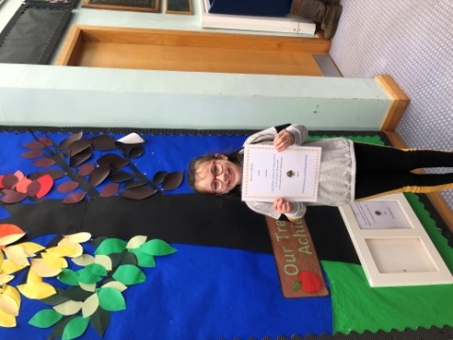
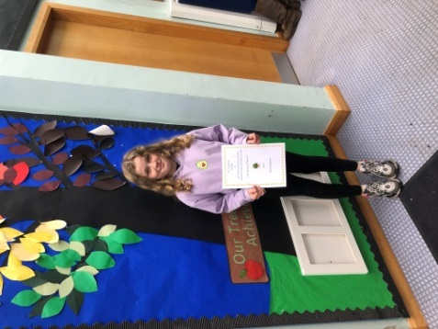

- It is anticipated that all schools will return on the Monday 12 April

- The new lunch menu starts after the Easter break, if you have not ordered a lunch via the form then please send your child with a packed lunch.

- If your child has milk at snack time please send £1 in an envelope clearly marked with your child’s name at the beginning of each week.

- PE will continue after the holidays on a Wednesday and a Friday – pupils should come dressed in their PE kit.

- Indoor Shoes if possible – we appreciate it is not so easy to purchase these when non-essential shops have yet to open, but a spare pair of shoes for your child to change into would be appreciated by our carpet and cleaner!

FORMS TO COMPLETE
Parent Council invite
https://forms.office.com/Pages/ResponsePage.aspx?id=oyzTzM4Wj0KVQTctawUZKUW24qU1tIVHikdiRiM0NrhUN1c4WUg4STIzSjlOSk9YMERaM1MxOUdWNy4u

ATTACHMENTS
Keep your Kids Safe Online

