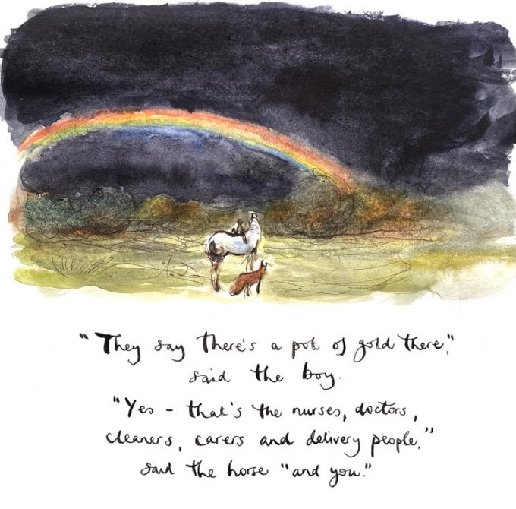
Let us take a moment to acknowledge how fantastically well we, as a school community, have maneuvered our way through all the different challenges over the past year. It is difficult to believe a year ago staff were beginning to pull together individual packs for our pupils to use just before the Easter holidays. A year later and we are waiting with open arms to welcome back all our pupils, together, on Monday 15 March. Each and every pupil, parent, carer, learning assistant, clerical assistant, cleaner, catering manager, janitor, taxi driver and teacher have continually gone above and beyond through these months. Everyone has demonstrated resilience, perseverance and an ability to adapt to change, whether we have been working from home or in school.
There is a great appreciation that this has not always been an easy journey, there has been some storms on the way, and a degree of uncertainty. I hope as we move forward, we can hang on to the good that has come out of this and continue to be prepared for whatever comes our way. At the heart of what matters is our health and wellbeing, be kind to yourselves, enjoy the outdoors and look after each other. We all know that circumstances can change overnight.
Mrs Fraser

APPLEGARTH AND HUTTON WORLD BOOK DAY CELEBRATION
Thursday 4 March 2021

How lovely to see most of our pupils looking so cosy and relaxed in their pyjamas. I’m also very impressed at staff participation this year! Please take time to look at our sway which captures the moments.
The ‘takeaway’ from our book swop collection – don't worry if you don’t like the book that was selected for you- there will be an opportunity to swop it when you come back.
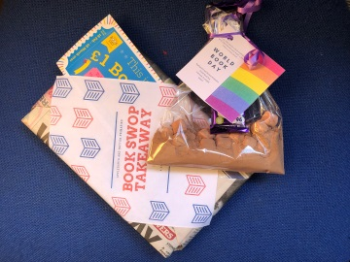
Some fantastic examples of vege- tate vegetables dressed up as favourite book characters. Thank you for making the effort.
We hope that your child has enjoyed all the activities celebrating World Book Day – the mission now is to encourage and motivate our pupils to read for pleasure as well as continually develop their reading skills in school and at home.
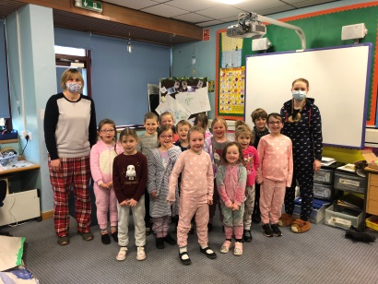
‘Snuggling in with my children to read their bedtime story every night is one of my most treasured memories.’
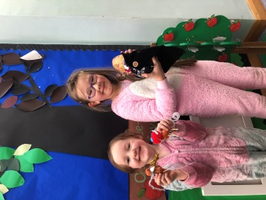

Arrangements for from Monday 15 March 2021
As we welcome back all our pupils, at the same time, arrangements will be similar to term 1 and term 2. All pupils will return to Applegarth Primary.

Classes:
- Miss Fergusson P5-7
- Miss Bremner and Miss Keenan team teach P1-4
- RICCT teacher Mrs Clark

Organisation – Each group of pupils will be taught in the class base, the outdoor classroom or the main hall.

Snack: Pupils should bring a small, preferably healthy snack and water bottle.

Milk: Morning snack milk can be ordered, (P4-7 please complete the link at the end of the newsletter). Payment is £1 per week.

Lunches:
Lunch arrangements to be confirmed next week.

Uniform:
All pupils should wear school uniform. There is an opportunity to order additional items – I know how much and how quickly some of our pupils have grown! Please access the order form for both schools via the link at the end of the newsletter.
Bank Transfer details:
Applegarth School Fund
Sort code: 80-08-88
Account number: 00133465
Reference: Name of child

Cheques made payable to Applegarth School Fund or Hutton Primary.

PE kit should be worn to school on Wednesday and Friday each week.
Indoor shoes and wellies to be left in school if possible.

CONTACT DETAILS
The central team within Education has requested that all email addresses are correct and up to date. This will ensure that you receive relevant communication from Education and Learning Directorate. Please complete the attached link with your correct details. Thank you.

https://forms.office.com/Pages/ResponsePage.aspx?id=oyzTzM4Wj0KVQTctawUZKUW24qU1tIVHikdiRiM0NrhUNEZaM1BYM1JURUFTQjJYN0FaOFgxV0lNTy4u

Primary 7 transition
A reminder for all the P7’s to check out the new Lockerbie Academy Team. There will be a new task on Tuesday.
Follow the link below.

http://www.lockerbieacademy.dumgal.sch.uk/p7_information/p7_transition_2021.html

SWAY
Visit the link to visit this week’s activities.
https://sway.office.com/Byhl1megY2IfYW7G?ref=Link&loc=play

This Photo by Unknown Author is licensed under CC BY-SA
CERTIFICATES
Please remember to send in your photos with your child and their certificate. Well done Durrie, Holly and Andi.

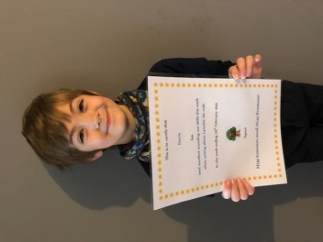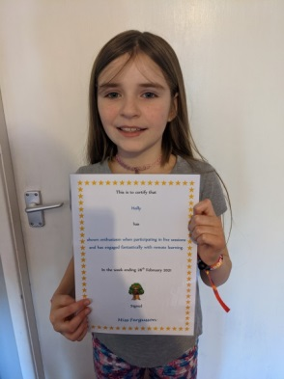

ATTACHMENTS
Miss Bremner’s Learning Overview
Miss Kennan’s Leaning Overview
Miss Fergusson’s Learning Overview
Rainbow Day Learning Overview

FORMS TO COMPLETE
Applegarth And Hutton Uniform Order
https://forms.office.com/Pages/ResponsePage.aspx?id=oyzTzM4Wj0KVQTctawUZKUW24qU1tIVHikdiRiM0NrhUOU00NkhTUldOTzAyRVM5MFdRWlYxVVBWOS4u

Wider Achievement
https://forms.office.com/Pages/ResponsePage.aspx?id=oyzTzM4Wj0KVQTctawUZKUW24qU1tIVHikdiRiM0NrhUMkRXSFoxSEw0QTZLSVhETUJRQ09PR0hMVC4u

Milk
https://forms.office.com/Pages/ResponsePage.aspx?id=oyzTzM4Wj0KVQTctawUZKUW24qU1tIVHikdiRiM0NrhUMVdZRk1PQ1NKRFdXVUtaOEswTVI2MUYySC4u

