RAINBOW DAY
Team: Mrs McWhirter’s Rainbow Team |  | Week beginning:  Monday 08/03/2021
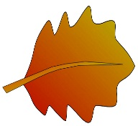  Numeracy  Learning with Leaves!  You will need:  - Leaves (obviously )  - String  - Squared paper  - Ruler or tape measure  USE THE LINKS BELOW TO PRINT OFF A RULER OR TAPE MEASURE & SQUARED PAPER IF YOU DON’T HAVE THEM AT HOME.  Printable cm Ruler  CM Tape Measure to print  CM-SQUARE Graph Paper  LEAF INVESTIGATION & PROBLEM SOLVING…  Investigate the ‘dimensions’ of your leaf…  First ESTIMATE & then MEASURE…Record your method & results on paper or in photographs which you can edit.  - Length  - Width  - Perimeter (the measurement around the outside of your leaf) HINT: Use the string.  - Area (the space ‘covered’ by your leaf) HINT: Use the squared paper.  Remember to include the UNITS! HINT: For area this will be in cm². | Project ECO Code!  Use the link below to access STEP-BY STEP instructions for this Eco Coding project.  Raspberry Pi - GREEN GOALS CODING PROJECT  You may need to download software if you haven’t got it already.  Alternatively, you could try the link below from Hour of Code,  https://hourofcode.com/kodablebeach  Just take a photo or film clip of your finished product or of you enjoying your coding and upload it to the Rainbow Team. | 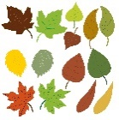  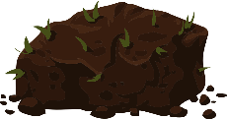  NATURE ART  Using objects from nature or your garden can you create a PORTRAIT of someone or something famous? (or even someone you know - if you are feeling really brave!?)  Think about…  - What materials you will use?  - How will you get the colours you need?  - Or will you try ’alternative’ colours instead!?  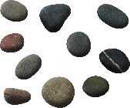  - What textures do you need, for hair for example?  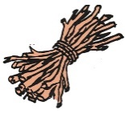  Once you have created your masterpiece don’t forget to  Upload a photo to the Rainbow Team.  Then we can play ‘GUESS WHO?’
HEALTH & WELLBEING  1. Don’t forget about your  #DGRepItUp  Challenge!  You can access the TRACKING sheet and VIDEO CLIPS here  A&E Active Schools Facebook  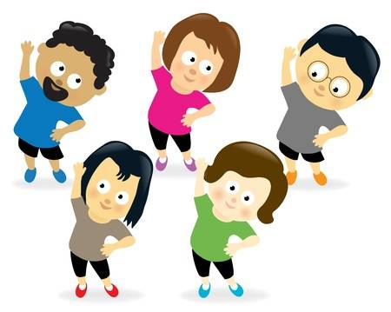  2. Exercise Cards  Literacy/Health & Wellbeing  Use your knowledge of the #DGRep It Up exercises!  Design and create a set of…  Exercise Instruction Cards!  You will need:  - Card or Paper  - Coloured pens  - Illustrations as VISUAL instructions (watch the videos it may help)  - Simple, CLEAR descriptions of what to do e.g. ‘Do this 10 X’ | Rainbow Music  (Solfège)  This a VISUAL music system which uses symbols & sounds to help us learn scale of musical notes!  You may know the ‘Doh, Ray, Mi Song’ from the sound of music already or you can listen and join in using the link below…  Doh Ray Mi SONG  Then you can have a go at learning the hand signs as you sing using the poster below. You can download your own version using the link below…  Kodaly-Curwen-music- hand-sign-poster  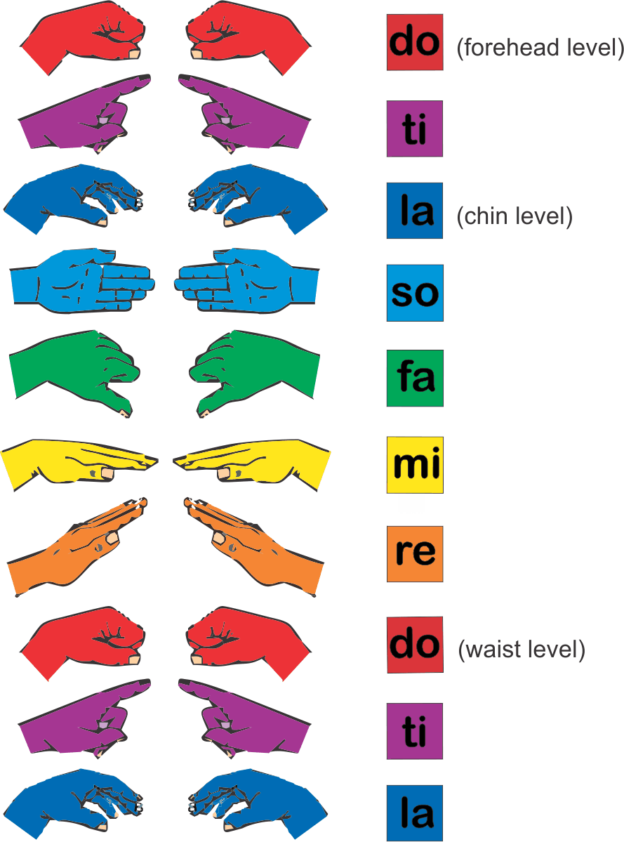  Then video upload a video  of yourself performing! | 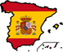  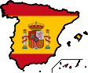  Rainbow Languages  Following our IDL theme of Community – Imagine your community was Spanish?! Would you know how to …  Meet & Greet in Spanish?  Hola (Hello)  Me llamo (My name is…)  Como estas? (how are you?)  Que tal? (How’s it going?)  Bien (Good)  Muy bien (Very good)  Adios (Goodbye)  Hasts la vista (Goodbye, see you later)  Practise, then video your greeting and upload it to the Rainbow Team!  Vamos!

