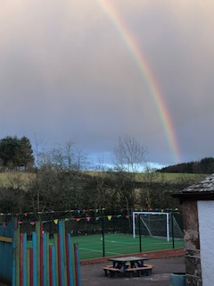
There is hope – and this week we have certainly sensed this in our community. I took this photograph as I left school yesterday afternoon, it made me think how close we are to reaching our own pot of gold, a full school.
It is an absolute delight to welcome our P1-3 pupils and pupils from the learning hub back to school this week. To hear them outside playing and laughing is such a treat. I can’t deny there is something missing – ah yes the rest of our pupils and teachers, I so hope it all goes to plan and we see you all back on the 15 March. In the meantime thank you so much for what you are doing in your efforts to maintain motivation and engagement in your child’s learning.
Exciting things are afoot next week as we are planning a fantastic World Book Day. Read on for more details….
Mrs K Fraser

APPLEGARTH AND HUTTON WORLD BOOK DAY CELEBRATION
Thursday 4 March 2021

Order your takeaway!
Second hand book give away! Whether you are in school or at home – your child will get a special delivery from our book swop collection. Unwrap the newspaper to see what delight awaits you inside.
Vege – tate with a good book.
There is nothing better than when you take the time to relax reading a fabulous book – we would like you to dress up a vegetable to resemble a character from one of your favourite stories. You can use any other materials you like, fabric, paper, recycling bits and pieces as long as you have a vegetable base! Bring in your models or send a photo into school.
It’s pyjama book day!
Everyone can enjoy their day without getting changed – we would like you to dress in your pyjamas for the day – so we can all read in comfort!
Create a book nook
We like to read anywhere! Photos are most welcomed of you reading in your favourite place – it may be under your bed, up a tree or simply on a sofa OR have a think and use your imagination to create your very own special book nook.

Author on demand
Catch up with famous authors on demand – our pupils will be given the opportunity to catch up with the authors live through the Scottish Book Trust, whether you are at home or in school. Your teacher will arrange this for you!
Fairtrade Treat
To celebrate Fairtrade Fortnight there will be a wee treat ready for you in school and to enjoy at home. Book Day items can be collected from school on Wednesday morning for those learning at home.

DROP OFF/PICK UP
A wee reminder to pass on the pick up arrangements to all family members. As we continue to follow guidelines to reduce gatherings of parents/carers pupils should be collected within the coned area. Pupils travelling in taxis leave first and the remainder of pupils will be guided to the car when it reaches the coned area. Thank you for your patience and co-operation.

SWAY
Visit the link to visit this week’s activities.
https://sway.office.com/4jKa4bzUxihF2JHX?ref=email

Home school Link
P1-3 and learning hub pupils will receive their home school link book today. Please take time to discuss this with your child – your comments are always valued. Remember to complete the Wider Achievement cheques enclosed in the homelink.

MENU CHOICE
For all children attending school there is a lunch menu enclosed in the front cover of the homelink. Please indicate your child’s choice and return to school on Monday 1 March.

MILK
If your child wishes to have snack milk please complete the form via the link. £1 should be sent in an envelope with your child every Monday clearly stating your their name. This will start on Monday 8 March 2021. Please note orders cannot be placed on this form after Thursday 4 March at 3pm.
https://forms.office.com/Pages/ResponsePage.aspx?id=oyzTzM4Wj0KVQTctawUZKUW24qU1tIVHikdiRiM0NrhUMDgwTUFFS0kzTVhJNU1RUk82TjEyQkcwNS4u

Welcome new staff
As well as many of our pupils returning some of our teachers and Learning Assistants have returned too, it is lovely to see you all back in school. I would also like to welcome a new Learning Assistant to our team – Mrs Wilson, who has settled in really quickly to our partnership.

FUN ACTIVITIES, STORIES AND SONGS FOR FAMILIES AND YOUNG CHILDREN
Visit the link to view all the fun activities created by The Early Years Team.
https://sway.office.com/hhdcPptaDJgeGCNa?ref=email&loc=play

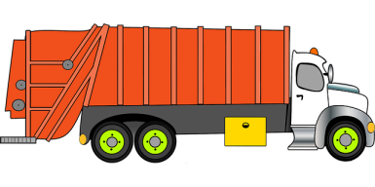

DGC Vehicle Naming Competition
Dumfries and Galloway Council are looking for inspiration to name a Bin Lorry. To enter your suggestions click on the information attached to the email. Good Luck.

SUPER 4’s
Dumfries and Galloway Active Schools and Community Sport team would normally be running cross countries throughout the region, with this in mind they are launching a virtual super 4’s for the month of March.

Details of the virtual challenge are below and shared on this actify link
https://www.actify.org.uk/module/1390

CERTIFICATES
This Photo by Unknown Author is licensed under CC BY-SA
Please remember to send in your photos with your child and their certificate.

Here’s Pippa receiving hers from a previous week.
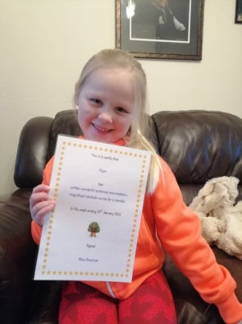

Congratulations to Our Valentine Heart winners Otto and Brooke. Huge smiles on receiving their prizes, well done.

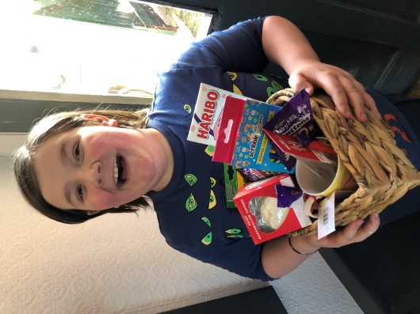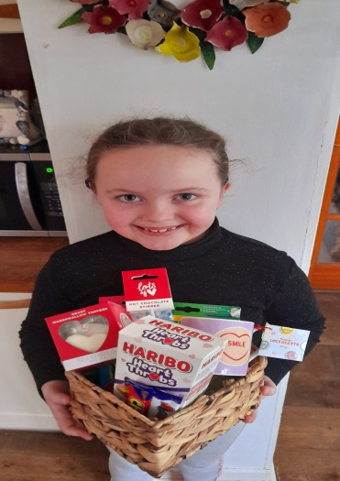

ATTACHMENTS
Library Flier
Miss Fergusson’s Learning Overview
Rainbow Day Learning Overview
Lorry Naming Information.

FORMS TO COMPLETE
Wider Achievement
https://forms.office.com/Pages/ResponsePage.aspx?id=oyzTzM4Wj0KVQTctawUZKUW24qU1tIVHikdiRiM0NrhUMDZJWkJZWlI4TFIyU0FaNlFLQ1k1TzBUSS4u

Parent & Pupil Questionnaire
P1-3/Learning Hub Pupils

https://forms.office.com/Pages/ResponsePage.aspx?id=oyzTzM4Wj0KVQTctawUZKUW24qU1tIVHikdiRiM0NrhUM1NDVjhORUkyMzFEMkxNQ1BIQTVRV0FWMC4u

Parent & Pupil Questionnaire
P4-7
https://forms.office.com/Pages/ResponsePage.aspx?id=oyzTzM4Wj0KVQTctawUZKUW24qU1tIVHikdiRiM0NrhUMTZBU002TkwzOE0xOVpZTkY2TFg2S0ZITC4u

P1 Bookbug Survey
For all those who received their P1 Bookbug bags please could you take a minute to complete the survey.
https://www.surveymonkey.co.uk/r/WBKNWHQ

