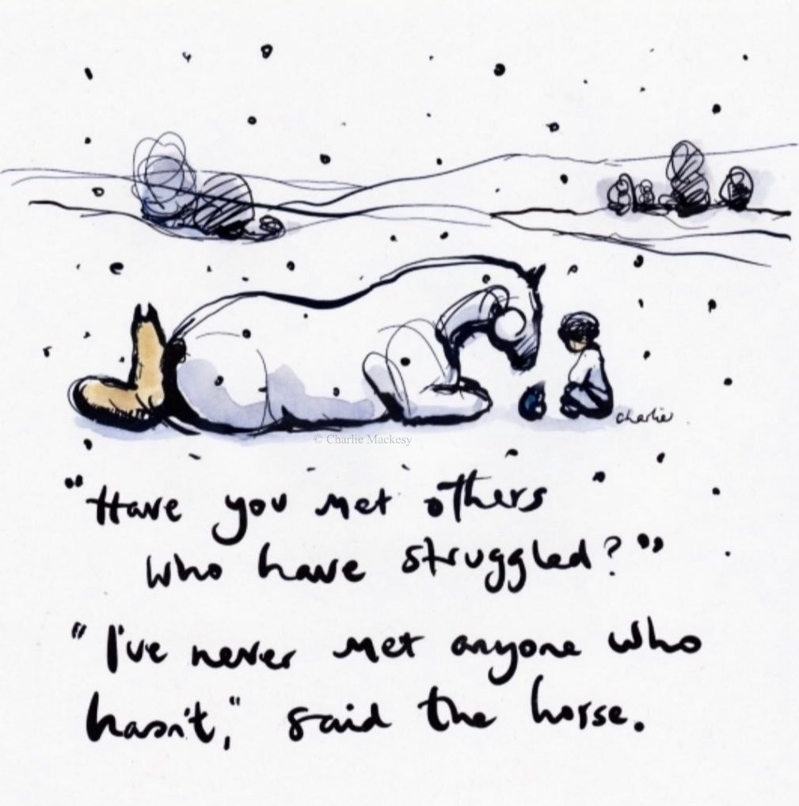
Thank you so much to everyone for joining us this week at our Virtual Valentine Coffee morning. The cakes were absolutely delicious. A slightly slow game of Bingo but ended with two very lucky winners – well done to Brooke S and Jasmine. A big well done goes to Isaac who found the winning heart tucked inside his box of delicious cakes and finally to Otto and Brooke for their winning entries in the Heart competition.
As we have reached midterm holiday I would like to say thank you again to those of you who have managed to support us by supporting your child/ren. There is a survey link in the body of the newsletter, please do take time to complete it for us as this will directly influence our provision going forward.
Please do enjoy the break from remote learning, take time to relax, and most importantly have some fun.
Key dates to note
All families have been sent a letter yesterday from the Director of Skills, Education and Learning, Dr Gillian Brydson, who has outlined the current plan to welcome P1-3 back to school. As was previously intimated the First Minister stated that this is dependent on the continued suppression of the virus, and an update will be given on Tuesday 16 February. I will write to you all on Thursday 18 February confirming the arrangements for our return after the holidays. Please be reassured that we will be prepared to deliver quality learning and teaching for our pupils whether they are in school or at home.
Mrs Fraser

APPLEGARTH AND HUTTON VIRTUAL VALENTINE COFFEE MORNING
After being involved with the Valentine Coffee morning for several years I never anticipated the virtual twist we all enjoyed this week. Applegarth and Hutton Primary’s coffee mornings have always benefited from tremendous support from small local businesses and the wider community, this year was no exception. Thank you to Just Be for offering to produce the cream teas and for all the prize donations they made, ensuring
Applegarth and Hutton could provide a COVID safe treat for hard working children. Also thanks to the school staff for coordinating the event and collections ensuring every pupil enjoyed a Valentine Coffee Morning.

Emma Boyes
Chairperson

SWAY
Mrs Clark’s Rainbow Day.
Visit the link to view our gallery of Hearts.
https://sway.office.com/oq392dhVcKJbE8W0?ref=Link&loc=play

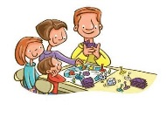
FUN ACTIVITIES, STORIES AND SONGS FOR FAMILIES AND YOUNG CHILDREN
Visit the link to view all the fun activities created by The Early Years Team.
https://sway.office.com/1WVQlQ6u29RJkzzF?ref=Link&loc=play

CERTIFICATES
This Photo by Unknown Author is licensed under CC BY-SA
Well done to last week’s certificate winners Pippa, William and Gregor.

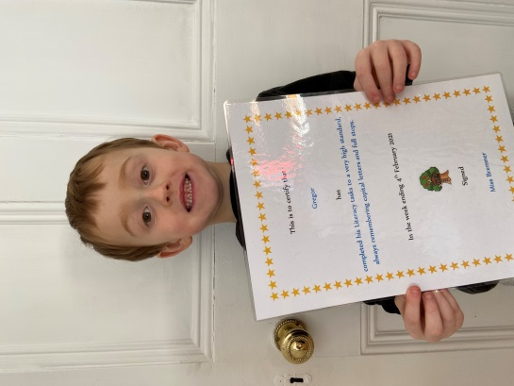
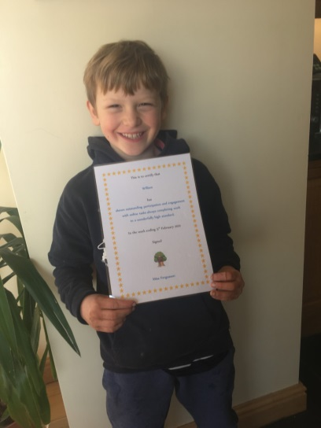

ATTACHMENTS
Sound Space 3

FORMS TO COMPLETE
Pupil Survey P4-7
https://forms.office.com/Pages/ResponsePage.aspx?id=oyzTzM4Wj0KVQTctawUZKZ1O2J7PzLFBrXDBxDZ139BUQUQzV1JaSzhIVFNSN0RBODJBWDJZN1ZaMC4u

Pupil Survey P1-3
https://forms.office.com/Pages/ResponsePage.aspx?id=oyzTzM4Wj0KVQTctawUZKZ1O2J7PzLFBrXDBxDZ139BUOThEWk1KRE9aQ0IzTTJXOURIVlc5WEk0US4u

Parent Survey
https://forms.office.com/Pages/ResponsePage.aspx?id=oyzTzM4Wj0KVQTctawUZKZ1O2J7PzLFBrXDBxDZ139BUOEZPQzBDWjQwTERaSEpOQkNSN04xTjZXMi4u

