RAINBOW DAY
Team: Mrs. Clark’s Rainbow Team  Remember that these are for the whole week and you do not need to do all of them! Pick and choose what works best for you at a time that suits. 😀 |  | Week: Wednesday 10-02-2021
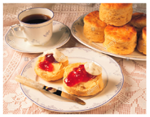Virtual Valentine’s Day Coffee Morning  Where: The Assembly Channel of Mrs Clark’s Rainbow Team/Assembly Team (please join using the following link):  Valentine's Day Coffee Morning and Family Bingo  When: 10:30 am Wednesday, February 10th, 2021  What’s happening: Bingo fun and a get together with treats/coffee/cakes/juice  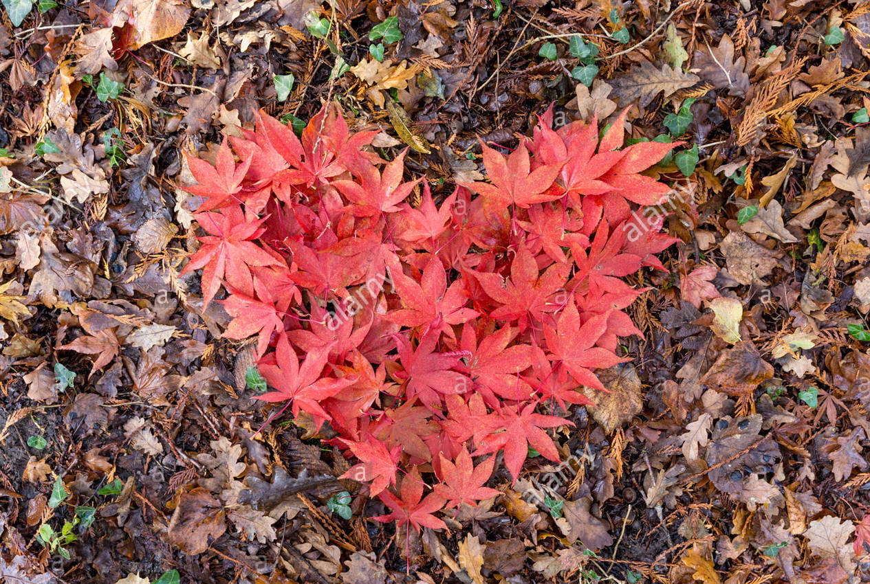 | HEALTH & WELLBEING/RME  Pancake Day  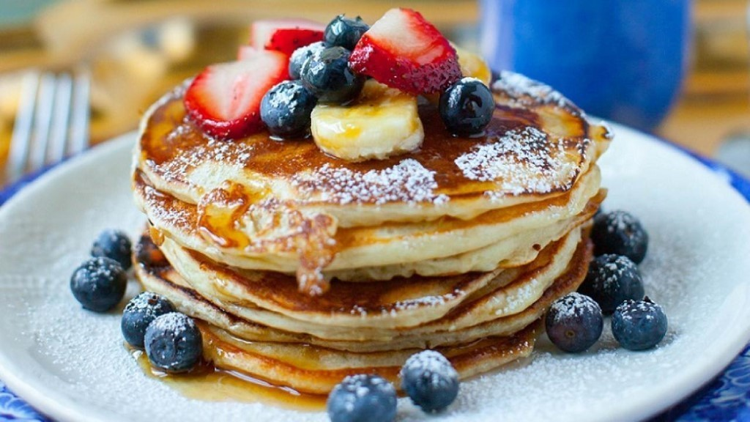  February 16th is pancake day!  Use the following links to learn more about Pancake day, or Shrove Tuesday:  Everything you need to know about Shrove Tuesday  Pancake Day Fun  These include some fun quizzes and different recipes to try.  Challenge: try making your own pancakes with your family. What kind are you going to make and why? Did you use a recipe? How would you describe them (fluffy, sweet, flat, round, etc.)?  Please upload photos/videos to the Rainbow page and have fun! | Community Buildings Eco Construction  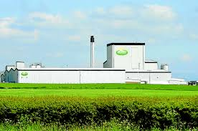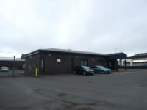  This week you are going to become a builder! Choose an important local community building (hospital, shop, fire station, police station, library, farm, etc.) and re-create it using your choice of materials (natural or otherwise, for example, lego, playdough, leaves, sticks, etc). Remember to draw out a plan of what you are going to create first (including a list of your materials if you can). What did you choose to build and why?  Design challenge extension: Include 2 moving parts as part of your design. How did you add these features? What materials did you include?  You can dress up as a builder for this task if you would like! Please post any photos/videos of your work on the Rainbow page.
💕Valentines Day💕  Create a HEART design activity  We want you to create a heart in ANY way that you would like! This could be in any form, decorated in any way using any materials! There are no rules here, this is all about fun and creativity. If you need some guidance, perhaps think about what kind of heart design has meaning for you. Please upload a photo of your heart(s) onto the Rainbow page.  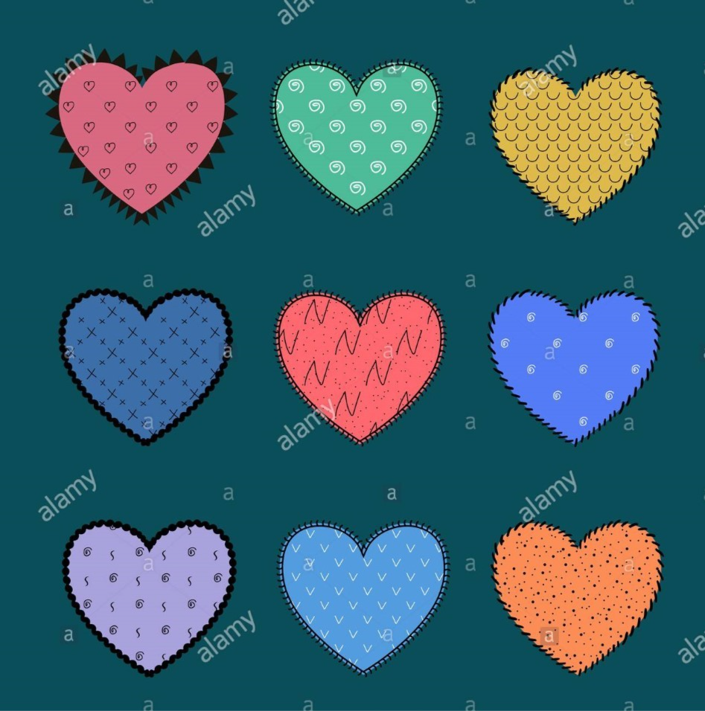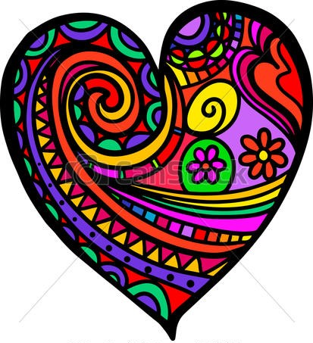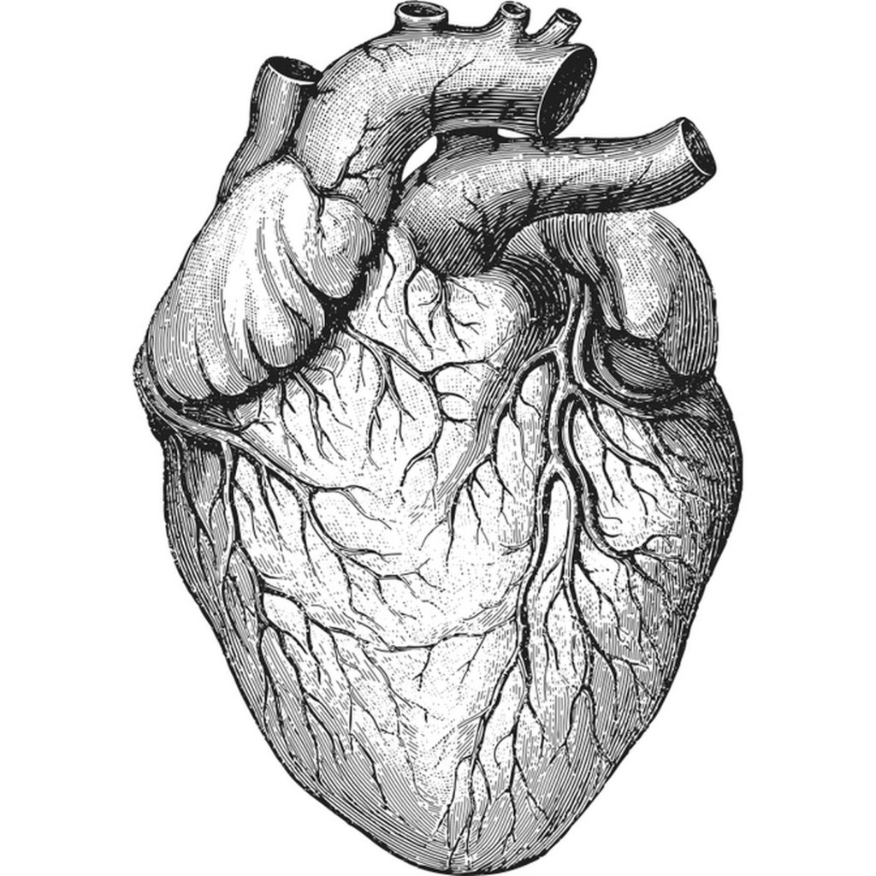 | ✅Marvellous Measure🔢  In Numeracy this week, I want you to focus on measure (weight). You are going to become a post office worker and identify heavier and lighter objects that you imagine are being posted (please dress up if you wish!). Post photos/videos to the Rainbow page.  Resources: empty tin, strong cardboard, tape, scissors, and sticks/random objects  Have a go at making some scales and weigh items to see which is heavier.  Can you weigh natural items against everyday items and see which is heaviest?  Can you guess which will be heavier?  How many more do you need to make it balanced?  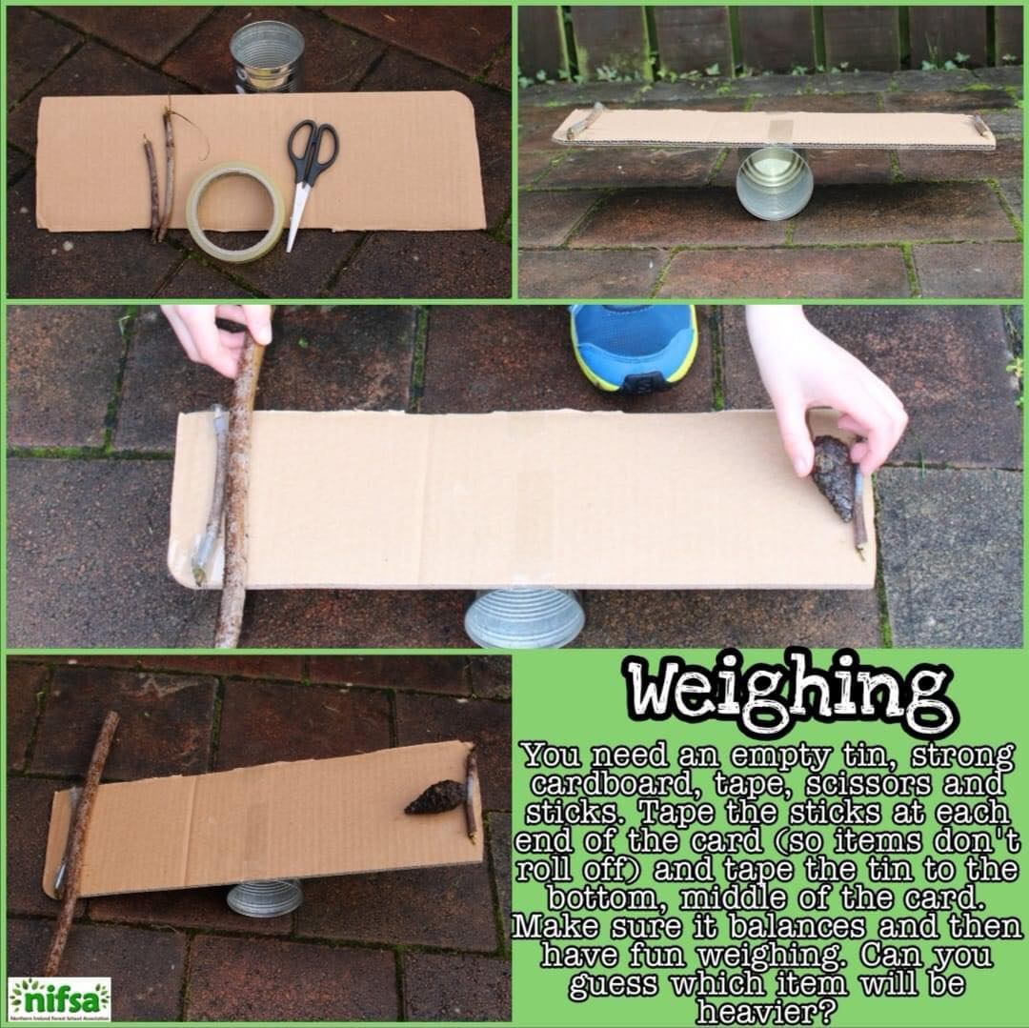 | 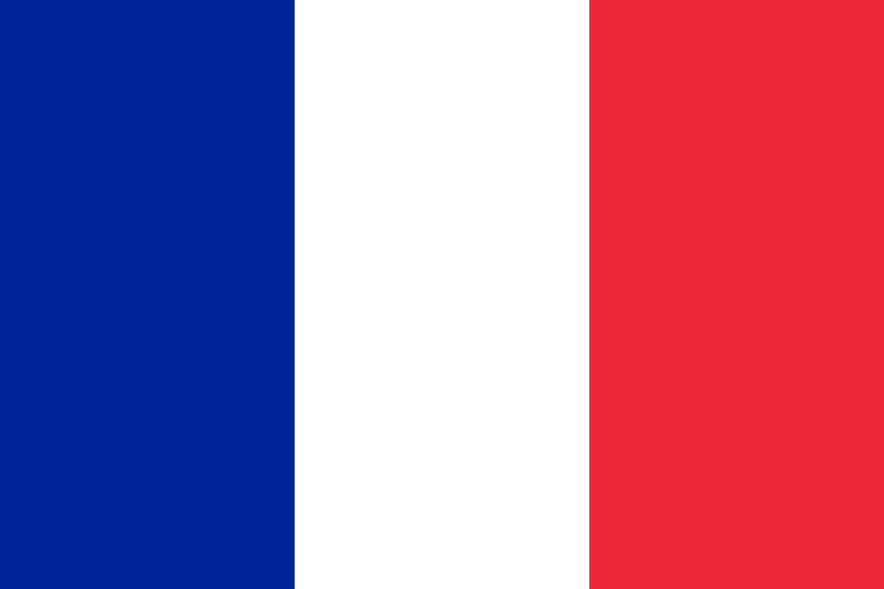French Colours!🌈  Recap your knowledge of ‘Les Couleurs’ (colours in French) using the following link (you may need support). There is a tutorial on French colours which takes you through the pronunciation as well as some fun quizzes/games to try!  Les Couleurs Tutorial  TASK: Take a walk outside or around your home and identify the different colours you see in French. Please upload a video clip to the Rainbow page!  Êtes-vous sûr de parler en français?  (Are you confident in speaking French?)  ⭐⭐⭐Extension:  Can you describe what you see in simple sentences? You could use google translate to help! For example, ‘The leaf is green,’ becomes, ‘La feuille est verte.’

