RAINBOW DAY
Team: Mrs. Clark’s Rainbow Team  Remember that these are for the whole week and you do not need to do all of them! Pick and choose what works best for you at a time that suits. 😀 |  | Week: Wednesday 03-02-2021
🎨Art – Landscape Drawing  For this task you will need: Coloured pencils/pens/pastels (whichever is available), paper  Watch the following clip about Australian artist Ken Done.  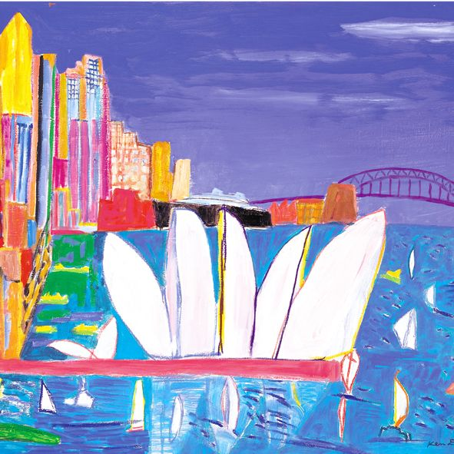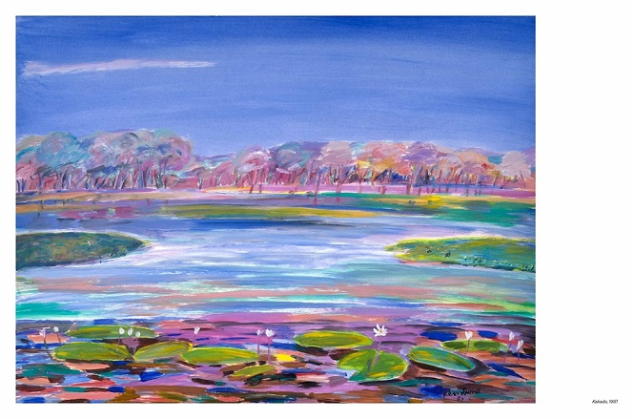  Ken Done Landscape Artist  Inspired by his work, choose a landscape from your local area to draw. You can find an image online or take a walk and photograph where you would like to draw. You could choose somewhere where community helpers work or simply somewhere that inspires you!  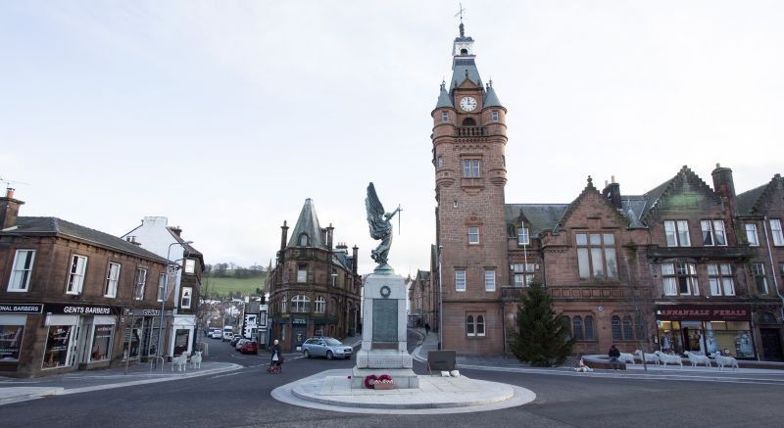 | 🎵Scottish Music🎶  Miss Bremner and Miss Keenan’s Team:  Learn to sing and keep the beat to ‘Ye Cannae Shove Yer Granny Aff a Bus,’ using the following link:  Ye Cannae Shove Yer Granny Aff a Bus  Miss Fergusson’s Team:  Learn to sing ‘Caledonia,’ and keep the beat to ‘Donald Where’s Yer Troosers’ and ‘Scotland the Brave’ using the following link:  Caledonia Donald Wheres Yer Troosers  Please upload any photos or videos from these tasks into the Music channel on the Rainbow page. | Drama - Community Helpers ‘Hot-Seating Activity’👮👷💇  Choose a community helper and become that person. For example, dress-up and play a doctor, farmer, Tesco worker, postie, etc. You will have to research their role in the community to participate in this task. Then have a family member interview you with the following questions (some or all):  What is your job?  How do you help others in the community?  Where do you work?  What skills and qualities are important for your role?  What is your favourite thing about your job?  Extension: If possible, make some of your own interview questions or answer these if you can:  What is the most challenging part of your role?  What does a typical day look like for you?  Did you have to study for this role? If so for how long?  What is the funnest part of your role?  Who inspires you?  Please film/photograph this task and post your results on the Rainbow page.
HEALTH & WELLBEING  Nutrition  Miss Bremner and Miss Keenan’s Team:  Have an adult help you explore this link on seasonal food:  Seasonal Food  Miss Fergusson’s Team:  Explore this link on seasonal food:  Seasonal Food 2nd  Challenge: Make a seasonal food calendar. Write down the months of the year and draw a healthy food product that is in season to match the month. I will attach Scottish Food Seasonality Posters to the task announcement to help with this.  Extension: Help prepare a meal/dish that includes at least one seasonal ingredient (or more if possible!) and share on the Rainbow page.  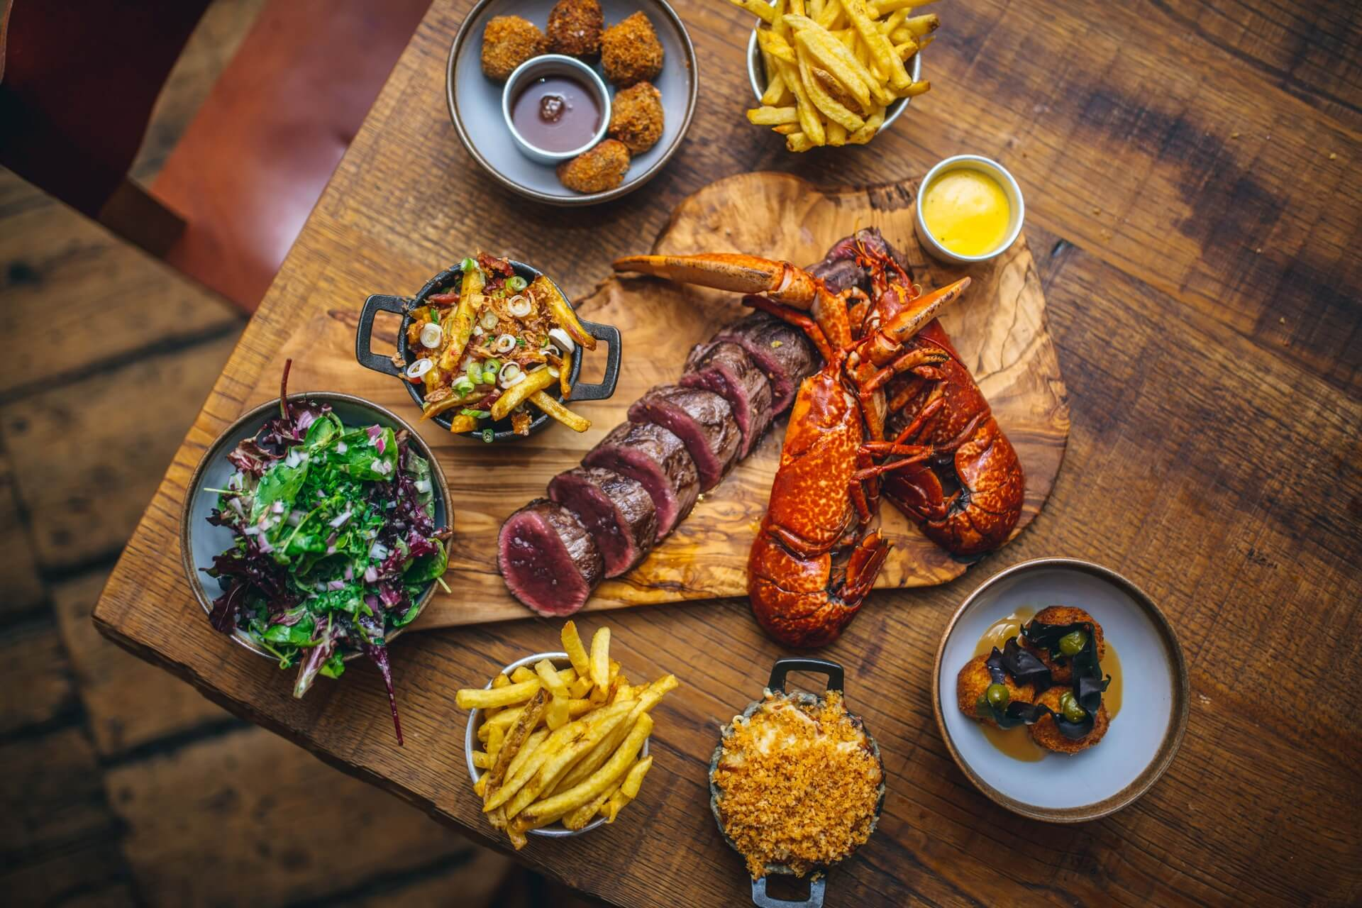 | ✅Marvellous Measure🔢  In Numeracy this week, I want you to focus on measure (size and area). These tasks are online.  Miss Bremner’s Team:  Use the link to play a game where you compare size:  Comparing Size  Miss Keenan’s Team:  Use this link to explore how to calculate area:  Calculating Area 1st  Now use this game to explore calculating area:  Area Exploration  Miss Fergusson’s Team:  Use this link to explore calculating area:  Calculating Area 2nd  Now use this game to explore calculating area:  Area Exploration  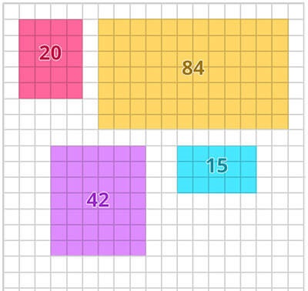 | Confident Coding!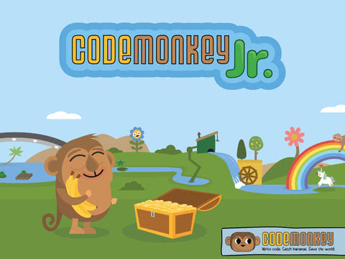  Visit the following link (with adult support at first if needed):  Hour of Code Continued  Here you will find several different activities to try that are differentiated by age. You can choose ‘beginner or comfortable’ based on how confident you are with coding. There is also a ‘Pre-reader’ level for younger pupils. Please explore the resources available or take a look at Mrs. Clark’s recommendations for this week (beginner level):  Miss Bremner’s Team:  Code Monkey  Miss Keenan’s Team:  Code Beach  Miss Fergusson’s Team:  Code Oceans  Please post photos/videos of your work on the Rainbow page.

