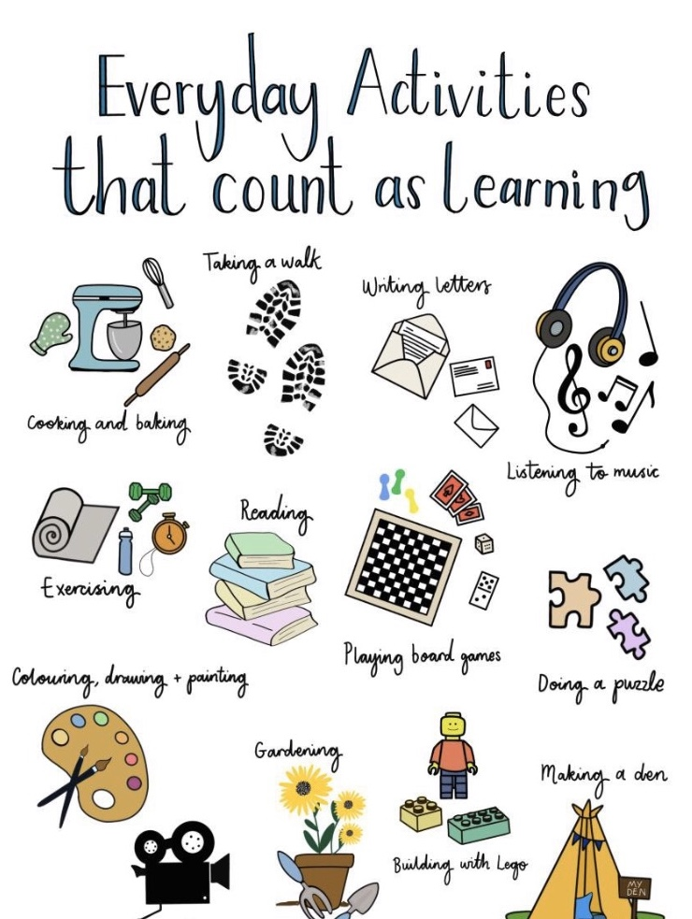

As January comes to an end, I think it is a really good time for us to reflect on how well this month has gone. I’m amazed at how we have overcome any challenges that seem to come from nowhere, and without warning, and most importantly, how we have supported each other through them. We appreciate how difficult this can be for so many of you as you juggle work, homeschooling and everyday life. Your efforts are appreciated and we are all very impressed at your engagement. Please remember to get in touch if we can continue to support you in any way and also to contact us if you would like to talk through concerns, achievements, anything.

I remember the buzz around the school during December as we focused on kindness, the more we gave the more we seemed to receive. The generosity everyone demonstrated was unbelievable and the gratitude expressed made it all worthwhile. I think it is timely to suggest that we think of each other, within your household, or neighbours, friends and family that you cannot see. What would make their day and bring a smile to their face? Small gestures and acts of kindness go a long way. What would make your day? Are you taking time to make sure that you are okay in the midst of trying to do everything for everyone else? Be kind to yourself and each other.

Navigate your way through in whichever way it suits you best and remember this is unmapped territory.

Mrs Fraser

HOME LEARNING PACKS
This week there are materials to collect for all classes. Packs will be situated in the foyer ready for collection from 9.00am on Monday morning. It would be helpful if you let the office staff know when you collect a pack, thank you.

PARENT COUCIL MEETING
Tuesday 9 February 2021 @ 6.30pm via Zoom
This is the date for the rescheduled meeting. Hope you can join us in our virtual meeting, all welcome. Please confirm your wish to attend via the link.
https://forms.office.com/Pages/ResponsePage.aspx?id=oyzTzM4Wj0KVQTctawUZKUW24qU1tIVHikdiRiM0NrhUQUpXTEc5UFNQMUROR1JFTDNXQUlFNUFRTC4u

CONTACT DETAILS
To ensure our records are up to date, please email or telephone the office with any changes to your contact details. Thank you.

SWAY
Check out this week’s Rainbow activities on Sway.
https://sway.office.com/1KPdWdL1TcO6PT5Q?ref=Link&loc=play

CERTIFICATES
This Photo by Unknown Author is licensed under CC BY-SA
Please remember to send in your little stars photos for our gallery.
Well done to last week’s certificate winners Carly, Isaac and Eva, and to Caleb for the previous week.
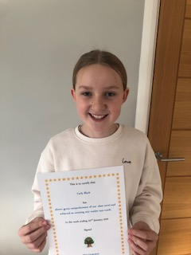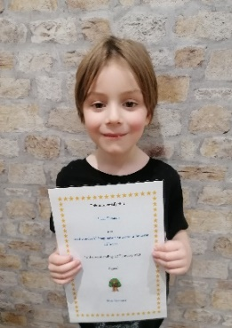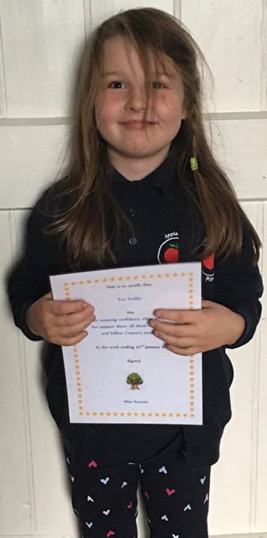
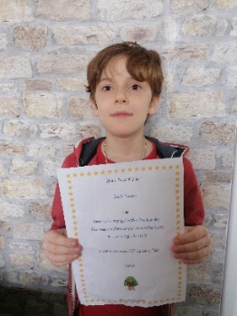
ATTACHMENTS
Learning Overviews
Family Learning Leaflet
The Future Speaks

FORMS TO COMPLETE
Wider Achievement
https://forms.office.com/Pages/ResponsePage.aspx?id=oyzTzM4Wj0KVQTctawUZKUW24qU1tIVHikdiRiM0NrhURVczNFRJQ1dJOFBQQzFXRloxWDg4MVJJOS4u
Pupil feedback
https://forms.office.com/Pages/ResponsePage.aspx?id=oyzTzM4Wj0KVQTctawUZKZ1O2J7PzLFBrXDBxDZ139BUQUFSSE8yTUpROTBOWUM4QUNYV0VBUUYzVi4u

