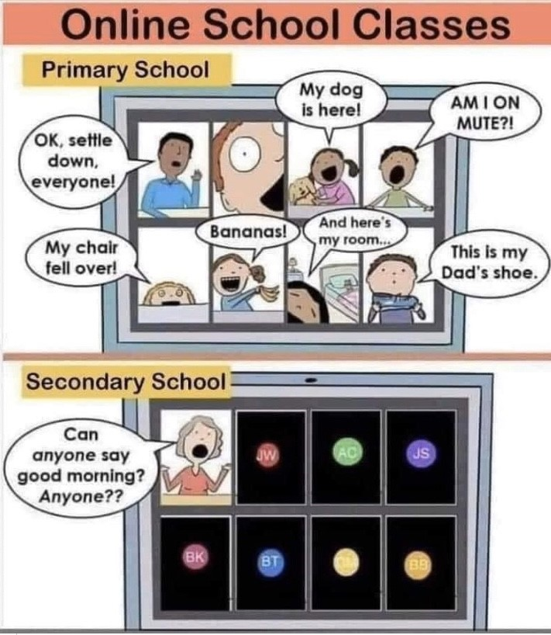
As you are aware our pupils will continue remote learning until at least the middle of February. The First Minister said that this decision will be reviewed on 2 February. It therefore remains our priority to get this right for all our families as we continue to navigate our way through these times.
We are most grateful for your responses to our surveys and your child’s feedback as this helps us shape future learning. All your family’s responses are most appreciated. We will continue to request feedback through our brief surveys throughout the term, but please do drop us an email or call us at any time.
Thank you for all the hard work and engagement from our pupils this week.

Mrs Fraser

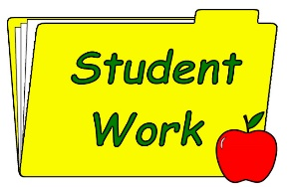
Learning Packs
There will be packs available for collection for
P1 and P2 pupils
P3 and P4 pupils
P5, P6 and P7 pupils this week
The packs include the Burn’s Booklet as well as other literacy and or numeracy resources.

It is The Big Garden Birdwatch next week; we have printed some of the bird identification help sheets for you if you would like to collect them from the school, they will be available when you are collecting your packs.

Burns Night is fast approaching, and our teachers have threaded a wee touch of Scots throughout their learning activities next week to mark the occasion. I can certainly identify with the following excerpt from Burn’s poem this week.

Cauld blaws the wind frae east to west,
The drift is driving sairly;
Sae loud and shrill’s I hear the blast,
I'm sure it’s winter fairly.
Burns – suggested by Love Outdoor Learning Ltd.

I’m really looking forward to hearing the poetry recitals!

UPLOADING WORK
If you are continuing to experience difficulty in uploading your child’s work on Teams, you can share it via the AppleHut email applehuthelp@outlook.com or the office email gw08officeapplegarth@ea.dumgal.sch.uk. Feedback will continue to be given by their teacher.

Wider Achievement
Thank you to everyone who sent in their child’s wider achievement. It was lovely to be able to give them a ‘shout out’ at assembly. The form will be attached each week for your convenience to use as and when required.

SWAY
Follow the link to see some of this week’s activities
https://sway.office.com/dOnzzrF6lHIMab8J?ref=Link

CERTIFICATES
Well done Charlie, Ellie and Caleb

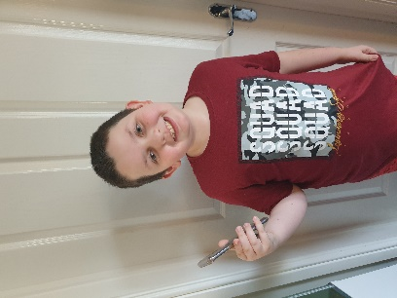

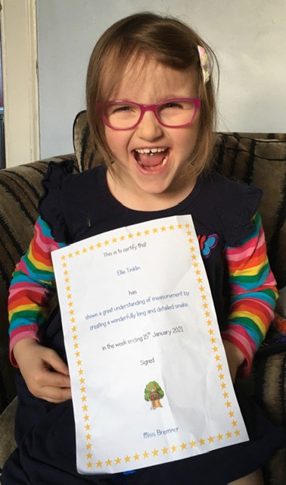

ATTACHMENTS
Learning Overviews
Rabbie for Kids

FORMS TO COMPLETE
Wider Achievement
Pupil feedback

