RAINBOW DAY
Team: Mrs. Clark’s Rainbow Team  Remember that these are for the whole week and you do not need to do all of them! Pick and chose what works best for you at a time that suits. 😀 |  | Week: Wednesday 27-01-2021
🎨Art – How to Draw Community Helpers  What you will need: a device to watch these links on, paper, a black pen (or pencil), coloured pens or pencils if available  Learn how to draw people in our community using the following links:  Start with a postman:  How to Draw a Postman  If you are more confident with drawing, try one of these two links:  How to Draw Community Helpers  How to Draw a Fire fighter, Police officer and Doctor  Remember that you can pause the video if and when you need to so don’t worry about keeping up! Please share your creations on the Rainbow page. | 🎵Scottish Music🎶  Miss Bremner and Miss Keenan’s Team:  Learn to sing and keep the beat to ‘Ma Ma’s a Millionaire,’ using the following link:  Ma Ma's a Millionaire  Miss Fergusson’s Team:  Learn to sing and keep the beat to ‘Loch Lomond’ using the following link:  Loch Lomond  In both links you can listen to the Scottish Symphony Orchestra Ceilidh play music.  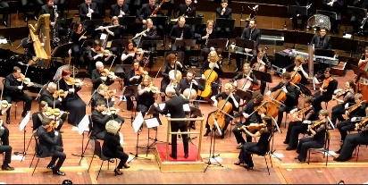 | Eco-Construction: Burns Cottage  Challenge: To re-create Burns cottage using natural materials.  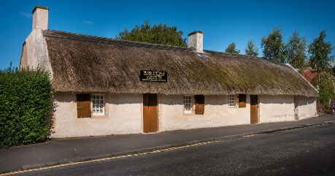  This is a design challenge and you can be creative...what could you use to re-create this famous building? Remember that any natural material is okay...this could be wood, stone, mud, fruit or vegetables, etc. Please upload a photo of your creation onto the Rainbow page.  To learn more about Burns cottage visit:  Burns Cottage  Challenge: What 3D shapes are included in your design?
HEALTH & WELLBEING  Nutrition  With adult support plan, prepare and enjoy a Burns supper with your family! If you can, include a starter, main, dessert and a drink. Have a discussion with members of your family about what they would like to eat and plan your grocery shop. Are any of the ingredients that you are using local? If so where do they come from?  💫Extension: research how far away your ingredients travelled from in miles or kilometres.  Attached in the announcement for this lesson is a ‘Design a Scottish Meal’ template, a Scottish Food map, an ‘Eco Global Map’ as well as a Powerpoint about Burns supper. Use this link to learn more about Burns supper:  Burns Night | 📈The Amazing Data Collectors!! 📊  Please continue to keep track of what you recycle each week. 😃  This week, join in with ‘The Big Garden Birdwatch’ and record what birds you see using tally marks. Remember when using tally marks you are grouping by 5. Follow this link for more information:  Big Garden Bird Watch  When you sign up, the RSPB will send you a pack to use at home or you can access it online 😄🐥  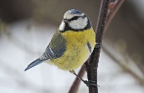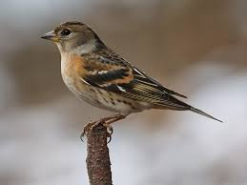  This link recaps tally marks and how to use them:  Tally Marks | Scots Poetry  I challenge you to record yourself reciting a Scots poem! This could be a poem that you learn or one that you write yourself.  Looking for some inspiration?  Here are some simple nursery rhymes in Scots to get started:  Coulter's Candy  3 craws  You could also use one of the Scottish songs you learned this past week or one of the poems from the ‘Rabbie Burns’ booklet attached to this task announcement.  If you are looking for something more advanced, this link to the Scottish Poetry Library has several poems to choose from:  Scottish Poetry Library  Remember that poetry is meant to be read aloud and I look forward to your recitals!

