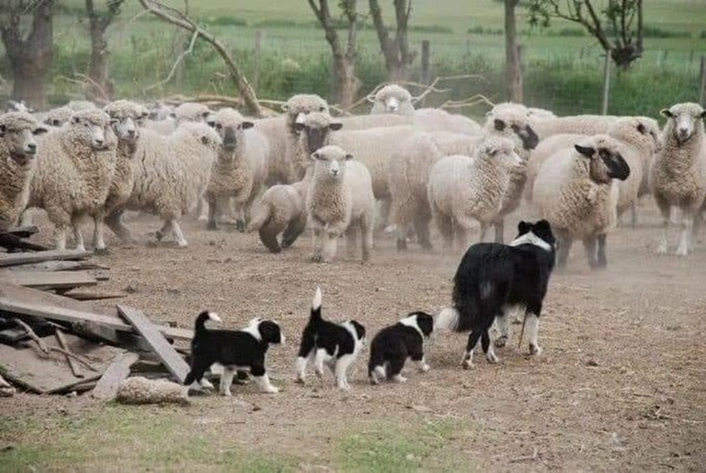

When you are a sheep dog but you still have to home school the kids!

**THANK YOU**

A huge thank you to everyone this week for adapting so quickly and so well to home learning. The skills your children are developing at the moment aren’t just for this moment in time, they are for the future, preparing them for the unexpected, being able to adapt and change their thinking and most importantly develop their resilience. I’m delighted that the vast majority of our pupils, through support from school and home, are taking the opportunity to participate. As always, please do get in touch if we can help you in any way.

Mrs Fraser

# 



**Parent and Pupil Survey**

As we continuously keep everything under review our staff, families and pupils have the opportunity to share their thoughts in a snap shot survey. How has this week been for you? Let us know through the parent survey. Pupils will be able to complete their leavers pass when the assembly is finished, this is also attached for your child’s convenience.

As a staff we constantly discuss and review what we are providing to fine tune our service to meet the needs of our pupils and families.

There is no indication that home schooling will end in the imminent future, so help us to get it right for you.

Please take time to let us know how you have managed this week, the parent survey is attached.



**EMOTION WORKS**

Emotion Works is an educational programme which we have invested in this session. Pupils have been introduced to the various cogs from August and are beginning to develop their knowledge and understanding of emotional literacy, something I consider will be of great importance, currently and for the rest of their lives. To give you a little more information on Emotion Works you will find attached a parent information leaflet. Emotion Works will remain a focus each week in your child’s learning tasks.



**Prioritising**

We have been doing distance learning for only 5 days. I think it is important to remember this as I’m sure for some it may feel like a term already!

Our priorities are Literacy, Numeracy, Health and Wellbeing and Inter Disciplinary Learning

All the activities the teachers put up on TEAMS are there to support your child’s learning. Please do not feel guilty if on occasions your child is unable to complete all the activities – we know you are doing other things. Your child is constantly learning through play, taking part in games, going walks, cooking to mention but a few.

**Preparation**

We also appreciate it is good to feel prepared. To support you in this, a weekly overview will be sent home on a Friday for the forthcoming week and our teachers will post the activities the night before.

We hope this supports you and enables you to work round learning times which are more convenient to you and your family.

Feedback on completed activities:

* When your child posts their work on the activity page feedback comments will be general.
* When your child posts their work in the assignments they will receive more personal feedback, which will include next steps.

It is exceptionally rewarding for staff to view their pupils work and note the huge effort they have put in to each activity.

Teachers will respond to each child each day between 9.00am -3.00pm – don’t worry if work is uploaded in the evening, teachers will respond the next day.

**Recommendation**

This has been a revelation in school this week- we highly recommend that you download the Microsoft Teams App as it has additional capacity.

Here is a link to a short clip courtesy of Mr Stevenson, Lockerbie Academy, which should assist you greatly.

<https://youtu.be/yOZHem5u734>

**Live Sessions**

During lock down, last session, the whole school community commented on the lack of contact with the class teacher and pupils. I am absolutely delighted at the transformation of being able to do the live session with our pupils this term. It is such a joy for us all to see our pupils and for them to see their teachers. Thank you for facilitating their meets!

**Timetable Change**

I would like to draw your attention to the slight change in timings of the live team sessions for next week.

**Monday, Tuesday, Thursday and Friday**

9.00 - 9.25 P3/4

9.30 - 9.55 P1/2

10.00 - 10.25 P5/7

10.30 - 10.45 Cyber snack time

**Wednesday**

9.30 - 9.55 P1-7

10.30 - 10.45 Cyber snack time

Friday 1.30 - 2.00 Assembly

We are trying to make our plans as consistent as possible – apologies for this change but we hope it works best for all our pupils.

Of course none of this would be possible if our pupils did not feel supported – whoever is supporting our pupils, you are very much appreciated.

**Wider Achievement**

As we are planning on a weekly assembly it would be lovely if you could share your child’s wider achievements with us. I’m sure there are many moments when you feel a real pride in what your child is doing. Let us know and we will give them a shout out each week.

A form will be sent home each week (a temporary substitute for our cheque book). Please tell us of real milestones and/or examples of your child going above and beyond.

**Pupil Packs P1/2 only**

Pupil Packs will be ready for P1/2 parents to collect from school on Monday – please place completed work in the P1/2 drop off box and collect the envelope from the P1/2 box. Please consider others and remember to keep your distance and wear a facemask. Thank you.

There are no packs to collect this week for the other two classes.

 **ENROLMENT 2021/22**

Enrolment dates in Dumfries and Galloway Primary Schools are between 18 - 22 January 2021. In light of the current COVID-19 pandemic, we are reducing parental contact with schools and asking that rather than attend schools to enrol, parents submit applications via post or electronically, where possible, along with supporting proof of date of birth and home address to the catchment school.



**SWAY**

Please visit the link to view this week’s Rainbow Activities.

<https://sway.office.com/xZ1j0pNZCMbm3DlP?ref=email>



I am delighted to announce the safe arrival of Baby Harry Leo James. Congratulations to Mr and Mrs James and Clara, both mummy and baby are doing well.

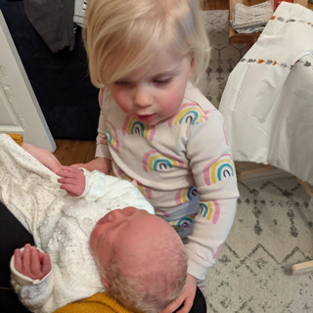

**ATTACHMENTS**

CAHMS Information

Emotion Works

Weekly Learning Overviews

**FORMS TO COMPLETE**

Parental Survey

Pupil Survey (this has also been sent to your child via TEAMS)

Wider Achievement