What a December! I cannot recall a school festive period like this in all of my career.
I am overwhelmed at the generosity of our pupils, parents, carers, staff and community this year. Both schools have pulled together to make it an unforgettable Christmas, not just for others but for our pupils too.
We really enjoyed the Pantomime, Jack and the Beanstalk. Oh yes we did! We have had a slight hold up producing the activity booklet as the photocopier has gone on strike! Hopefully our pupils will have it before the end of term.
The First Base gentleman who came to collect the many bags of food was absolutely amazed how much we have collected and said that they’ve never had so many donations across the region.
A big thank you to Durrie’s parents for so generously taking, producing and gifting a special photograph of your child for you.
The Crossdykes Windfarm has been exceptionally generous in their support this year as they have willingly agreed to donate all the ‘Seasonal Special Guest’ presents. I truly hope your child enjoys their gift.
We also received another incredible donation of gifts for all the pupils from an ex Parent Council Chairperson, Jill Hollis, who I remember always described the school as the best kept secret of the authority. Amazing after all these years Jill still thinks of us.
One Planet Picnic – we were contacted this week to inform us we had won the draw from all the participants who entered into The One Planet Picnic, which we took part in during lockdown. Well done everyone who participated – we have received the prize in the post, a ‘sour dough’ recipe may be coming your way in the new year.
A special gift - Your child will be taking home a very special gift for you this year – a beautiful photograph in a personalised frame, a hand decorated Christmas decoration for your tree and a copy of our 2020 Christmas Production to

entertain you and your family, to watch at any time – over and over!
I can’t thank you enough for embracing our theme of giving a little love and kindness this year – you really have demonstrated how amazing and thoughtful you are. I am sure we have touched the hearts and lives of many.
The arrangements across the partnership will remain the same. Hutton pupils will continue to come to Applegarth Primary for the foreseeable future. This has been an enriching experience for both staff and pupils and we fully appreciate your support.
On behalf of all the staff I would like to take this opportunity to wish you all a very happy Christmas – whatever way you have chosen to celebrate this year – please stay safe, enjoy the times you have together and most of all have fun.
I look forward to seeing you all after the holiday.
Mrs Fraser

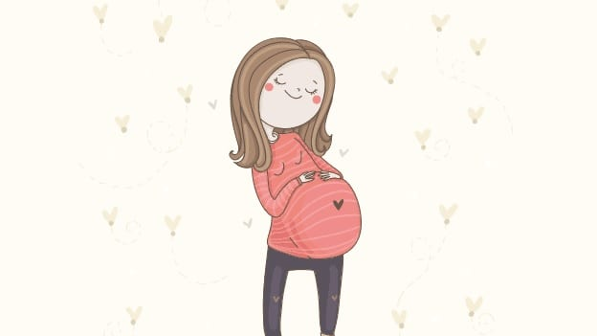
UPDATE ON STAFFING
Mrs James has left to start her maternity leave. We wish her all the best and will keep you updated on the arrival of baby.

CHILDREN’S MESSIAH
Dunedin Consort’s is streaming a live performance of the Children’s Messiah,
The stream is going live at 1pm on Tuesday 22nd December, and can be accessed at home from then on by following the link below:
https://dunedin-consort.org.uk/childrensmessiah2020/
The Children’s Messiah is a 45-minute bitesize performance of Handel’s celebrated Messiah, specially designed for primary school children, with fun games and activities throughout. This year it will be presented by the amazing Jamie MacDougall, who will be appearing as Mr Handel himself, and bringing lots of festive fun to the programme!

CHRISTMAS HAMPER WINNERS
The draw was carried out
this afternoon by our Pupil Council and the winners are …….

Chloe McGarva - Girls Hamper
Lorna Curtis – Boys Hamper
Emma Boyes – Luxury Food Hamper
Edmund Carr-Saunders – Pamper Hamper
Christmas cake – Adam Dalgliesh

The Hamper draw took an amazing
£327 which goes towards funds for the school.

END OF TERM
At the end of the day tomorrow your child will be sent home with their wellies, indoor shoes and medicines (if applicable). Please return on the first day of term.

HOLIDAY DATES
Last day of term – Friday 18 December 2020

Term 3 pupils return – Wednesday 6 January 2021
Mid Term pupil holiday – Monday 15 February 2021 – Friday 19 February 2021
Pupils return – Monday 22 February 2021 – Friday 26 March 2021

CERTIFICATES
Well done to last week’s recipients Holly and Denzel
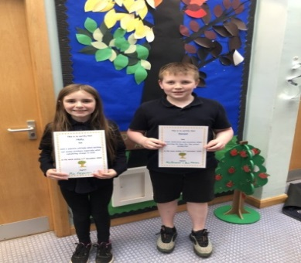
And this week to Finlay and Charlie
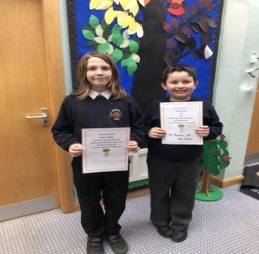

Homework Awards to William, Carly, Ellie, Eva and Pippa. Well done.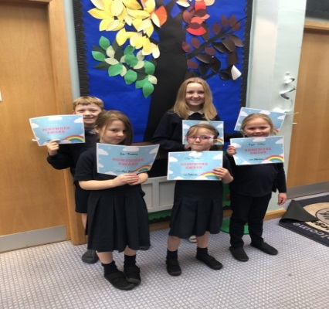

ENCLOSURE
Jack and the Beanstalk Activity Pack

