Are we having a great time in the run up to Christmas? – Oh yes we are!
We have just had such a fun afternoon watching the wonderful Jack in the Beanstalk Pantomime. Oh yes we really did! Pupils will receive an activity book with a few puzzles, recipes etc. – maybe you could all plant a magic bean this year…
The Christmas Enterprise has kept our pupils busy, not to mention our alternative festive production this year. Thanks again to everyone, especially staff and parents at this time as we try our best to make it a Christmas to remember for all the right reasons.
We had a ‘cracking’ Christmas lunch and rolled out the red carpet for our pupils this year – yes the cracker jokes were flying and our tummies were full. Thanks to our wonderful catering staff.
One last week of festivities ahead of us – details are in the newsletter as a wee reminder – I know first hand how difficult it is to remember all the different arrangements at this time of year.

Thanks again for your support
Mrs Fraser

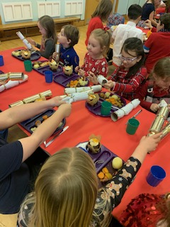

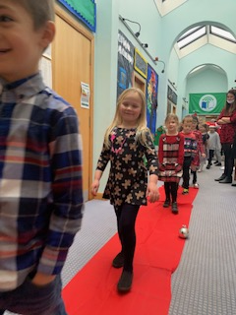

CHRISTMAS ENTERPRISE
They did it!!! Our Elves have managed to meet the high demand for their Christmas crafts and your orders will be delivered to you today. We hope you like them. A lot of hard work and effort has been put in to making these gorgeous homemade gifts. Well done to our Elves and their helpers for raising
£240.80, We really do have some hard working entrepreneurs in the making.

CHRISTMAS HAMPERS
Donations are still welcome for our Christmas Hamper raffle. Please return all square sheets if they have been completed or not, by Monday 14 December. The draw will take place on Wednesday 16 December. Good luck everyone.

ADVENT AND ABERLOUR DONATIONS
The last day for the food and toy donations will be Monday 14 December. All of your kindness will
make a difference in someone’s life.
Thank you.
MENU
All outstanding menu choices must be returned by Monday 14 December 2020. A school lunch will not be provided if a menu has not been returned. Thank you in advance.

READ WRITE COUNT
Our P2 & 3 pupils were presented with their Read Write Count bags last week. We hope your child and family are enjoying them.

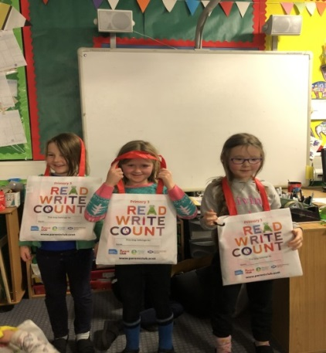

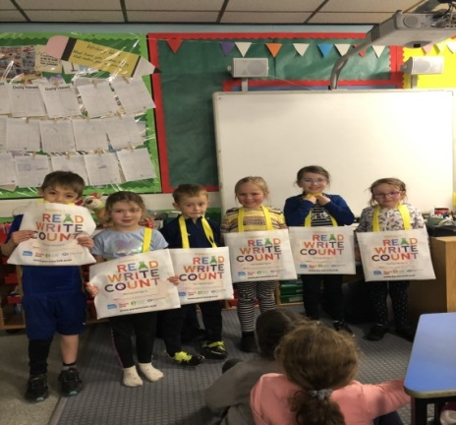

P1 ENROLMENT
The new enrolment dates for 2021 pupils will be week ending 22 January 2021.

As the process is different this year please follow the link to access the information.
https://www.dumgal.gov.uk/article/15241/School-places

If you require any further information please contact the school office.

HOMELINKS
This week will be the last homelink for this term.

NEWSLETTER
Our last newsletter for the term will be Thursday 17 December 2020.

LAST DAY OF TERM
18 DECEMBER 2020
As we are having a fun activity in our forest classroom for part of the last day, pupils can come dressed in their Christmas jumpers or something similar to keep them warm.

CERTIFICATES
Well done to Eve and Tilly

