What a fantastic start to December, the school is sparkling and Santa is waving to welcome everyone each morning. There is bird seed and glitter everywhere not to mention a few stray reindeer around the school – Christmas is most definitely happening this year!
Our fantastic elves served us well this week as they delivered the Christmas trees with a little help from Santa and his ‘sleigh’ to the care homes in Lockerbie.
Thank you to everyone who has already given so generously to the food bank, selling squares and the hamper prizes. We are so appreciative, as will all the families be, as they receive your donations. Keep sending them in – it will mean so much to everyone.
The special elves (all the pupils) have also gone into factory mode as they form a production line making up your amazing orders.
Thanks again everyone, ‘Give a little love and kindness’ is certainly happening all around us.
Mrs Fraser
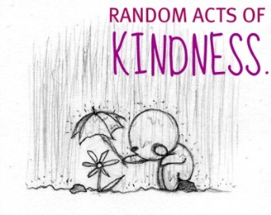
Give a little love and kindness this Christmas

Santa and his Elves made their special delivery of our decorated Christmas trees to our local care homes Westfield, Dryfemount and Abbeyfield. It was a wonderful experience for our P7 pupils to see how the art of giving can make such a huge difference to their community. Thank you to our P7 parents for transporting their children, and thank you to Robinsons/FarmFit for their kind donation of three beautiful trees.

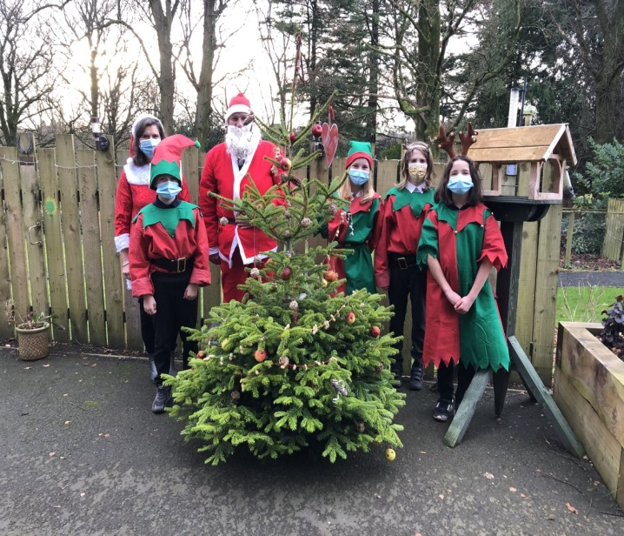

We have been overwhelmed with everyone’s generosity in either donating to the Giving Advent, Hampers, Aberlour or making a purchase of crafts. It really does reflect our theme for December. Donations can still be received until 14 December 2020.
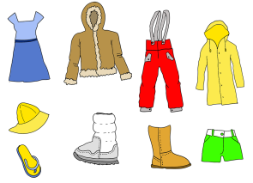
CHRISTMAS SHOW COSTUMES
As the production is underway could all pupils please bring their costumes in on Monday 7 December 2020. These should be in a carrier bag clearly marked with your child’s name.

CHRISTMAS ENTERPRISE
Thank you for all your orders, our special elves are busy meeting all your requirements and these should
be delivered to you the week commencing 7 December 2020. Fingers crossed there are no malfunctions in the factory!

CHRISTMAS LUNCH
WEDNESDAY 9 DECEMBER
A reminder that our Christmas lunch will be a formal event this year. The dress code is smart/partywear.
All P1, 2 and 3 pupils are not required to pay for their lunch. If you have sent money in this will be returned and enclosed in your newsletter bag today.

CHRISTMAS CARDS
Pupils can, if they wish,
exchange Christmas cards this year however we ask that these are
handed in to the office by Friday 11 December to be distributed the following Monday. A list of pupils’ names are available from the office on request.

PARENTAL SURVEY
Thank you for all your responses to our recent survey. All comments are taken into consideration. Further information to follow.

CERTIFICATES
Apologies to our previous week’s recipients we forgot to include them in our gallery of fame. So here are the winners of the past 2 weeks.

WELL DONE
Caleb, Lukas and Brooke

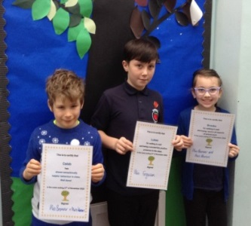

WELL DONE
William and Izzy

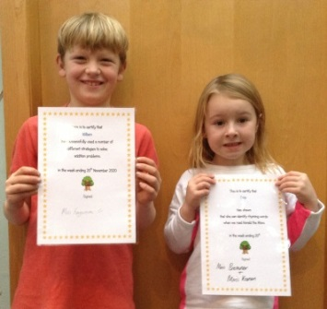
ENCLOSURES
- A4 Community Link
- Healthy Weight Information
- Children (Equal protection from Assault) (Scotland) Act 2019
- P1 & P2 Toothpaste pack

CHILD POVERTY ACTION GROUP - COST OF THE SCHOOL DAY PROJECT
How does your school talk to you about costs and money? A survey for parents and carers The National Parent Forum of Scotland (NPFS) and Cost of the School Day project at the Child Poverty Action Group in Scotland (CPAG Scotland) would like to hear from you about how your school community keeps in touch with you, particularly about costs and money. Whether you are living on a low income or haven’t experienced this but have views about how your school communicates with you, we want to hear from you. Maybe there are things that you think your school does well, or perhaps you think there are things that it could do better? We want to hear what you have to say, so that we can let schools, parent councils, local authorities and the Scottish Government know what works and what could be better. What you tell us could make a real difference – click here for our survey. https://www.surveymonkey.co.uk/r/VX3S7DZ This survey closes on the 6th of December 2020.

