Definitely the highlight this week has been receiving recognition for our pupil’s outdoor learning experiences. Thank you to our families for nominating us. We all know learning outdoors develops creativity, problem solving, independence and confidence and so much more. We are so fortunate to have such amazing surroundings and I’m so appreciative of our staff making learning outdoors happen for our pupils.
One more week then it will be full steam ahead in our lead up to Christmas! Look out for all the exciting activities – we are focusing on the theme of kindness this year and hopefully you’ll see it spread throughout the school and beyond.
FABULOUS NEWS
We are so excited to announce that Applegarth and Hutton Partnership have won the Love Outdoors competition that was running on Facebook. Mrs Yule and Mrs Tinklin kindly entered our wonderful little schools to the competition to win a free year’s membership to Love Outdoors Ltd. There were 2 prizes up for grabs and Applegarth and Hutton were chosen to be the judges’ choice. The decision was made after they reviewed the schools entry and looked at our social media and websites. They commented that our schools truly have outdoor learning embedded into their teaching and sustainability at their core. Not only have we free membership, we have access to all their resources. This is a huge benefit to our partnership and staff. Well done and thank you again for nominating us.

HALLOWEEN COSTUMES
We are a very lucky school this week once again, as Tesco have generously donated Halloween costumes for all our pupils. Each child has been sent home with a costume that is theirs to keep. The Pupil Council are sending a thank you letter to Tesco for their act of kindness.

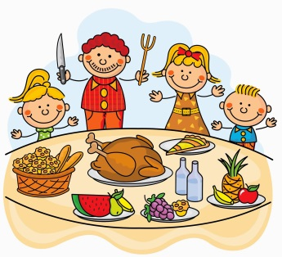
CHRISTMAS LUNCH
9 December 2020
We plan to make our Christmas lunch extra special this year by inviting everyone to dress up for lunch. More information to follow.

If your child wishes to have the Christmas lunch, complete the menu enclosed in your newsletter bag.
Please return by 23 November 2020.

SCOTTISH BOOK TRUST
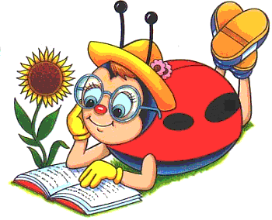
BOOK BUG BAGS
Our P1 pupils have been presented with their bags. They are filled with exciting resources that I am sure they will enjoy. Hope you like the ladybird picture Mrs McWhirter.

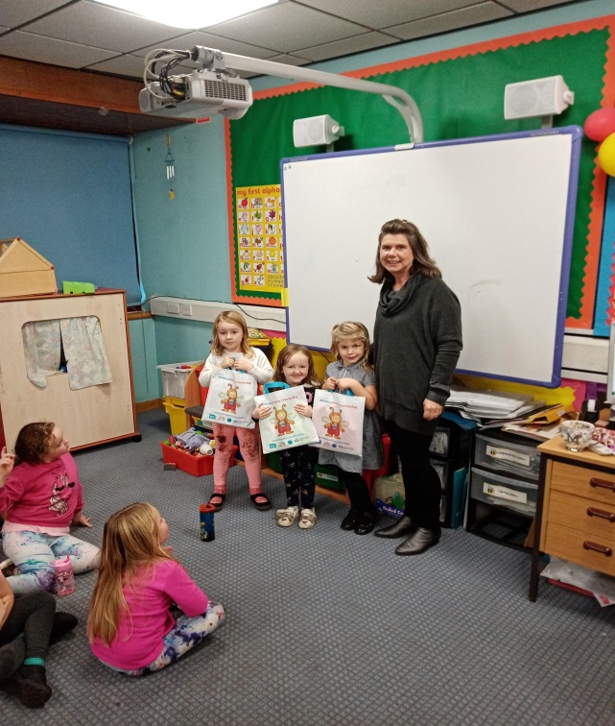

READ WRITE COUNT BAGS
Unfortunately there has been a slight delay in the distribution of the P2/3 bags. These will be presented to pupils once they arrive at school, hopefully next week!
RAIN RAIN GO AWAY
Our pupils are encouraged to have fresh air at every opportunity and as the climate is unpredictable pupils should be prepared for all weathers. Please can you ensure your child has appropriate clothing for being outdoors, ie jackets or coats.

WELLIES
You will be aware that we sometimes have very muddy conditions in the playground and forest classrooms, please send a pair of wellies into school for your child to change into.

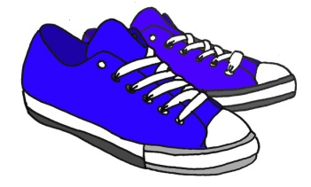
INDOOR SHOES
A reminder that pupils need indoor shoes to change into.

WATER BOTTLES
Your children are working very hard at school, to make sure they are keeping hydrated please can you remind them to bring in their water bottles. These should be taken home daily to wash and returned the next day.

PARENT SURVEY
As our Drop Off and Pick Up procedure has been changed slightly this term we would appreciate if you could complete the short survey. This will inform us of any further changes. Click on the link to access the form. Thank you.
https://forms.office.com/Pages/ResponsePage.aspx?id=oyzTzM4Wj0KVQTctawUZKUW24qU1tIVHikdiRiM0NrhUOEU0UU05NklSNjY0QzRYQ0ZXWDNLSjUxUi4u

CERTIFICATES

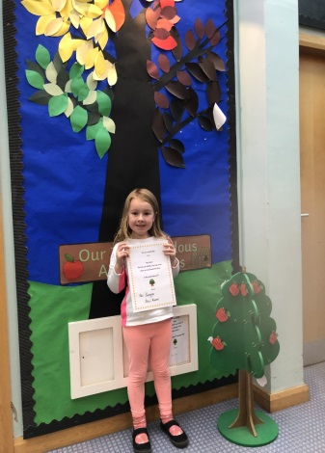
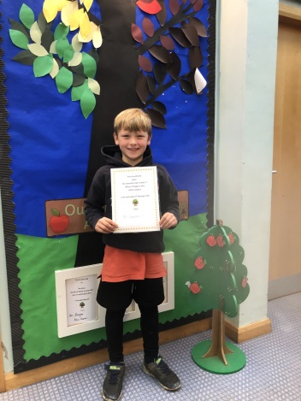

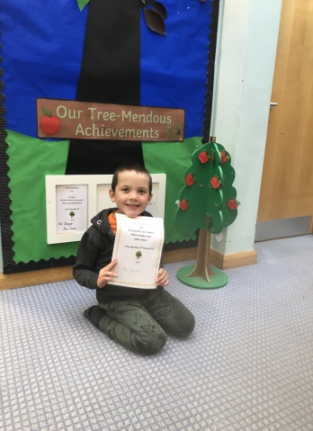
Well done to William, Izzy and Oliver.

