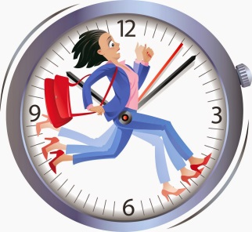
This week appears to be as fast as last!
Plans are coming together as we start to prepare for Christmas – our pupils certainly have a lot of great ideas. It was lovely to hear our Pupil Council read out their suggestions. Hopefully we will be able to make some of their dreams come true!
This week’s assembly was about ‘Colour the school with kindness’ which I think is so apt as we lead into Christmas. It’s not always easy in the current climate to stay positive, especially in winter but I’m sure as we work together we can continue to support and care for each other too.
GOOD NEWS
I’m delighted to announce that Mrs Shenton-Ross gave birth to a beautiful baby boy, Douglas.
Both mum and baby are doing well.

REMEMBERANCE
To mark Remembrance Day a few Hutton and Applegarth pupils continued with tradition of laying a poppy at the War memorial in the grounds of Hutton and Corrie church.
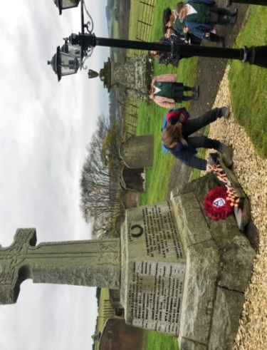
Later in the morning at 11am all staff and pupils from Applegarth and Hutton marked the 2 minutes silence followed by pupils reading a poem to the class and staff.

Thank you to everyone who purchased poppies. We raised £23 for Poppy Scotland.

SWAY
To view this week’s activities click on the link.
https://sway.office.com/YKuW0XgbkVjtnb3W?ref=Link

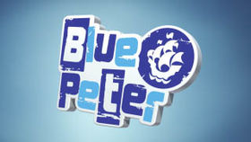
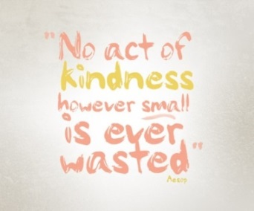
CRISP PACKETS FOR THE HOMELESS
We are collecting crisp packets with PacketProject to aid the homeless this winter. Visit the link to find out how the recycling of crisp packets can help. Please send in all your washed and cleaned crisp packets and we can forward on. Thank you for your kindness.
https://www.youtube.com/watch?v=2bfhwRwghVA&t=1s

SCOTTISH BOOK WEEK
16-22 NOVEMBER 2020
Applegarth and Hutton pupils will be celebrating Scottish Book week during their literacy sessions next week. Primary 1 pupils will be
presented with their Bookbug family bag at assembly next week . Primary 2 and 3 children will receive their Read Write Count bag at assembly from the Scottish Book Trust.

BLUE PETER ON YOU TUBE
Blue Peter is the longest running kids TV show in the world and they are uploading videos to their new you tube channel. These are suitable for 5-11 year olds. They have world record breaking challenges, arts and crafts, environmental videos, cooking and baking how tos, inspirational films, gaming, celebrity appearances, dance routines and music performances. The channel also feature ways of getting a Blue Peter badge, behind the scenes footage and extra content about their incredible presenters Adam, Lindsey, Mwaksy, Richie and Henry the Blue Peter dog.
If you think your child would be interested you can subscribe free at https://www.youtube.com/bluepeter

CERTIFICATES
Well done to Maddie and Millie.
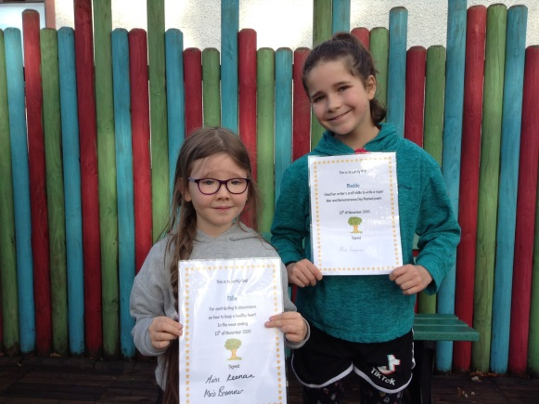

The Children (Equal Protection from Assault) (Scotland) Act 2019
SMACKING BAN
Recently Scotland has become the first part of the UK to introduce a ban on smacking with the introduction of The Children (Equal Protection from Assault) (Scotland) Act 2019 which became law on November 7th 2020.
The legislation now makes any physical punishment or discipline illegal and removes the defence of ‘reasonable chastisement’, meaning that parents could face prosecution for any use of physical punishment on their children, giving children the same rights and protection from assault as adults.
Acts such as hitting, smacking or slapping with a hand or an implement; kicking; shaking or throwing children; scratching; pinching; biting; pulling hair or boxing ears; forcing children to stay in uncomfortable positions; burning; scalding; or forced ingestion are all covered by the legislation.
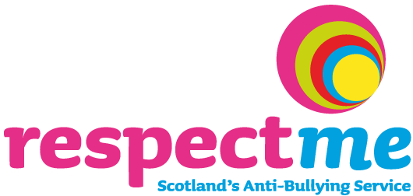

ANTI-BULLYING WEEK 2020
16th – 20th November

This year’s campaign, #WhatMadeItBetter aims to support people to explore approaches that have helped them to deal with bullying behaviour and provides a platform for young people to share anti-bullying solutions.
Pupils will be participating in anti-bullying activities from Scotland’s Anti-Bullying Service, Respectme throughout the week as part of the Health & Wellbeing programme.

Parents and carers can find out more about the Respectme’s work via the links below;
https://respectme.org.uk/
https://www.facebook.com/respectme.scotland/?fref=ts
https://twitter.com/_respectme_

We would also like to draw your attention to Respectme training webinars aimed at supporting parents and carers.

Bullying...it's never acceptable (for parents and carers)
Designed to help parents and carers understand what bullying is and how it plays out online and face-to-face. It will assist
parents and carers in offering support to children and young people affected by
bullying behaviour, and help them consider their role in promoting positive, respectful relationships.

Bullying...it's never acceptable - Parent/Carer Training Wed 18 Nov 6.30-7.30pm
Bullying...it's never acceptable - Parent/Carer Training Wed 9 Dec 11-12am

Online bullying and how to deal with it
Children are spending more time online than ever before. Most enjoy positive experiences of learning and connection, but some can have negative experiences. Find out more about what can be done when children experience bullying online.

Online bullying and how to deal with it - Training Wed 18 Nov 11 -12am
Online bullying and how to deal with it - Training Wed 9 Dec 6.30-7.30pm

