This week has absolutely flown by! We enjoyed a very good Parent Council meeting on Monday evening and it was lovely to see new parents join us. The draft minutes and Head Teacher report will be uploaded soon to our website page.
Our pupils enjoyed PE with a new coach – unfortunately he is unable to return next week due to current restrictions – hopefully these will be lifted soon.
Our Eco committee met for the first time with Mrs McWhirter on the big screen though TEAMS, they were then joined, surreptitiously, by the rest of the pupils. They have already set their targets and I am sure you will support them in their endeavours to make us all become more eco friendly and aware.
Staff have prepared the Learning Overviews which you will find in your child’s home link folder today.
Although outdoor learning is established and typically happens every day the teachers prepared a special #love the outdoors on Thursday to mark the National event. We now have very happy birds as well as children! Check out our pupils outdoor learning through the link in the newsletter.
Mrs Fraser
ONE WAY PICK UP AND DROP OFF
It has been raised again through the parent council and from the parental questionnaires that a few families are not adhering to the one way system. We would encourage all families, to ensure the safety of the children, to use the one way route.
It has also been brought to our attention that cars are using the staff entrance to reverse their cars into. This area is only to be used for the taxis and staff. It is a potential hazard and we have previously had near misses where drivers have not been aware of smaller children crossing the entrance.
Effective from Monday 9 November the collection time and procedure will slightly change to help alleviate the volume of traffic lined up.

The following system will be;
3pm – taxi pupils collected only
3.05pm – P1-4 will be brought to the gate.
3.15pm – P5-7 will be brought to the gate
A sign will indicate which class is ready to be collected. We ask that when it is your child’s class please drive slowly forward to the cone area where your child will be brought to your car. This will prevent any gathering of parents and there will be no requirement for you to leave your car. This will also help prevent the long line of traffic and pupils having to walk down the grass verge particularly as the weather is changing.
It would be appreciated if you do not arrive too early for your child to reduce the volume of traffic.
I would like to thank everyone for your co-operation on this. It has been implemented with the best of intentions and to keep all our school community safe amidst these challenging times.
Thank you.

Dyslexia Awareness Week Scotland 2 - 7 November
As this event draws to a close, we would like to draw your attention to the sites below which offer information about Dyslexia as well as support to families. dyslexiascotland.org.uk and young people unwrapped.dyslexiascotland.org.uk dealing with Dyslexia.
POPPIES
We have poppies available in school if you would like to send in a donation, clearly marked in a separate envelope. Please state how many poppies you require and send in to school on Monday 9 November 2020.

Message from Dumfries and Galloway Council

Honour our fallen heroes with two-minute doorstep silence
this Remembrance Sunday
Remembrance Sunday is set to be a very different occasion, as so many services have been cancelled, or attendance at places of worship strictly limited on numbers for those who are allowed to pay their respects – so that’s why we’re joining Legion Scotland
to encourage you to join the nation in a two-minute doorstep silence at 11am this Sunday.
Pupils will also adhere to a 2 minute silence at school on Wednesday 11 November.

PARENTAL QUESTIONNAIRE
Thank you to everyone who gave their feedback via the form that was issued prior to the holidays. Your comments have been collated and are being taken into consideration.

LEARNING OVERVIEWS
The termly overviews are in this week’s homelinks. If your child’s homelink has not been returned to school you will not receive the learning overview this week.

# LOVE OUTDOOR LEARNING

Please follow the link to view our exciting outdoor learning day.

https://blogs.glowscotland.org.uk/dg/applegarthandhutton/celebrating-success/love-outdoors/

EASY FUNDRAISING
With Christmas fast approaching lots of us parents will be thinking about on-line shopping. If we use the Easy Fundraising Search Engine, the school will receive a donation. This is the link to sign up and choose Applegarth Primary as your cause https://www.easyfundraising.org.uk/causes/applegarthschool/?invite=idxkge&referral-campaign=c2s “

Caring Christmas Crisp Challenge!!
As an Eco School, Applegarth & Hutton Partnership are always keen to reduce, reuse & recycle!
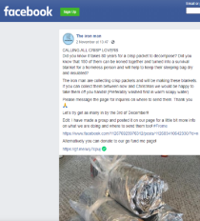
In the current circumstances recycling can present a bit of a challenge however, we have been made aware of this very worthwhile project which our Eco Committee would like to encourage everyone in our school community to take part in:
Use the link below to find out more;
https://www.facebook.com/TheIronManFrome/photos/a.115152630211741/179416187118718/?type=3
The Eco Committee are asking you to:
- Collect your empty crisp packets at home.
- Wash them in warm soapy water and allow them to dry.
- Send them into school by 27th November 2020 so that we can send them to The Iron Man!
It takes 150 crisp packets to make 1 foil blanket to help keep a homeless person a little bit warmer and drier this winter.
LET’S SEE IF WE CAN COLLECT AT LEAST ENOUGH TO MAKE ONE BLANKET!
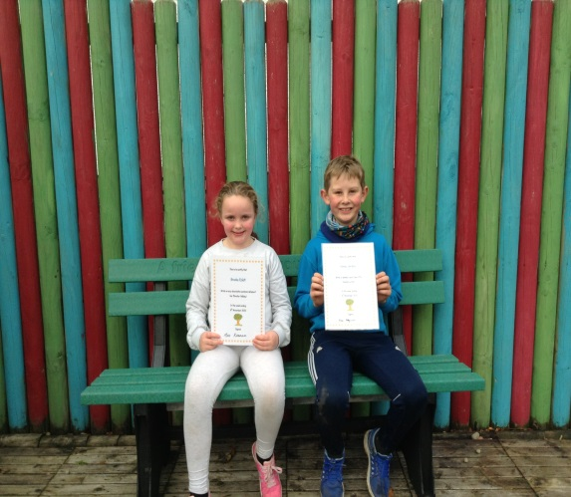
- Please ensure your child has wellies or footwear appropriate for playing on the grass and in the woods. These can be left at school for the term and should be clearly labelled.
- Lunch and milk money should be sent into school on a Monday in your child’s newsletter bag.
- Homelinks should be returned on a Monday
- All children should have their clothing labelled with their names on.
- Indoor shoes are required to change into.

CERTIFICATES

Well done Kade and Durrie

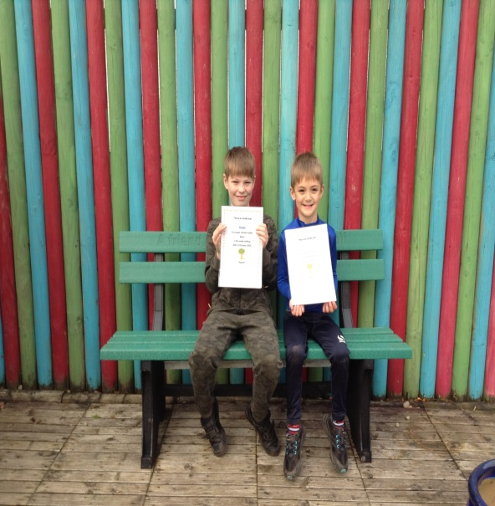

Brooke and Howie

