The holidays are here! I’m so proud of all my staff, pupils and parents for making the return to school so successful. I’m sure you’ll agree that your children have been amazing. To help inform us we continue to navigate our way through these unusual times – can I ask that you take a few minutes to complete the parent survey. Just click on the link.

I’d like to wish you all a very happy October holiday and look forward to seeing you all after the break.

Mrs Fraser

The days for P.E will be changing after the holidays. They will be on a Monday and Friday. Pupils should continue to come to school in their PE kits and be prepared for all weather conditions.
(Pupils will not have PE on the 30 October 2020)

VIEW OUR SWAY for MATHS WEEK SCOTLAND 2020
Don’t forget to view the Maths Week Scotland SWAY if you haven’t already. There are a few new contributions to the Maths@Home Challenge to enjoy!
Our SWAY has also been shared with the Maths Week Scotland & Dumfries & Galloway STEM teams 😊.
This Photo by Unknown Author is licensed under CC BY-SA-NC
WELL DONE EVERYBODY!!

SWAY
Follow the link to view this week’s activities.
https://sway.office.com/kXcCiVfzE9135y0r?ref=Link

PARENT QUESTIONNAIRE
We would appreciate you and your child’s feedback on reaching the end of a very unusual term, let us know how it has gone. All your responses will help us plan going forward. Please click the link to complete the form. Thank you.

https://forms.office.com/Pages/ResponsePage.aspx?id=oyzTzM4Wj0KVQTctawUZKUW24qU1tIVHikdiRiM0NrhUMkYzV1M2QTJFVTZQWU43TUdPWTczRVRTUS4u

WITCH WAY TO THE FOREST?

If you dare to enter in
The forest is where it all begins
With witches, ghouls and lanterns too
This Hallowe’en party is for you

So get dressed up and cosy too
As outdoor fun is what we do
A spooktacular time we will have
And don’t forget the trick or treat bag!!!

HALLOWE’EN
30 October 2020
We could not let the current COVID restrictions prevent us from having a spooktacular time this year so we shall be taking our Halloween party outdoors, into our spooky forest.

All pupils should come dressed in their warm, fancy dress costumes and be

prepared for all the outdoor Halloween fun.
Enter the annual family pumpkin competition bring along your decorated pumpkin. Prizes to be won!

PARENT COUNCIL
Spooktacular fundraiser
A huge hit across the partnership has always been the Witches Drive. Sadly due to current COVID restrictions we are unable to hold the event.

However, we can still have some fun in other ways. Each child has been given a plastic tub to create something for Halloween. This could be a spider, a pumpkin or an idea of your own, be as creative as you will. The aim is to fill your tub with money to raise funds for the parent council. Why not help doing chores to try and get your tub filled up? I am sure your family would love some help around the house! There will be a prize for the best decorated tub. Please bring along your entry on Friday 30 October 2020.

READY STEADY COOK
A reminder to send all your tasty recipes and photos to
apgparentcouncil@hotmail.com

STAFFING UPDATE
Thanks to Mrs James and Miss Fergusson for covering staff
absence during this term. Mrs James will continue her role as PT 2 days a week. If all goes to plan we will have a new teacher full time in Primary 5-7, ready to start in term 2.
This week Mrs Shenton Ross started her maternity leave. I know everyone will join us in wishing her a restful break. We will keep you updated and share the news when baby Shenton-Ross arrives.

This has been a long departure but Mr Walker–Jones has now officially left the building! I’d like to thank him for his contribution over the last 3 years, and wish him luck in his new post.

RAG BAG
Wow! Those lockdown clear outs have definitely helped raise funds for the schools. Applegarth raised £121.60 and Hutton £66.40. These are amazing amounts. Thank you.
Please continue to fill the Rag Bag bins with any unwanted items.
Remember to bag all items, bags can be requested from the school office.

WALK TO SCHOOL
Our daily walk to school certainly wakened staff and pupils up. We were lucky with the weather and it was great to see 100% participation! Well done everyone.

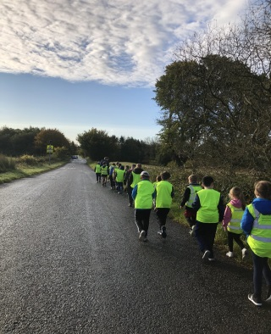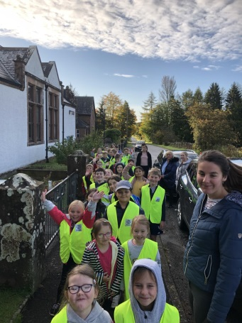

CERTIFICATES
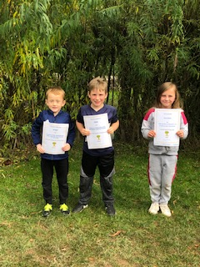
Well done Gregor, Caleb and Emma

WIDER ACHIEVEMENTS
GALLERY
At our end of term assembly we proudly recognised and presented certificates to our pupils. Well done to all.

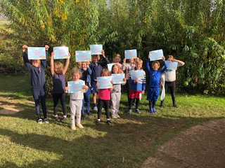
RAINBOW HOMEWORK ACHIEVERS
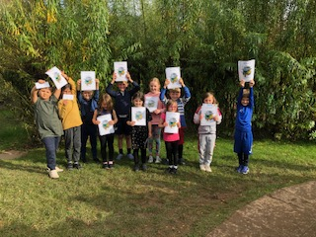
MATHS CHALLENGE PARTICIPANTS

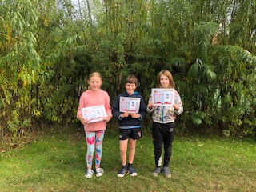

ACCELERATED 100% ACHIEVERS

